Annual Progress Report (APR)



2022 Air Quality Annual Progress Report (APR) for Falkirk Council In fulfilment of Part IV of the Environment Act 1995
Local Air Quality Management June 2022

Information | Falkirk Council Details
Local Authority Officer | John Millar
Department | Environmental Health
Address | Abbotsford House, Davids Loan, Falkirk FK2 7YZ
Telephone | 01324 504873
E-mail | JohnA.Millar@falkirk.gov.uk
Report Reference Number | Annual Progress Report 2022
Date | June 2022

Executive Summary: Air Quality in Our Area

Air Quality in Falkirk Council
In 2021, the air quality within the Falkirk Council area continued to be good from 2020.

There were no National Air Quality Strategy (NAQS) objective exceedances recorded throughout Falkirk Council’s air quality monitoring network in 2021.
The Falkirk Council air quality monitoring results have shown a decrease in NAQS objective exceedances from 2019 for all pollutants measured.
Falkirk Council endeavour to help reduce vehicle emissions by completing agreed Air Quality Action Plan long-term key point measures, promotion of alternative / sustainable modes of transport and to educate / inform the public on relevant local air quality issues.
In 2021, Falkirk Council made significant progress in implementing these measures. To illustrate, there are now ninety-six vehicle charging bays providing various charging capacities (7, 22, 50, 150kW) with an additional thirty-three chargers (with sixty-six vehicle bays) being planned to be installed in various locations throughout the Falkirk Council area in the upcoming year. This action helps to promote alternative / sustainable modes of travel and to achieve measures included in Falkirk Council’s Climate Change and Sustainability Policies.
On the 10th August 2020, the Falkirk Stadium Vehicle Charging Hub was opened and became operational accepting electric vehicles to park and charge-up. The £1.4m facility has charging capacity for twenty-six electric vehicles - 30% more than the second largest EV facility in Scotland which supports the Scottish Government’s ambition to phase-out the need for new petrol and diesel vehicles by 2032 as outlined in the Scottish Government’s Renewable and Low Carbon Energy Policy. The Falkirk Stadium Vehicle Charging hub is an integral part of Transport Scotland’s Electric A9 project with the overall aim of improving the electric vehicle charging infrastructure throughout Scotland.
Falkirk Council’s vehicle fleet was enhanced in 2021 which now includes seventy-seven fully electric vehicles (EV) including minibuses, vans and cars. This is due to increase to one hundred EVs in 2022. Further information on the Council’s new electric fleet can be found using the following Falkirk Council weblink: https://www.falkirk.gov.uk/employees/news/article.aspx?aid=6735

The Council also promoted a variety of active and sustainable travel measures in 2020/21 to help reduce overall local traffic emissions. Full details of the progress Falkirk Council are making towards these measures are outlined in Section 2 ‘Actions to Improve Air Quality’.

Summary of Monitoring Results
Nitrogen Dioxide (NO2)
The 2021 air quality monitoring results (as displayed in Appendix A ‘Tables A.3’ and ‘A.4’) show that all seven automatic nitrogen dioxide (NO2) analysers in Falkirk Council’s air monitoring network achieved both NO2 NAQS (1hr and annual mean) objectives.
Particulate Matter (PM10)
Falkirk Council measured particulate matter (PM10) concentrations at eight site locations during 2021. The relevant Scottish NAQS objectives for PM10 were achieved at all eight site locations.
The monitoring site with the highest recorded annual mean PM10 concentration in 2021 (but within the Scottish NAQS PM10 objective) was Main Street, Bainsford (11.1µg/m³). Over a five-year period (from 2017 to 2021), five sites have recorded PM10 (annual mean) concentration reductions, these were: A4 Falkirk Haggs, A7 Falkirk West Bridge Street, A10 Grangemouth Municipal Chambers, A14 Banknock 3 and A15 Main Street, Bainsford. The Grangemouth AURN site recorded a slight concentration increase over this period from 9 to 9.3µg/m³. There were no PM10 24-hour mean exceedances recorded in 2021.
Particulate Matter (PM2.5)
Falkirk Council measured particulate matter (PM2.5) concentrations at eight site locations during 2021. The relevant Scottish NAQS objectives for PM2.5 were achieved at all eight site locations.
The monitoring site with the highest recorded annual mean PM2.5 concentration in 2021 (but within the Scottish NAQS PM2.5 objective) was Main Street, Bainsford (6.1µg/m³). Over a five-year period (from 2017 to 2021), three sites have recorded PM2.5 (annual mean) concentration reductions, these were: A7 Falkirk West Bridge Street, A8 Grangemouth AURN and A14 Banknock 3.These PM2.5 reductions may be may be attributed to the commissioning of the Tail Gas Treatment (TGT) unit at the INEOS Grangemouth complex in 2013. Since the commissioning of the TGT unit, SO2

concentrations have reduced within the Grangemouth AQMA. As sulphate species are known to contribute towards the formation of secondary PM2.5, a reduction in SO2 could also impact local PM2.5 concentrations.
Sulphur Dioxide (SO2)
In 2021, Falkirk Council monitored SO2 at six site locations. Four of the monitoring sites are located within the Grangemouth AQMA (declared for 15-minute SO2 NAQS objective) and two of the sites are located outwith this AQMA.
There were no exceedances of the SO2 NAQS objectives (15-minute, hourly or daily) recorded at any of the Falkirk Council monitoring site locations during 2021.
This is the eighth consecutive year that no exceedances of the SO2 NAQS objectives (15- minute, hourly or daily) have been recorded at any site in the Grangemouth AQMA. It is anticipated that the the Grangemouth AQMA will be eligible for revocation in 2022 if this trend continues.
Benzene and 1,3-Butadiene
The benzene and 1, 3-butadiene diffusion tube monitoring completed by Falkirk Council in 2021 met the NAQS (annual running mean) objectives for each pollutant respectively.

Actions to Improve Air Quality
Falkirk Council made significant improvements to its air quality monitoring network during 2021.
Upgrade of Five Horiba APSA / APNA 360 Analysers to Teledyne APIs
Falkirk Council (using Scottish Government provided LAQM funding) upgraded five Horiba APSA/APNA 360 analysers to new Teledyne API versions – this upgrade will ensure that the analysers will continue to be serviceable, have manufacturer parts available and provide reference method / consistent / high quality air quality monitoring data into the future. The sites that have received these analyser upgrades in 2021 were: A5 Falkirk Hope St (NOx+SO2), A10 Grangemouth Municipal Chambers (NOx), Grangemouth Zetland Park (SO2) and A15 Main St, Bainsford (NOx).
Photo 1: New API Analysers (T100 + T200) at Falkirk Hope Street Air Quality Station
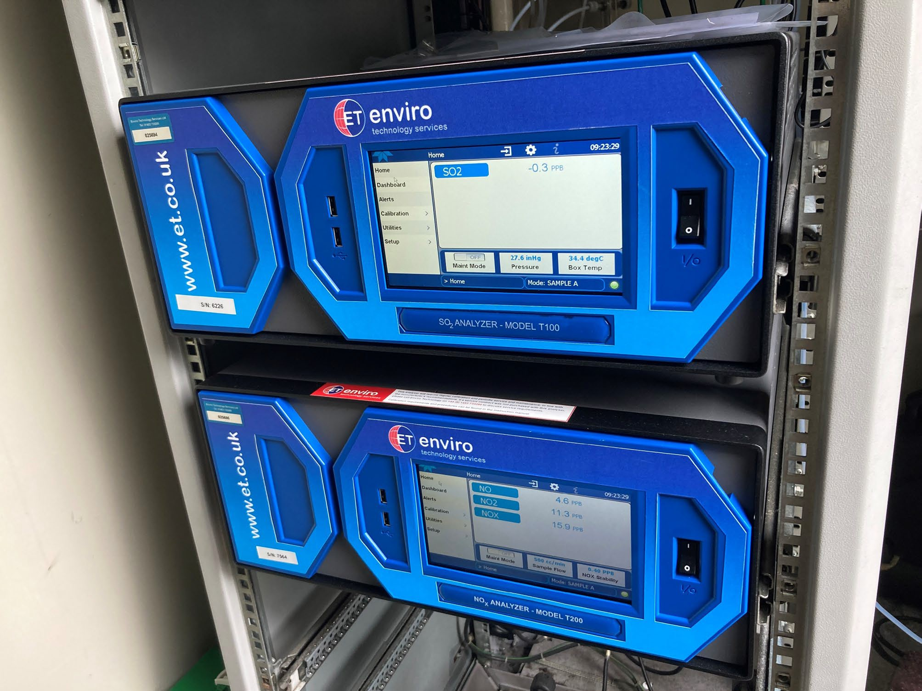
Improved Site AQ Communications and Data Storage
Eight of Falkirk Council’s air quality monitoring sites had their communication and data logging equipment upgraded in 2021. This upgrade included installing 4G-enabled routers

and standalone, high capacity dataloggers in each monitoring station. This upgrade will enable consistent air quality data polling (for Falkirk Council and other users such as external contractors and the ‘Air Quality in Scotland’ website consultant) with secure and flexible data storage into the future.
Photo 2: New 4G Router at Grangemouth Zetland Park Air Quality Station
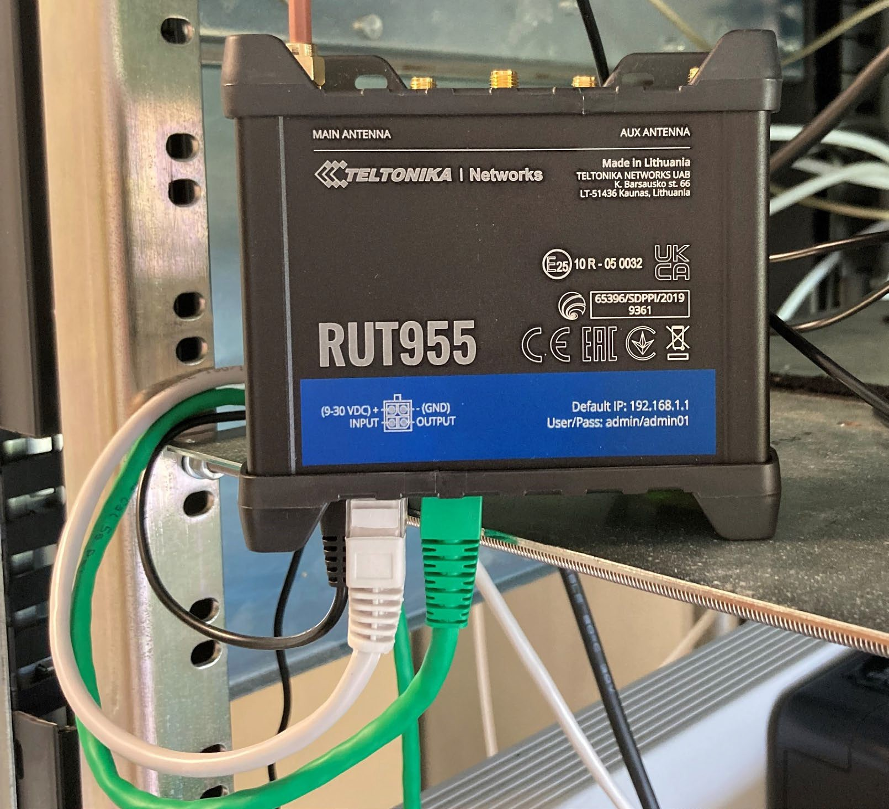

LAQM Annual Progress Report 2022 v

Photo 3: Rack Mounted High-Capacity Datalogger at Grangemouth Municipal Chambers Air Quality Station
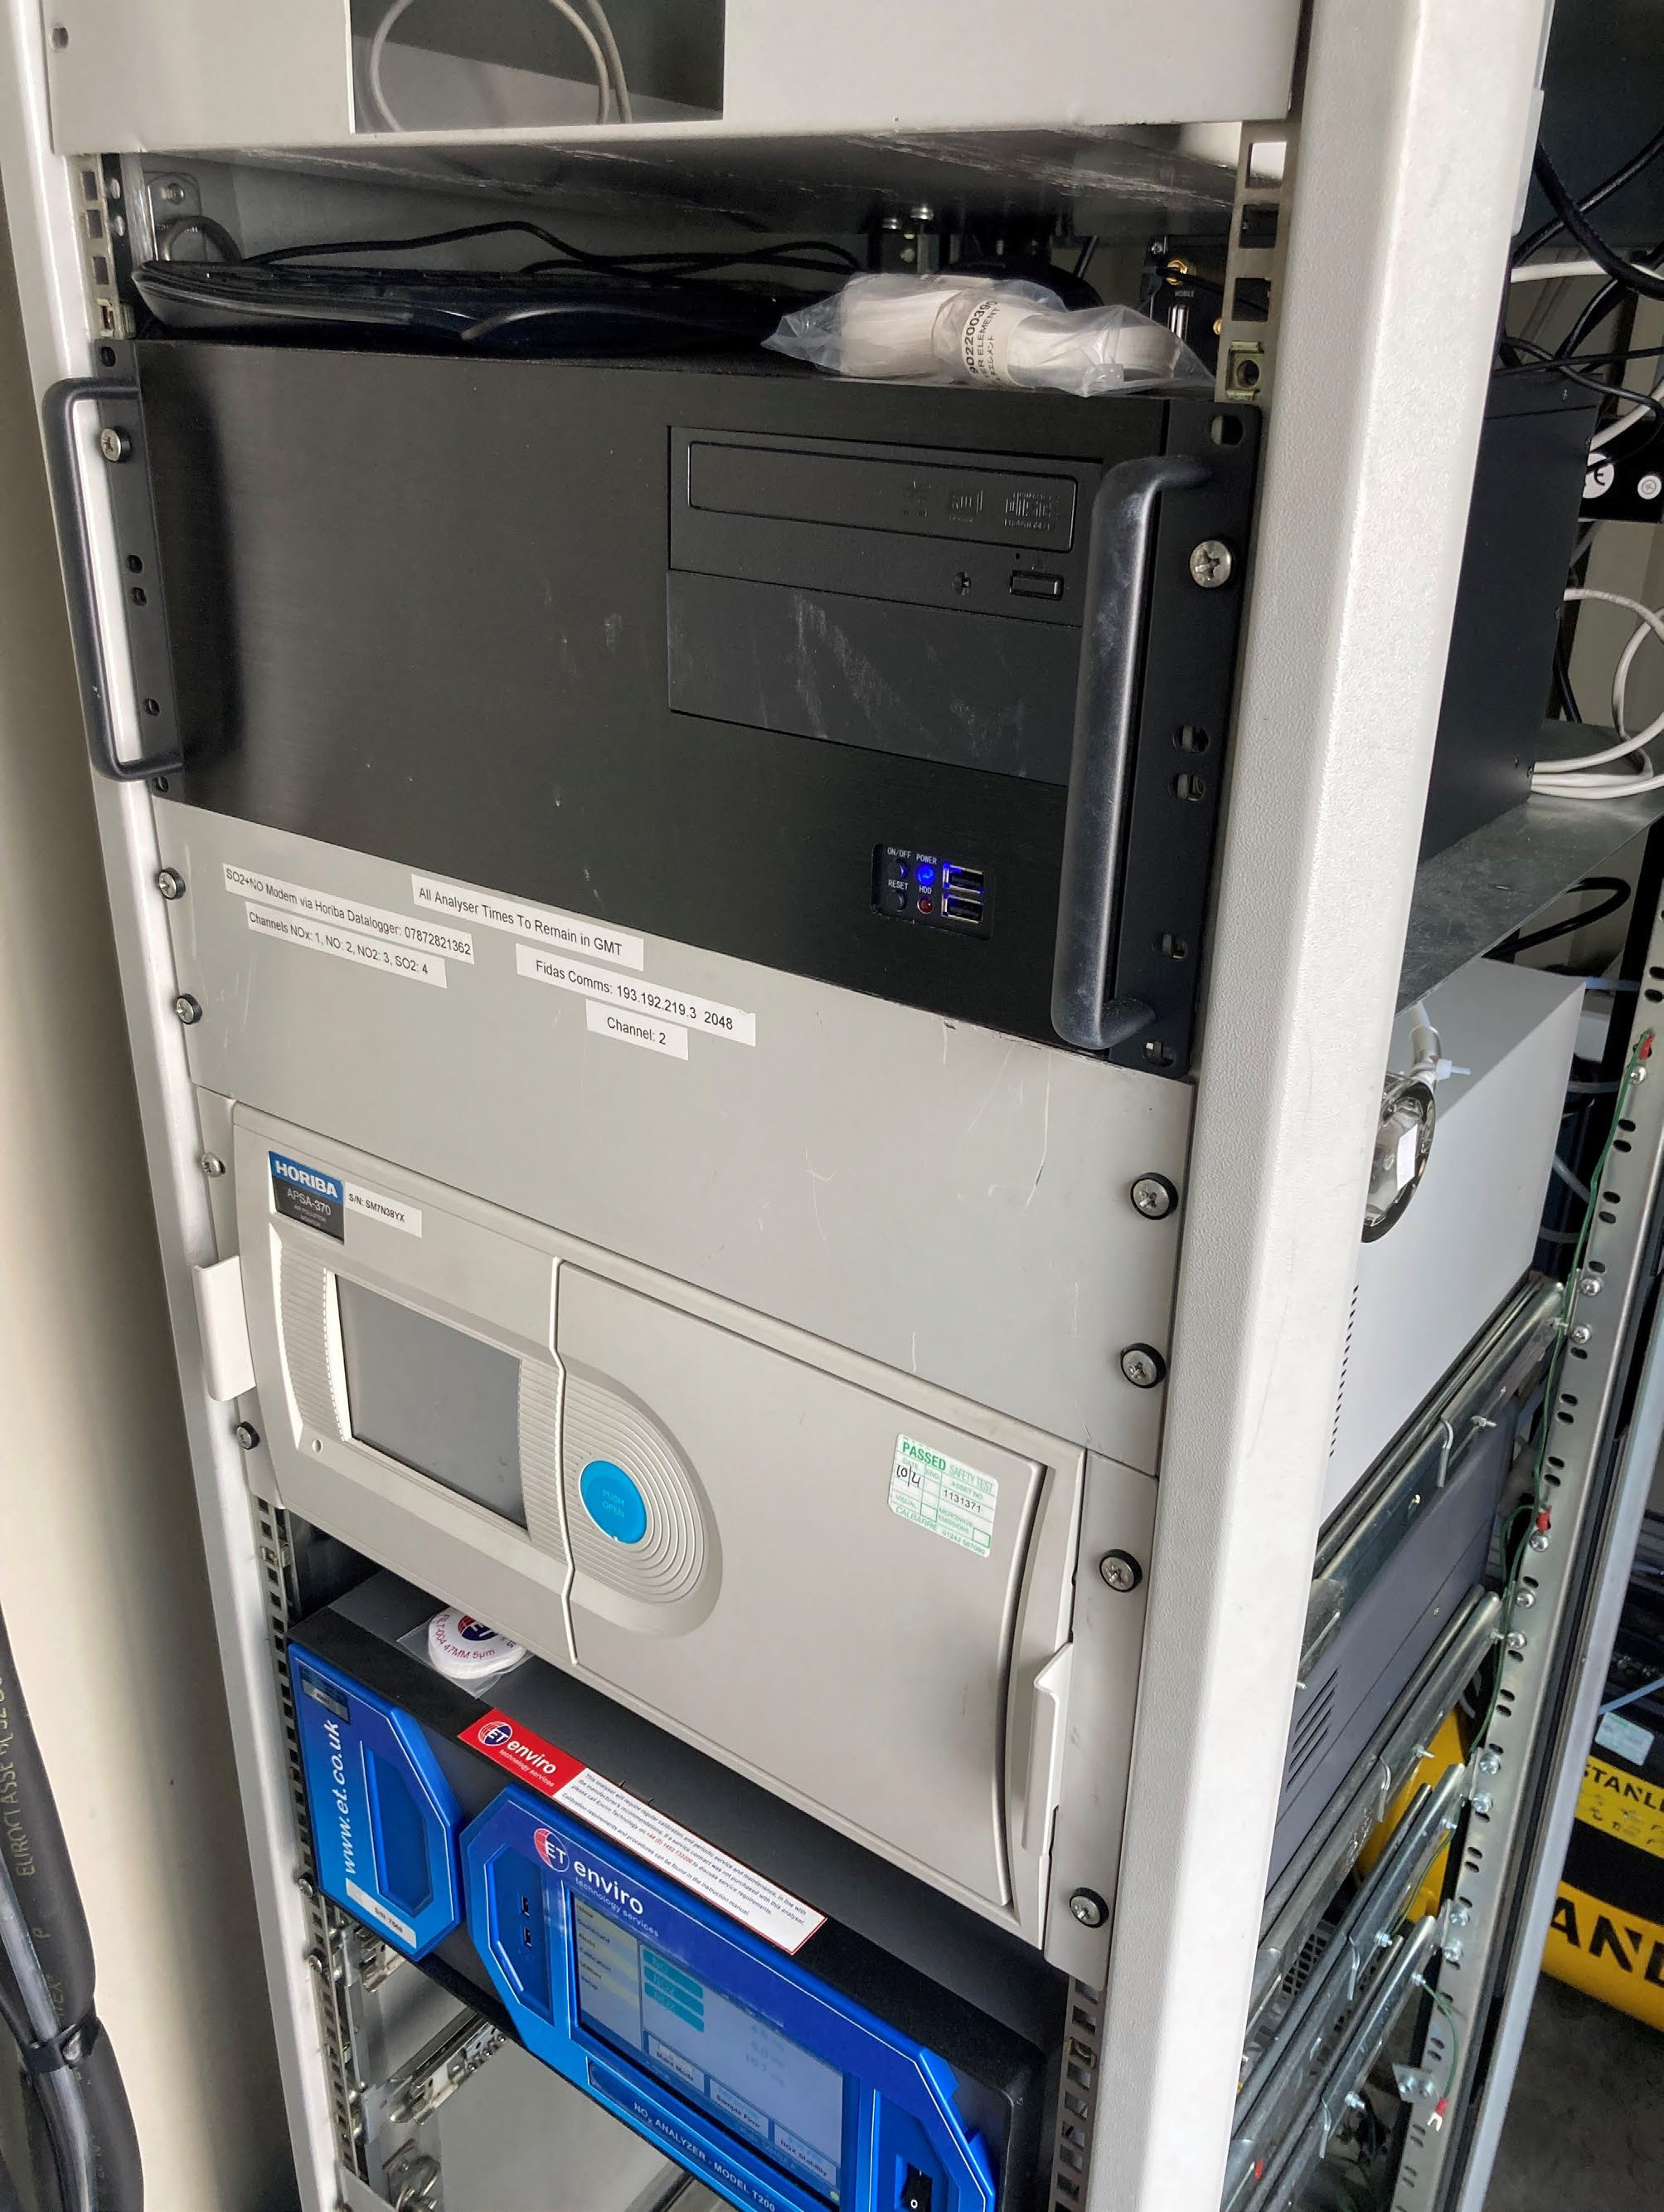

Improved Data Collection / Management Service
Falkirk Council now employs a specialist contractor to poll, present (via a secure webpage), securely store and regularly back-up (via multiple dedicated servers) all the live air quality data from its network of nine fixed, automatic stations. This ensures high quality data access, reporting and secure back-up into the future.
New Air Conditioning Unit – Grangemouth Municipal Chambers
A new air conditioning system was installed in the Grangemouth Municipal Chambers air quality station to replace the older, smaller capacity unit that was unsuitable for providing heating / cooling within the site throughout the year.
Photo 4: New A/C at Grangemouth Municipal Chambers Air Quality Station
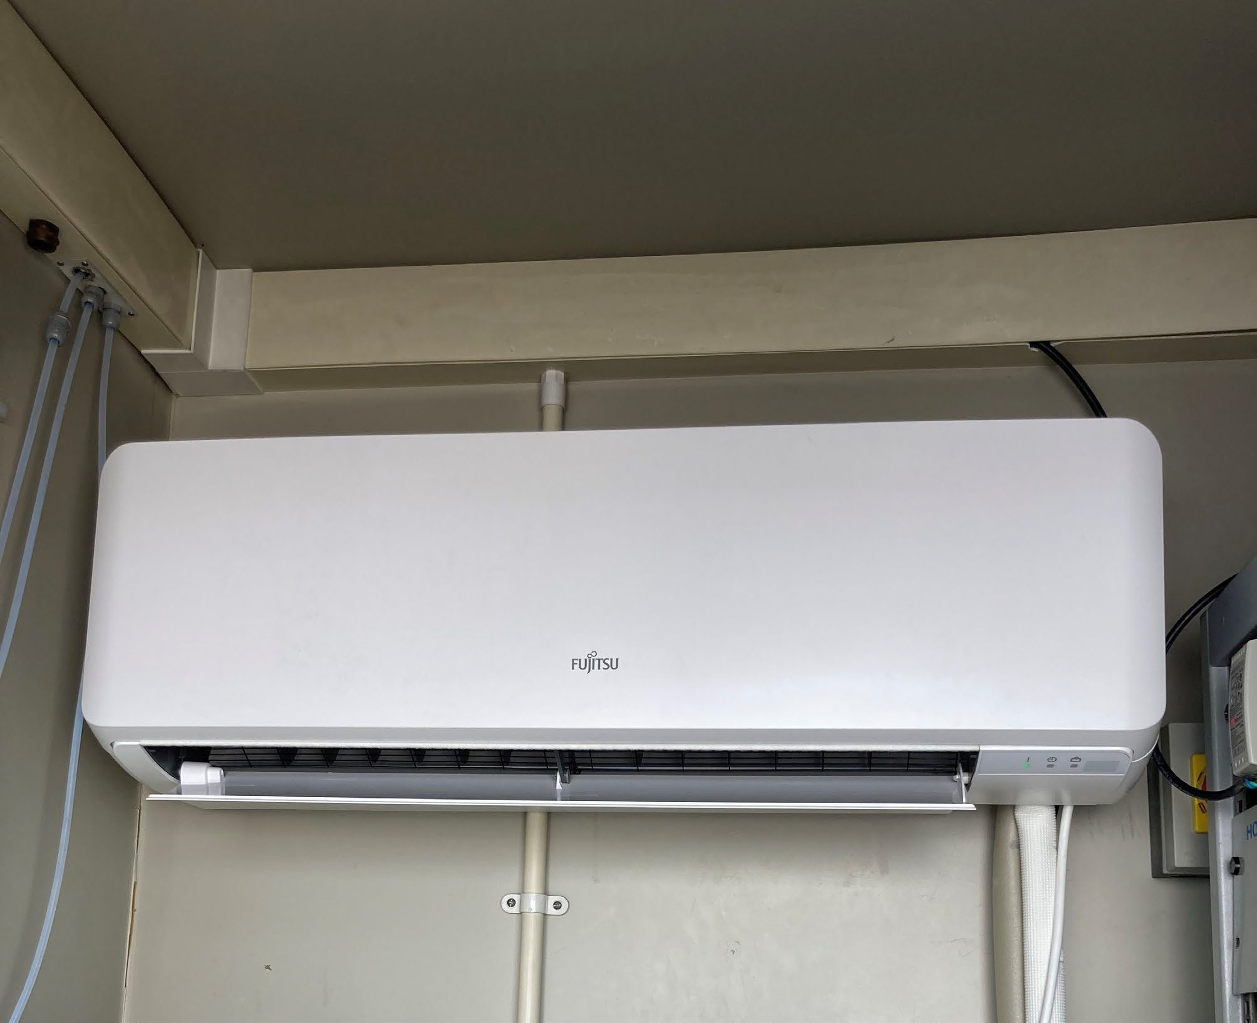

Grangemouth Emissions Study Phase 2
Scottish Government LAQM funding was provided to undertake Grangemouth Emissions Study Phase 2. This follows on from the initial Falkirk Council Grangemouth Emissions Study completed by consultants Sweco in 2020. Phase 2 of the study aims to build on the findings of the initial study and complete the following:
- Produce a comprehensive and expanded Grangemouth industrial source air emissions modelling assessment
- Complete an associated emissions inventory for the Grangemouth industrial area including pollution source apportionment
- Complete an expanded Grangemouth-wide road-traffic emissions modelling assessment
- Outline of any significant changes in road and industrial air emissions from COVID-19 to be considered
- Produce a technical report presenting all findings in points 1 to 4 including a Local Air Quality Management (LAQM) approvable ‘Review and Assessment’ report of the Grangemouth Air Quality Management Area (AQMA) for 2021.
The Grangemouth Emissions Study Phase 2 report is anticipated to be published in late 2022 which will help inform the Grangemouth AQMA revocation eligibility.
Environmental Health Electric Van
The Falkirk Council Environmental Health department own a fully electric van (Renault Kangoo ZE33), this van is used for all routine air quality site work.

ECOStars Fleet Recognition Scheme
Throughout 2021 / 22 Falkirk Council’s ECOStars fleet recognition scheme has grown from two-hundred and fifty-two to two-hundred and sixty-three members. Falkirk Council’s ECOStars taxi scheme has a small but engaged membership of seven members.
ECOStars membership consists of vehicle fleet operators located within the Falkirk Council local authority area as well as those whose depots are located out with the Council boundary but operate vehicles within that area; all of these operators have an impact on local air quality. In addition, Falkirk Council has been working closely with fellow members of the East Central Scotland Vehicle Emissions Partnership (ECSVE, Switch Off and Breathe) to work to the objectives set out in the Scottish Government’s Cleaner Air for Scotland (CAFS, 2015 and CAFS2, 2021) strategies. Air Quality Action Plan (AQAP) funding has been provided to continue the operation of the Falkirk ECOStars scheme (for fleet operators and taxis) during 2021 / 22.

Falkirk Council also continues to work closely with its partner organisations to manage local air quality issues. The Council works regularly with organisations such as SEPA, INEOS and Petroineos to help reduce exceedances of the SO2 NAQS objectives within the Grangemouth AQMA.

Local Priorities and Challenges
In 2022, Falkirk Council will be developing our engagement with local schools through promotion of air quality education resources such as the ‘Learn About Air’ teaching package, promoting the Clean Air Day in Scotland and working closer with the Falkirk Council Transport Planning department on promoting alternative and sustainable local transport solutions.

Low Emission Zones

Low Emission Zones (LEZ) are currently being planned and operated in the four major Scottish cities: Glasgow, Edinburgh, Aberdeen and Dundee over the next few years. There are no current plans for any form of LEZ in the Falkirk Council area. Falkirk Council has undertaken the ‘Stage 1 Screening Exercise (clause 2.2.25)’ assessment in the 2020 APR in accordance with the Scottish Government’s National Low Emissions Framework to inform this process.

How to Get Involved
To obtain further information on air quality within the Falkirk Council area, please visit our air quality policy webpage:
http://www.falkirk.gov.uk/services/environment/environmental-policy/air-quality/

There are nine automatic air quality monitoring sites across the Falkirk Council area. The air quality data from all the monitoring sites (excluding Banknock 3) can be viewed on the Scottish Air Quality website at:
http://www.scottishairquality.co.uk/latest/summary?view=la

To learn more about the ECOStars Fleet Recognition Scheme and for details of how to join if you are a commercial fleet operator please visit:
https://www.ecostars-uk.com/eco-stars-schemes/

Table of Contents

Executive Summary: Air Quality in Our Area i
Air Quality in Falkirk Council i
Actions to Improve Air Quality iv
Local Priorities and Challenges ix
How to Get Involved ix
- Local Air Quality Management 1
- Actions to Improve Air Quality 2
  - Air Quality Management Areas 2
  - Cleaner Air for Scotland 2 4

Placemaking – Plans and Policies 5

Transport – Low Emission Zones 8
  - Progress and Impacts of Measures to address Air Quality in Falkirk Council 9
- Air Quality Monitoring Data and Comparison with Air Quality Objectives 23
  - Summary of Monitoring Undertaken 23

Automatic Monitoring Sites 23

Non-Automatic Monitoring Sites 23
  - Individual Pollutants 24

Nitrogen Dioxide (NO2) 24

Particulate Matter (PM10) 25

Particulate Matter (PM2.5) 26

Sulphur Dioxide (SO2) 28

Carbon Monoxide, Lead and 1,3-Butadiene 28
- New Local Developments 30
  - Road Traffic Sources 30
  - Other Transport Sources 31
  - Industrial Sources 32
  - Commercial and Domestic Sources 35
  - New Developments with Fugitive or Uncontrolled Sources 36
LAQM Annual Progress Report 2022 x
- Planning Applications 38
- Conclusions and Proposed Actions 41
  - Conclusions from New Monitoring Data 41
  - Conclusions relating to New Local Developments 42
  - Proposed Actions 42
Appendix A: Monitoring Results 44
Appendix B: Full Monthly Diffusion Tube Results for 2021 96
Appendix C: Supporting Technical Information / Air Quality Monitoring Data QA/QC
. 101
New or Changed Sources Identified Within Falkirk Council During 2021 101
Additional Air Quality Works Undertaken by Falkirk Council During 2021 101
QA/QC of Diffusion Tube Monitoring 101
Diffusion Tube Annualisation 102
Diffusion Tube Bias Adjustment Factors 103
NO2 Fall-off with Distance from the Road 104
QA/QC of Automatic Monitoring 108
PM10 and PM2.5 Monitoring Adjustment 110
Automatic Monitoring Annualisation 111
NO2 Fall-off with Distance from the Road 111
Glossary of Terms 113
References 115

List of Tables
Table 1.1 – Summary of Air Quality Objectives in Scotland 1
Table 2.1 – Declared Air Quality Management Areas 3
Table 2.2 – Progress on Measures to Improve Air Quality 10
Table A.1 – Details of Automatic Monitoring Sites 44
Table A.2 – Details of Non-Automatic Monitoring Sites 47
Table A.3 – Annual Mean NO2 Monitoring Results (µg/m³) 52
Table A.4 – 1-Hour Mean NO2 Monitoring Results, Number of 1-Hour Means > 200µg/m³
. 56
Table A.5 – Annual Mean PM10 Monitoring Results (µg/m³) 64
Table A.6 – 24-Hour Mean PM10 Monitoring Results, Number of PM10 24-Hour Means > 50µg/m3 65
Table A.7 – Annual Mean PM2.5 Monitoring Results (µg/m³) 73
Table A.8 – SO2 2021 Monitoring Results, Number of Relevant Instances 76
Table A.9 – 1,3 Butadiene Annual Mean Diffusion Tube Results for 2021… 88
Table A.10 – Benzene Annual Mean Diffusion Tube Results for 2021 89
Table A.11 – Pumped Benzene Annual Mean Results for 2021… 90
Table B.1 – NO2 2021 Monthly Diffusion Tube Results (µg/m³) 96
Table B.2 - 1,3 Butadiene Monthly Diffusion Tube Results for 2021… 99
Table B.3 – Benzene Monthly Diffusion Tube Results for 2021 100
Table C.1 – Bias Adjustment Factor 103
Table C.2 - Comparison of Local vs National Bias Factor Summary 103

Table C.3 - Details of the QA / QC at the Automatic Monitoring Stations in 2021 108

Table C.4 - Automatic Monitoring Annualisation Required… 111

Table C.5 - Annualisation Summary… 112

List of Figures
Figure 1 – A4 Falkirk Haggs Long Term NO2 Concentrations 57
Figure 2 – A5 Falkirk Hope St Long Term NO2 Concentrations 58
Figure 3 – A7 Falkirk West Bridge St Long Term NO2 Concentrations 59
Figure 4 – A8 Grangemouth AURN Long Term NO2 Concentrations 60
Figure 5 – A9 Grangemouth Moray Long Term NO2 Concentrations 61
Figure 6 – A10 Grangemouth Municipal Chambers Long Term NO2 Concentrations 62
Figure 7 – A15 Main St, Bainsford Long Term NO2 Concentrations 63
Figure 8 – A4 Haggs Long Term PM10 (Hourly Measured) Concentrations 66
Figure 9 – A5 Falkirk Hope St Long Term PM10 (Hourly Measured) Concentrations 67
Figure 10 – A7 Falkirk West Bridge St Long Term PM10 (Hourly Measured) Concentrations 68
Figure 11 – A8 Grangemouth AURN Long Term PM10 (Hourly Measured) Concentrations 69
Figure 12 – A10 Grangemouth Municipal Chambers Long Term PM10 (Hourly Measured) Concentrations 70
Figure 13 – A11 Grangemouth Zetland Park Long Term PM10 (Hourly Measured) Concentrations 71
Figure 14 – A15 Main St, Bainsford Long Term PM10 (Hourly Measured) Concentrations 72
Figure 15 – A7 Falkirk West Bridge St Long Term PM2.5 Concentrations 74
Figure 16 – A8 Grangemouth AURN Long Term PM2.5 Concentrations 75
Figure 17 – A3 Bo’ness Long Term SO2 Concentrations 77

Figure 18 – A5 Falkirk Hope St Long Term SO2 Concentrations 78
Figure 19 – A8 Grangemouth AURN Long Term SO2 Concentrations 79
Figure 20 – A9 Grangemouth Moray Long Term SO2 Concentrations 80
Figure 21 – A10 Grangemouth Municipal Chambers Long Term SO2 Concentrations 81
Figure 22 – A11 Grangemouth Zetland Park Long Term SO2 Concentrations 82
Figure 23 – Polar Plots of Average SO2 Concentrations Recorded at the Grangemouth Sites A)–H)… 83-86
Figure 24 – Exceedances of the 15 Minute SO2 NAQS Objective Concentration at the Grangemouth Sites 2011 – 2021 87
Figure 25 – Maps of the AQMA Boundaries in the Falkirk Council Area A)-B) 91-92
Figure 26 – Maps Showing Automatic Monitoring Locations A)-F) 93-95

List of Photos
Photo 1: New API Analysers (T100 + T200) at Falkirk Hope Street Air Quality Station iv
Photo 2: New 4G Router at Grangemouth Zetland Park Air Quality Station v
Photo 3: Rack Mounted High-Capacity Datalogger at Grangemouth Municipal Chambers Air Quality Station vi
Photo 4: New A/C at Grangemouth Municipal Chambers Air Quality Station vii

Local Air Quality Management

This report provides an overview of air quality in Falkirk Council during 2021. It fulfils the requirements of LAQM as set out in Part IV of the Environment Act (1995) and the relevant Policy and Technical Guidance documents.
The LAQM process places an obligation on all local authorities to regularly review and assess air quality in their areas, and to determine whether or not the air quality objectives are likely to be achieved. Where an exceedance is considered likely the local authority must declare an Air Quality Management Area (AQMA) and prepare an Air Quality Action Plan (AQAP) setting out the measures it intends to put in place in pursuit of the objectives. This Annual Progress Report (APR) summarises the work being undertaken by Falkirk Council to improve air quality and any progress that has been made.

Table 1.1 – Summary of Air Quality Objectives in Scotland

Pollutant | Air Quality Objective Concentration | Air Quality Objective Measured as | Date to be Achieved by
Nitrogen  dioxide (NO2) | 200 µg/m3 not to be exceeded more than 18 times a year | 1-hour mean | 31.12.2005
Nitrogen  dioxide (NO2) | 40 µg/m3 | Annual mean | 31.12.2005
Particulate  Matter (PM10) | 50 µg/m3, not to be exceeded more than 7 times a year | 24-hour mean | 31.12.2010
Particulate  Matter (PM10) | 18 µg/m3 | Annual mean | 31.12.2010
Particulate  Matter (PM2.5) | 10 µg/m3 | Annual mean | 31.12.2021
Sulphur  dioxide (SO2) | 350 µg/m3, not to be exceeded more than 24 times a year | 1-hour mean | 31.12.2004
Sulphur  dioxide (SO2) | 125 µg/m3, not to be exceeded more than 3 times a year | 24-hour mean | 31.12.2004
Sulphur  dioxide (SO2) | 266 µg/m3, not to be exceeded more than 35 times a year | 15-minute mean | 31.12.2005
Benzene | 3.25 µg/m3 | Running annual mean | 31.12.2010
1,3 Butadiene | 2.25 µg/m3 | Running annual mean | 31.12.2003
Carbon Monoxide | 10.0 mg/m3 | Running 8-Hour mean | 31.12.2003

Actions to Improve Air Quality

Air Quality Management Areas
Air Quality Management Areas (AQMAs) are declared when there is an exceedance or likely exceedance of an air quality objective. After declaration, the authority must prepare an Air Quality Action Plan (AQAP) within twelve months, setting out measures it intends to put in place in pursuit of the objectives.
A summary of AQMAs declared by Falkirk Council can be found in Falkirk Town Centre AQMA
The Falkirk town centre AQMA (NO2 annual mean) remains justified as although there were no exceedances of the NAQS objective recorded in 2021 there have been consecutive diffusion tube exceedances (such as the NA27 Falkirk West Bridge Street location) in previous years which haven’t been affected by Coronavirus (COVID-19) Scottish Government travel restrictionsRef1. One diffusion tube (NA27 Falkirk West Bridge Street) was relatively close to the NAQS annual limit (40µg/m3) with the highest concentration of 34µg/m3 being recorded in 2021.
There have been over five-years where PM10 (24-hr and annual mean) results at both Falkirk Town Centre AQMA automatic monitoring locations (Falkirk Hope Street and Falkirk West Bridge Street) have complied with the PM10 NAQS (Scottish annual mean) objective of 18µg/m³. It is anticipated that the PM10 element (24-hr and annual mean) of the Falkirk Town Centre AQMA will be assessed by Falkirk Council Environmental Health for revocation eligibility during 2022.
Grangemouth AQMA

There have been over seven years where SO2 (annual mean) results at all Grangemouth AQMA automatic monitoring locations (Grangemouth AURN, Moray, Municipal Chambers and Zetland Park) have complied with the SO2 NAQS (15-min mean) objective of 266µg/m3, not to be exceeded more than thirty-five times a year. It is anticipated that the Grangemouth AQMA will be assessed for revocation eligibility during 2022 after the publication of the Grangemouth Emission Study Phase 2.

Table 2.1. Further information related to declared or revoked AQMAs, including maps of AQMA boundaries are available online at https://uk-air.defra.gov.uk/aqma/local- authorities?la_id=371 – see full list at https://uk-air.defra.gov.uk/aqma/list.
Falkirk Town Centre AQMA

The Falkirk town centre AQMA (NO2 annual mean) remains justified as although there were no exceedances of the NAQS objective recorded in 2021 there have been consecutive diffusion tube exceedances (such as the NA27 Falkirk West Bridge Street location) in previous years which haven’t been affected by Coronavirus (COVID-19) Scottish Government travel restrictionsRef1. One diffusion tube (NA27 Falkirk West Bridge Street) was relatively close to the NAQS annual limit (40µg/m3) with the highest concentration of 34µg/m3 being recorded in 2021.
There have been over five-years where PM10 (24-hr and annual mean) results at both Falkirk Town Centre AQMA automatic monitoring locations (Falkirk Hope Street and Falkirk West Bridge Street) have complied with the PM10 NAQS (Scottish annual mean) objective of 18µg/m³. It is anticipated that the PM10 element (24-hr and annual mean) of the Falkirk Town Centre AQMA will be assessed by Falkirk Council Environmental Health for revocation eligibility during 2022.
Grangemouth AQMA

There have been over seven years where SO2 (annual mean) results at all Grangemouth AQMA automatic monitoring locations (Grangemouth AURN, Moray, Municipal Chambers and Zetland Park) have complied with the SO2 NAQS (15-min mean) objective of 266µg/m3, not to be exceeded more than thirty-five times a year. It is anticipated that the Grangemouth AQMA will be assessed for revocation eligibility during 2022 after the publication of the Grangemouth Emission Study Phase 2.

Table 2.1 – Declared Air Quality Management Areas

AQMA Name | Pollutants and Air Quality Objectives | City / Town | Description | Action Plan
Falkirk Town Centre | NO2 annual mean  PM10 24-hour mean and annual mean | Falkirk | An area encompassing an area of Falkirk Town Centre | Air Quality Action Management Plan (Falkirk Town Centre and Haggs) 2015  Air Quality Management Action Plan (Falkirk Town Centre and Haggs) June 2015
Grangemouth | SO2 15-min mean | Grangemouth | An area encompassing the Grangemouth industry areas, shipping port and adjacent residential areas | Air Quality Action Plan Update (Grangemouth) 2009  Available on request

Cleaner Air for Scotland 2
Cleaner Air for Scotland 2 – Towards a Better Place for Everyone (CAFS2) is Scotland’s second air quality strategy. CAFS2 sets out how the Scottish Government and its partner organisations propose to further reduce air pollution to protect human health and fulfil Scotland’s legal responsibilities over the period 2021 – 2026. CAFS2 was published in July 2021 and replaces Cleaner Air for Scotland – The Road to a Healthier Future (CAFS), which was published in 2015. CAFS2 aims to achieve the ambitious vision for Scotland "to have the best air quality in Europe". A series of actions across a range of policy areas are outlined, a summary of which is available on the Scottish Government’s website.
Progress by Falkirk Council against relevant actions for which local authorities are the lead delivery bodies within this strategy is demonstrated below.

Placemaking – Plans and Policies

Local authorities with support from the Scottish Government will assess how effectively air quality is embedded in plans, policies, City Deals and other initiatives, and more generally in cross-departmental working, identifying and addressing evidence, skills, awareness and operational gaps.
Falkirk Council has the following strategies, plans and policies currently in place which would help contribute to the principles of CAFS2:
Falkirk Local Development Plan 2 (LDP2)

The Falkirk Local Development Plan 2 (LDP2) is the statutory document which guides future development in the Council area for the period 2020-2040. It was adopted on the 7th of August 2020. LDP2 contains a vision for the area, an overall strategy, and detailed policies and proposals indicating where development should, or should not take place. It provides criteria which the Council uses in assessing planning applications. Air quality is considered throughout this plan and specifically within the following sections:
‘Place and Environment’ ‘PE01 Placemaking’ section 2 (p.30):

“Development should not exacerbate existing air quality issues or introduce new sources of pollution which impact on local air quality without appropriate mitigation”.
‘Place and Environment’ ‘PE20 Natural Environment’ section 4.21 (p.39):

“Trees and woodlands have many benefits, including timber production, placemaking, landscape enhancement, screening, shelter, biodiversity value, carbon fixing, air quality improvement, natural flood management, recreation, and opportunities to interact with nature. Hedgerows similarly have important benefits for landscape enhancement, screening, biodiversity, and air quality improvement. Protection of existing trees and woodland will be a priority, and the principles of the Scottish Governments Policy on ‘Control of Woodland Removal’ will be followed where woodland is affected. In addition, a number of Tree Preservation Orders (TPOs) are in force across the Council area, as shown on the Proposals Map. New development will be expected to contribute to woodland and green network objectives through management and new planting as appropriate.”

‘Place and Environment’ ‘PE26 Air Quality’ (p.42):

“Development should not exacerbate existing air quality issues or introduce new sources of pollution which impact on local air quality without appropriate mitigation. Impacts on air quality will be taken into account in assessing development proposals, particularly within Air Quality Management Areas (AQMA). An Air Quality Assessment may be required for developments that are within an AQMA or where the proposed development may cause or significantly contribute towards a breach of National Air Quality Standards. Development proposals that result in either a breach of National Air Quality Standards or a significant increase in concentrations within an existing AQMA will not be permitted unless there are overriding issues of national or local importance.”
‘Place and Environment’ ‘PE26 Air Quality’ Section 4.28 (p.42):

“Good air quality is an important element of sustainable place making which contributes towards health and well-being as set out in the Cleaner Air for Scotland Framework.
Planning has an important part to play in improving air quality, which can be affected by new development, and air quality can be a material consideration in determining planning applications. In areas with significant potential for further industrial development such as Grangemouth proposals may require an air quality assessment even where no breach of air quality standards is anticipated. The Council has put in place a network of monitoring equipment to measure whether it is meeting National Air Quality Standards, and Air Quality Management Areas have been established at Banknock, Grangemouth, Falkirk Town Centre and Haggs related to breaches in various air quality objectives. The Scottish Government has also committed to introducing Low Emission Zones (LEZ) to all AQMA areas by 2023.”
‘Infrastructures and Resources’ ‘IR05 Travel Hierarchy and Transport Assessment’ Section 2 (p.53):
“Transport assessments will be required for development proposals where the impact of the development on the transport network is likely to result in an increase in the number of trips, such that there will be significant impact on the operation of the transport network, requiring mitigation. Assessments will focus on the hierarchy of travel and should include, where appropriate:
- Travel plans

- Safety audits of proposed mitigation measures; and

- Air quality impact assessments.”

‘Infrastructures and Resources’ ‘IR12 Energy Generation Development’ Section 1 (p.55): Energy infrastructure developments will be assessed in relation to the following factors:
- Impacts on communities, whether settlements or individual residential properties, including issues of noise, shadow flicker and air quality

Falkirk Council Energy Management Policy

Falkirk Council's energy consumption represents a significant part of both its carbon footprint and budget. Effective management of energy is therefore essential to controlling these costs and protecting the environment.
Energy efficiency measures are implemented to reduce the Council's energy use and cover:
  - Street lighting
  - Vehicle fuel consumption
  - Electricity use in our buildings
  - Energy use to heat our buildings

To improve local air quality and increase our decarbonisation aims, a growing number of Electric Vehicle charging points will be installed throughout the Council area. We have expanded our District Heating System, providing an efficient and clean source of energy to more of the Callendar Park buildings.

Falkirk Council Greenspace Strategy
Through its delivery, the strategy will connect areas of natural, semi-natural and man- made open spaces within our towns and villages and create links into the wider countryside. The development of a high quality, multi-functional green network will provide a range of benefits for people, businesses and wildlife across our area. Air quality is considered throughout this strategy, specifically within Section 1.4 ‘Towards A New Greenspace Strategy’:
“In particular the green network will provide:
- A framework for landscape and regeneration place-making initiatives.

- Urban open spaces including parks, play spaces, sports areas, green corridors, and natural and semi-natural open spaces for community, educational and visitor use.
- An important opportunity for facilitating climate change adaptation through sustainable flood management and woodland planting, and by enabling species migration.
- Spaces for recreation and active travel through creating safer, more pleasant walking and cycling routes.
- Habitat and biodiversity value by providing and enhancing areas where flora and fauna can thrive.
- Sustainable water and soil management and help reduce air and water pollution.”

Falkirk Council also has published the following policies, strategies and initiatives which will aim to improve local air quality:
Sustainable Procurement Strategy 2020 to 2023 Sustainable Transport Policies, Strategies and Measures Sustainable Falkirk
Historic Environment Strategy Contaminated Land Inspection Strategy Open Space Strategy

Transport – Low Emission Zones

Local authorities working with Transport Scotland and SEPA will look at opportunities to promote zero-carbon city centres within the existing LEZs structure.
Falkirk Council has many sustainable transport options available which aims to improve local air quality in town centre locations throughout the Falkirk Council area including:
Local Transport Strategy

Take the Right Route

Green Travel Map

Low Emission Zones (LEZ) are currently being planned and operated in the four major Scottish cities: Glasgow, Edinburgh, Aberdeen and Dundee over the next few years. There

are no current plans for any form of LEZ in the Falkirk Council area. Falkirk Council has undertaken the ‘Stage 1 Screening Exercise (clause 2.2.25)’ assessment in the 2020 APR in accordance with the Scottish Government’s National Low Emissions Framework to inform this process. Although Falkirk Council have completed this assessment, we are always willing to explore initiatives with partner organisations to help reduce transport sourced emissions to help improve local air quality in town centres.

Progress and Impacts of Measures to address Air Quality in Falkirk Council
Falkirk Council has taken forward a number of measures during the current reporting year of 2021 in pursuit of improving local air quality. Details of all measures completed, in progress or planned are set out in Table 2.2. More detail on these measures can be found in the AQAP relating to each AQMA. Key completed measures in 2021 include:
- Measure 4: Replacement of older (NOX and SO2) analysers with new models (providing increased accuracy, availability of spares, less breakdowns and expensive maintenance visits etc.)
- Measure 15: Dedicated and tailored air quality data collection system with secure webpage log-in for data security and back-up which can be used on multiple devices.
- Measure 16: Continuation of ECOStars Fleet Recognition Scheme with new members added (Increased fleet efficiency measures / knowledge) – Scottish Government AQAP funding dependant.
Progress on the following measures has been slower than expected due to:
- Review of Falkirk Town Centre (PM10) AQMA with potential revocation (reduction of Falkirk Council AQMAs from three to two). This has been slower due to time taken for sufficient AQ data to be come available from the return of post COVID-19 normal traffic levels and particulate multi-analyser comparison studies to be completed / published.
Falkirk Council expects the following measures to be completed over the course of the next reporting year:
- Review and Update of ‘Measures to Improve Air Quality’ / AQAP Outcomes.
- Falkirk Town Centre (PM10) and Grangemouth AQMA (SO2) Revocations.

- Publication of the Grangemouth Emissions Study Phase 2.

Table 2.2 – Progress on Measures to Improve Air Quality

Meas. No. | Measure | Category | Focus | Lead Authority | Planning Phase | Impleme- ntation Phase | Key Performance Indicator | Target Pollution Reduction in the AQMA | Progress to Date | Estimated Completion Date | Comments
1 | Improving SO2 data access | Public Information | Supplying SO2 monitoring data to SEPA, Petroineos, INEOS and other interested organisations. | Falkirk Council | 2013 | 2013 | AQ Objectives achieved during 2016-2021. | Anticipated reduction in SO2 concentration/ breaches of NAQS  objectives. | Data sent after Grangemouth SO2  exceedances- monthly summary reports sent with ongoing totals. | Completed, and monthly reports to relevant organisation s ongoing.
2 | Grangemouth Working Group | Policy Guidance and Developmen t Control | Bringing together: Petroineos, INEOS, Scot Gov, SEPA  and Falkirk Council. | Falkirk Council | 2013 | 2013 | AQ Objectives met in during 2016-2021. | Reduction in SO2 due to cooperative working and agreement of priorities. | Completed.  TGU fully commissioned in August 2013, meeting held in November 2013. Further meeting only if breach of objective occurs. | Completed.

Meas. No. | Measure | Category | Focus | Lead Authority | Planning Phase | Impleme- ntation Phase | Key Performance Indicator | Target Pollution Reduction in the AQMA | Progress to Date | Estimated Completion Date | Comments
3 | Text Alert System | Public Information | Real-time notification of exceedances by SMS and Email. | Falkirk Council | 2013 | 2013 | Text alerts received by Falkirk Council, SEPA,  Petroineos and INEOS when an NAQS objective exceedance occurs within the Grangemouth AQMA. | Anticipated reduction in SO2 NAQS objective exceedances due to real time alerts of exceedances supplied to SEPA,  Petroineos and INEOS so action to rectify any plant emission / process issues can be addressed. | Completed and on-going. | Completed in 2013 / System upgraded in 2018 | Rather than a text alert system linked to individual analysers this system has been upgraded in 2018 to incorporate the Council’s data collection system and can be used for any measured pollutant.
4 | Review Monitoring Network | Public Information | Grangemouth Moray SO2 in Scottish Air Quality | Falkirk Council | Falkirk Park St ceased operation | 2014 and  2015 | All Grangemouth automatic monitoring sites | Affiliation with the SAQN increases data capture allowing | Completed.  In addition, the Bo’ness, Falkirk Graham’s Rd, | Completed.

Meas. No. | Measure | Category | Focus | Lead Authority | Planning Phase | Impleme- ntation Phase | Key Performance Indicator | Target Pollution Reduction in the AQMA | Progress to Date | Estimated Completion Date | Comments
 |  |  | Network (SAQN).  Monitoring conducted in Grangemouth Zetland Park. |  | in April 2014.  Zetland Park commen ced operation April 2015. |  | are affiliated with the SAQN. | better comparison to the NAQS objectives. | and Main St, Bainsford stations were affiliated to the SAQN in 2016.
5 | Electric Vehicles and Plug-ins | Promoting Low Emission Transport | Cars / Fleet | Falkirk Council | 2012 | 2012 and on-going | Charging points at Falkirk Council depots | Anticipated reduction in NOX and PM emissions due to increased use of electric vehicles. | In 2021, the EV charging point bays increased to 96. These are located at depots and public places across the Falkirk Council area.. Falkirk Council increased its  electric vehicle | Completed and on-going | The air quality team within the Env. Health Department at Falkirk Council have received a new fully electric (Renault Kangoo  ZE33) van in

Meas. No. | Measure | Category | Focus | Lead Authority | Planning Phase | Impleme- ntation Phase | Key Performance Indicator | Target Pollution Reduction in the AQMA | Progress to Date | Estimated Completion Date | Comments
 |  |  |  |  |  |  |  |  | fleet to 77 available for use by Council staff. |  | June 2019 – further details provided in Section ‘Actions to Improve Air Quality’, page v
6 | Eco-advanced Driver Training | Promoting Low Emission Transport | All types of vehicles, fuel use and emissions | Falkirk Council | 2014 | 2015 | Offered to Council services by fleet | Anticipated reduction in NOX and PM emissions due to promotion of efficient driving practices. | Offered to Council services by fleet. | Completed and on-going training offered.
7 | Review of School Bus Contracts with View to Raising EURO Engine | Vehicle Fleet Efficiency | Buses | Falkirk Council | 2017 | 2022/23 | n/a | Anticipated reduction in NOX and PM emissions from buses operating | Services to discuss the feasibility of raising the EURO  standards for  local and school | 2022/23

Meas. No. | Measure | Category | Focus | Lead Authority | Planning Phase | Impleme- ntation Phase | Key Performance Indicator | Target Pollution Reduction in the AQMA | Progress to Date | Estimated Completion Date | Comments
 | Standards |  |  |  |  |  |  | within the Falkirk Council area. | bus contracts from 2022 onwards.
8 | Improvements of Traffic Lights at Bankside | Transport Planning and Infrastructur e | Congestion | Falkirk Council | 2013 | 2014 | n/a | Anticipated reduction in NOX and PM emissions due to traffic queue reduction at Bankside traffic lights. | Completed. | Completed.
9 | Feasibility Study of Haggs Infrastructure Changes | Transport Planning and Infrastructur e | Congestion | Falkirk Council | Depende nt on develope r contributi ons and planning applicatio ns. | Dependent on developer contributio ns and planning application s. | n/a. | Anticipated reduction in NOX and PM emissions. | Dependent on developer contributions and planning applications. | Dependent on developer contributions and planning applications. Future action.

Meas. No. | Measure | Category | Focus | Lead Authority | Planning Phase | Impleme- ntation Phase | Key Performance Indicator | Target Pollution Reduction in the AQMA | Progress to Date | Estimated Completion Date | Comments
10 | Feasibility study of West Bridge St and Town Centre Traffic Management Changes (speed limits, TROs etc.) | Transport Planning and Infrastructur e | Congestion | Falkirk Council | n/a | n/a | n/a | Anticipated reduction in NOX and PM emissions. | This measure was linked to a planning application to build new council offices at Falkirk Town Centre Municipal Buildings.  However, this project is still being decided upon. However, traffic signals along West Bridge St have been altered to improve traffic flows. | Completed
11 | Take the Right Route / Walk to School & | Promote Travel Alternatives | Car travel | Falkirk Council | 2009 | 2013 and ongoing | Scheme in place and publicly advertised on | Anticipated reduction in NOX and PM | In 2021 Take the Right Route continually | Completed and on- going.

Meas. No. | Measure | Category | Focus | Lead Authority | Planning Phase | Impleme- ntation Phase | Key Performance Indicator | Target Pollution Reduction in the AQMA | Progress to Date | Estimated Completion Date | Comments
 | School Travel Plan Pack |  |  |  |  |  | Falkirk Council website. | emissions due to an increase in green travel such as walking and cycling. | promoted across the Falkirk Council area with on street interviews, online campaigns, bus and newspaper advertising and leaflets distributed.
12 | Bike Hire Scheme | Promote Travel Alternatives | Mode transfer | Falkirk Council | 2016 | 2018 | Unknown | Anticipated reduction in NOX and PM emissions due to an increase in green travel alternatives. | Forth Bike (in conjunction with Forth Environment Link) operates an electric bike hire scheme within the Falkirk and Stirling area The Forth Bike system currently includes over  one hundred | Completed. Forth Bike scheme established and running in 2021.  Expansion of the scheme expected in future years.

Meas. No. | Measure | Category | Focus | Lead Authority | Planning Phase | Impleme- ntation Phase | Key Performance Indicator | Target Pollution Reduction in the AQMA | Progress to Date | Estimated Completion Date | Comments
 |  |  |  |  |  |  |  |  | electric pedal assist (Pedelec) bikes spread between their four local stations: the Falkirk Wheel, the Helix, Forth Valley Royal Hospital, and University of Stirling.
13 | Soft Measures  e.g. travel planning (larger employers, schools), journey sharing, changes to mileage, home and mobile working. | Promote Travel Alternatives | Variety | Falkirk Council | 2006 | 2014 | Development of Travel Plans | Anticipated reduction in NOX and PM emissions due to promotion of travel alternatives. | Increased fuel efficient and electric pool car vehicles for staff use as part of Council’s travel plan.  Operational car sharing database for Falkirk Council area. | On-going

Meas. No. | Measure | Category | Focus | Lead Authority | Planning Phase | Impleme- ntation Phase | Key Performance Indicator | Target Pollution Reduction in the AQMA | Progress to Date | Estimated Completion Date | Comments
14 | Consideration of Air Quality in Local Development Plan | Policy Guidance and Developmen t Control | Development | Falkirk Council | 2015 | 2015 | Air quality policy statement in local development plan | Air Quality Assessment required for developments within AQMAs. | Air quality policy statement in plan. | Completed
15 | Appropriate Air Quality Monitoring in AQMAs. | Public Information | Improving data capture. | Falkirk Council | 2005 | 2005 | Good data capture (90%) in AQMAs | Good data capture will allow strict comparison of PM10, PM2.5, SO2, NOX  concentrations against the NAQS  objectives. | Monitoring maintained in AQMAs.  Equipment upgrades completed during 2020. | Completed and on-going
16 | Promotion of ECO Stars | Vehicle Fleet Efficiency | Commercial vehicles, taxis and private hire cars. | Falkirk Council | 2013 | 2013 and on-going | The latest Falkirk Eco Stars report shows that recruitment in Falkirk has 227 members. | Anticipated reduction in NOX and PM emissions due to promotion of efficient driving practices. | During 2021, reference to EcoStars is now included in the tender specification for Falkirk Council | On-going

Meas. No. | Measure | Category | Focus | Lead Authority | Planning Phase | Impleme- ntation Phase | Key Performance Indicator | Target Pollution Reduction in the AQMA | Progress to Date | Estimated Completion Date | Comments
 |  |  |  |  |  |  |  |  | Adult and Children’s Service passenger transport.
17 | Review of Park and Ride Facilities | Transport Planning and Infrastructur e | Cars | Falkirk Council | 2017 | 2018 | Ongoing. | Anticipated reduction in NOX and PM emissions. | There is currently no progress in taking forward any new bus park and ride facilities.  However, additional parking has been created at Falkirk High and Larbert train stations to help improve park and ride facilities. | Completed and on-going

Meas. No. | Measure | Category | Focus | Lead Authority | Planning Phase | Impleme- ntation Phase | Key Performance Indicator | Target Pollution Reduction in the AQMA | Progress to Date | Estimated Completion Date | Comments
18 | Taxi Licensing | Vehicle Fleet Efficiency | Taxis | Falkirk Council | 2013 | 2015 | Increase in taxi services signed up to Eco Stars Scheme. | Anticipated reduction in NOX and PM emissions due to promotion of efficient driving and vehicles. | Changes to licensing in May 2013 and Eco Stars extended to taxis and private hire cars. | On-going
19 | Vehicle Emissions Partnership (testing and idling) - enforcement and fines rather than raising awareness. | Promoting Low Emission Transport | Cars | Falkirk and other neighbouri ng authorities. | 2012 | 2012 and on-going | Maintain membership of the partnership. | Anticipated reduction in NOX and PM emissions through anti- idling enforcement. | The ESVEP  continues to assist in promoting anti idling in the Falkirk Council area.  Improvements of the associated ‘Switch Off and Breathe’ website have taken place. | On-going subject to annual funding allocation.

Meas. No. | Measure | Category | Focus | Lead Authority | Planning Phase | Impleme- ntation Phase | Key Performance Indicator | Target Pollution Reduction in the AQMA | Progress to Date | Estimated Completion Date | Comments
20 | Introduce Quality Bus Corridors | Transport Planning and Infrastructur e | Buses | Falkirk Council | 2017 | On-going depending on funding to complete the scheme. | Unknown | Anticipated reduction in NOX and PM emissions through improved public transport. | The Council has secured areas of land along the A803 Glasgow Road corridor in Camelon. In addition to this the Council has updated the traffic signals on the B902 Grahams Road corridor  to “intelligent” traffic signals which better manage the flows of traffic increasing green time along the main corridor, the knock-on effect of this  improves bus | 2030

Meas. No. | Measure | Category | Focus | Lead Authority | Planning Phase | Impleme- ntation Phase | Key Performance Indicator | Target Pollution Reduction in the AQMA | Progress to Date | Estimated Completion Date | Comments
 |  |  |  |  |  |  |  |  | journey times into the town centre.

Air Quality Monitoring Data and Comparison with Air Quality Objectives

Summary of Monitoring Undertaken

Automatic Monitoring Sites

This section sets out what monitoring has taken place and how local concentrations of the main air pollutants compare with the NAQS objectives.
Falkirk Council undertook automatic (continuous) monitoring at nine sites during 2021. Table A.1 in Appendix A shows the details of these sites. National air quality monitoring results are available at the Air Quality in Scotland website.
Maps showing the location of the monitoring sites are provided in Appendix A, Figure 26
A) to F). Further details on how the monitors are calibrated and how the data has been adjusted for quality purposes (QA/QC) are included in Appendix C.

Non-Automatic Monitoring Sites

Falkirk Council undertook non-automatic (passive) monitoring of NO2 at sixty-one sites during 2021. Table A.2 in Appendix A shows the details of the sites.
Falkirk Council also undertook non-automatic (passive) monitoring of 1, 3 butadiene at three sites during 2021. Table A.9 in Appendix A shows the details of the 1, 3 butadiene sites.
In addition, Falkirk Council also undertook non-automatic (passive) monitoring of benzene at sixteen sites during 2021. Table A.10 in Appendix A shows the details of the benzene sites.
Maps showing the location of the monitoring sites are provided in Appendix A, Figure 25
A) and B). Further details on Quality Assurance/Quality Control (QA/QC) and bias adjustment for the diffusion tubes are included in Appendix C.

LAQM Annual Progress Report 2022

Individual Pollutants
The air quality monitoring results presented in this section are, where relevant, adjusted for annualisation and bias. Further details on adjustments are provided in Appendix C.

Nitrogen Dioxide (NO2)

Table A.3 in Appendix A compares the (ratified and adjusted) NO2 annual mean concentrations for the past five years with the air quality objective of 40µg/m3.
For diffusion tubes, the full 2021 dataset of monthly mean values is provided in Appendix B.
Table A.4 in Appendix A compares the (ratified) continuously monitored NO2 hourly mean concentrations for the past five years with the NAQS objective of 200µg/m3, not to be exceeded more than 18 times per year.
NO2 Automatic Analyser Results
The 2021 monitoring results (as displayed in Appendix A, Tables A.3 and A.4) show that all seven automatic NO2 analysers in the Falkirk Council’s air monitoring network met both NO2 NAQS objectives (1hr and annual mean). The highest NO2 annual mean result in 2021 was recorded at the Falkirk West Bridge Street site (31µg/m3) - this result has increased (by 4µg/m3) from 2020’s result (27µg/m3). The lowest result was recorded at the Grangemouth AURN (13µg/m³) site. The Grangemouth AURN NO2 annual mean result has increased from 11µg/m³ in 2020. Overall, most fixed automatic site’s NO2 concentrations have increased from 2020’s results however, this is most likley to be attributed to the Coronavirus (COVID-19) travel restrictionsRef1 which commenced in late March 2020 and continued throughout 2021. This resulted in less daily vehicle trips due to the ‘Stay at Home’ Scottish Government advice. The last exceedance of NO2 annual mean concentrations was recorded in 2014 at the Falkirk West Bridge Street site (41µg/m3).
Over a five year period (from 2017 to 2021), all seven monitoring sites have recorded annual mean NO2 concentration reductions. There have been minor fluctuations in results during this period but all remain within the NO2 NAQS (1hr and annual mean) objecvtives.
Long term NO2 trend graphs are shown in Appendix A, Figures 1 to 7. There is an overall downward trend in NO2 (annual mean) concentrations at the following monitoring sites: A5 Falkirk Hope Street (Figure 2), A7 Falkirk West Bridge Street (Figure 3), A10 Grangemouth Municipal Chambers (Figure 6) and A15 Main Street Bainsford (Figure 7).

The A4 Haggs (Figure 1) and A8 Grangemouth AURN (Figure 4) site’s trends have generally remained at the same concentration over this period.
Likely contributing factors to the reduction in NO2 concentrations at the above sites include the Coronavirus (COVID-19) pandemicRef 1 in March 2020 to 2021 (resulting in less road traffic), traffic-light timing amendments (on Falkirk West Bridge Street) to minimise congestion and prevent excessive idling (within the Falkirk town centre area), road upgrades (M80 at Haggs) and speed limit enforcement measures (30mph on the A803).
Increased ownership of hybrid and electric vehicles may also have contributed to the overall NO2 reduction.
Annual NO2 Diffusion Tube Results
The 2021 annual NO2 diffusion tube monitoring results (as displayed in Appendix A, Table A.3) shows that no (non-automatic) NO2 tubes exceeded the NAQS (annual mean) NAQS objective limit of 40µg/m³. All sixty-one tubes in Falkirk Council’s network met the NO2 NAQS (annual mean) objective.
The highest NO2 annual mean diffusion tube concentration in 2021 was recorded at the NA27 Falkirk West Bridge Street roadside location (35µg/m3).
The lowest NO2 annual mean diffusion tube concentrations in 2021 were recorded at the following locations: NA105 West of Shieldhill (Rural, 6µg/m3) NA86 Wolfe Road (Urban Background, 11µg/m3) and NA64 New Hallglen Road (Urban Background, 11µg/m3).
In addition, diffusion tubes are affected by several sources of interference which can cause substantial under or overestimation (often referred to as “bias”) compared to the automatic NO2 (chemiluminescence) reference analyser (as defined within the EU as the reference method)^{Ref} ². Due to this, NO2 concentrations recorded using diffusion tubes are typically of lower accuracy than that recorded by the reference method using automatic (chemiluminescence) NO2 analysers.

Particulate Matter (PM10)

Table A.5 in Appendix A compares the (ratified and adjusted) PM10 annual mean concentrations for the past five years with the NAQS objective of 18µg/m3.
Table A.6 in Appendix A compares the (ratified) continuously monitored PM10 daily mean concentrations for the past five years with the NAQS objective of 50µg/m3, not to be exceeded more than seven times per year.

Falkirk Council measured PM10 concentrations at eight locations during 2021. The relevant Scottish NAQS objectives for PM10 were met at all eight locations.
The site with the highest recorded annual mean PM10 concentrations in 2021 (but within the Scottish NAQS PM10 objective) was A15 Main Street, Bainsford (11µg/m³).
The site with the lowest PM10 (annual mean) concentration was A14 Banknock 3 (1µg/m³). Low annual data capture was also recorded at Banknock 3 (67%) - this was due to an overdue service issue with the Turnkey Osiris analyser.
It is noted that the PM10 (annual mean) concentration for site A14 Banknock 3 is significantly lower in 2021 than in previous years, a reasonable justification for this reduction would be that (in general) overall PM10 (and PM2.5) levels have been steadily decreasing in recent years due to the closure of the local quarry (main source of PM), with the monitoring site being located in a realtively rural location (within a garden area of a residence) which would not be expected to have elevated PM (annual mean) concentrations.
Over a five year period (from 2017 to 2021), six sites have recorded PM10 (annual mean) concentration reductions, these were: A4 Falkirk Haggs, A5 Falkirk Hope Street, A7 Falkirk West Bridge Street, A10 Grangemouth Municipal Chambers, A14 Banknock 3 and A15 Main Street, Bainsford. PM10 concentrations have generally remained the same concentration at A8 Grangemouth AURN (9 µg/m3) over this period.
There were no PM10 daily exceedances recorded in 2021.
Over a five year period (from 2017 to 2021), one site (A8 Grangemouth AURN) has recorded a PM10 (24-hr mean) concentration reduction. The remaining seven sites have remained at the same number of PM10 24-hour mean exceedances (zero) over this period.

Particulate Matter (PM2.5)

in Appendix A compares the (ratified and adjusted) monitored PM2.5 annual mean concentrations for the past five years with the NAQS objective of 10µg/m3.
PM2.5 is measured at eight locations within the Falkirk Council area, these are: A4 Haggs, A5 Falkirk Hope Street, A7 Falkirk West Bridge Street, A8 Grangemouth AURN, A10 Grangemouth Municipal Chambers, A11 Grangemouth Zetland Park, A14 Banknock 3 and A15 Main Street, Bainsford. Five sites: A4 Haggs, A5 Falkirk Hope Street, A10 Grangemouth Municipal Chambers, A11 Grangemouth Zetland Park and A15 Main Street,

Bainsford have PM2.5 data available from 2020 onwards after the installation of Palas Fidas (measuring PM10+2.5) analysers.
During 2021, there were no exceedances of the PM2.5 Scottish NAQS (annual mean) objective limit (10µg/m3) at any of the monitoring sites.
The site with the highest recorded PM2.5 (annual mean) concentrations in 2021 (but within the Scottish NAQS PM2.5 annual mean objective) was A15 Main Street, Bainsford (6µg/m3).
The site with the lowest PM2.5 (annual mean) concentration in 2021 was A14 Banknock 3 (1µg/m3).
It is noted that the PM2.5 (annual mean) concentration for site A14 Banknock 3 is significantly lower in 2021 than in previous years, a reasonable justification for this reduction would be that (in general) overall PM2.5 (and PM10) concentrations have been steadily decreasing in recent years due to the closure of the local quarry (main source of PM), with the monitoring site being located in a realtively rural location (within a garden area of a residence) which would not be expected to have elevated PM (annual mean) concentrations.
Over a five year period (from 2017 to 2021) three sites (A7 Falkirk West Bridge Street, A8 Grangemouth AURN and A14 Banknock 3) have recorded PM2.5 (annual mean) concentration reductions. The other sites have collected between 1-2 years worth of data to date.
The PM2.5 concentrations at the Grangemouth AURN site have, in general, remained at the same level of 6µg/m3. 2019 saw a marginal concentration increase to 8µg/m3 however, this concentration remains reasonably low and within the Scottish PM2.5 NAQS (annual mean) NAQS objective. This reduction may be may be attributed to the commissioning of the Tail Gas Treatment (TGT) unit at the INEOS Grangemouth complex in 2013. Since the commissioning of the TGT unit, SO2 concentrations have reduced within the Grangemouth AQMA. As sulphate species are known to contribute towards the formation of secondary PM2.5, a reduction in SO2 could also impact local PM2.5 concentrations.
Long-term trend analysis has been completed on two sites for PM2.5 and can be shown in Appendix A, Figures 15 and 16. In general terms, there has been a long-term reduction in PM2.5 concentrations at the A7 Falkirk West Bridge Street and A8 Grangemouth AURN sites since 2017.

Sulphur Dioxide (SO2)

Table A.8 in Appendix A compares the (ratified) continuously monitored SO2 concentrations for year 2021 with the NAQS objectives for SO2.
In 2021, Falkirk Council monitored SO2 at six locations. Four of the sites are located within the Grangemouth AQMA (15-minute NAQS objective) and two of the sites are located outwith.
There were no exceedances of the SO2 objectives (15-minute, hourly or daily) recorded at any of the Falkirk Council monitoring locations during 2021.
This is the eighth consecutive year that no breaches of the SO2 NAQS objectives (15- minute, hourly or daily) have been recorded at any site in the Grangemouth AQMA.
Polar roses displaying average SO2 concentrations for the Grangemouth sites are shown in Appendix A ‘Figure 23, A) to H)’.
It is anticipated that the Grangemouth AQMA will be assessed for revocation eligibility during 2022 after publication of the Grangemouth Emission Study Phase 2.

Carbon Monoxide, Lead and 1,3-Butadiene Carbon Monoxide
No monitoring undertaken.

Lead

No monitoring undertaken.

1, 3-Butadiene

In 2021, Falkirk Council monitored 1, 3-butadiene at three locations using passive diffusion tubes. All the results recorded were within the NAQS objective and are shown in Appendix A, ‘Table A.9’. No changes have occurred since the submission of the previous APR.

Benzene

In 2021, Falkirk Council monitored benzene at sixteen locations using passive diffusion tubes. In addition, at the A8 Grangemouth AURN site, a pumped diffusion tube operates as part of the AURN network. The results from the passive diffusion tubes are shown in

Appendix A Table A.10 with the pumped diffusion tube results shown in Appendix A Table A.11.
All the benzene concentrations recorded by the passive diffusion tubes were within the NAQS objectives. Eleven tubes achieved 100% data capture (NA21, NA27, NA38, NA41, NA42, NA44, NA55, NA80, NA81, NA116 and NA117). The remaining five tubes achieved 91% annual data capture (NA3, NA37, NA77, NA94 and NA105).
In 2021, the pumped diffusion tube at the A8 Grangemouth AURN site recorded an annual average concentration of 0.68µg/m3. The concentration recorded continues to be within the relevant annual mean NAQS objective (of 3.25µg/m3) and is a slight increase (of 0.15µg/m3) compared to 2020’s result (0.53µg/m3).

New Local Developments

Road Traffic Sources

Narrow Congested Streets
There have been no significant changes from last year’s APR. There are no new locations that are likely to be considered as congested residential streets that have not been assessed in previous APRs or are not already in AQMAs.

Busy Streets
Falkirk Council has not identified any streets where pedestrians may spend one hour or more in close proximity to road traffic.
For information: the Falkirk Council automatic air monitoring network recorded no exceedances of the NO2 NAQS (1hr mean) and the NO2 non-automatic diffusion tube NAQS objectives in 2021.

Roads with a High Flow or Buses and / or HGVs
Since the closure of the Falkirk town centre bus station in August 2018, additional buses are using Upper Newmarket Street. As this road has witnessed an increase in bus traffic, Falkirk Council have kept the additional NO2 (diffusion tube) monitoring location on Glebe Street and nearby Upper Newmarket Steet active.
HGVs may have been reduced as the restrictions impacted on non-essential retail and non-essential activities that would be dependent on delivery vehicles within the Upper Newmarket Street area.

Junctions
There were no new road junctions constructed during 2021 within the Falkirk Council area.

New Roads Constructed or Proposed
There were no new roads constructed or proposed during 2021 within the Falkirk Council area.

LAQM Annual Progress Report 2022

Roads with Significantly Changed Traffic Flows
There were no roads with significantly changed traffic flows in 2021 within the Falkirk Council area.

Bus or Coach Stations
The Falkirk town centre bus station was located adjacent to Meadow Street and closed in August 2018 after many years of operation. Bus routes have subsequently been diverted via the Upper Newmarket Street hub since the closure of the main town centre bus station. There are no new bus or coach stations constructed or planned for the foreseeable future within the Falkirk Council area.

Other Transport Sources

Airports
The nearest major airport to the Falkirk Council area is Edinburgh. The Airport’s “Terminal and Transit Passengers” in 2021 were 3,024,960Ref 3 - this is a decrease of 13% from 2020 (3,474,879). This airport does not need considering further as it is greater than 1km from the Falkirk Council boundary.
Falkirk Council is not aware of any significant changes to Cumbernauld airport. This is a small airport situated near to the Falkirk Council boundary.
No other new airports are constructed or planned for the foreseeable future.

Stationary trains
Falkirk Council has not identified any new locations where locomotives or trains are stationary for more than 15-minutes that would not have been assessed in previous APRs.

Railways (diesel and steam trains)
Falkirk Council confirms that there are no new locations with a large number of movements of diesel trains, and potential long-term relevant exposure within 30m.

Ports for Shipping
Falkirk Council confirms that there are no ports or shipping that requires further consideration. The Grangemouth Port is the nearest major port within the Falkirk Council area and this has been operating for many years.

Industrial Sources

Industrial Installations – New / Proposed Installations
Small-scale Gas Peaking Plant – Caledon Generation, Caledon Green, Grangemouth
In 2019, planning permission was approved for a gas peaking plant development at Caledon Green, Grangemouth (Planning ref: P/18/0588/FUL). The proposed development comprised of ten containerised gas generators, with stack heights of 11m generating an electricity export capacity of less than 20 Megawatts (MW). The application was accompanied by an Air Quality Impact Assessment (AQIA) which, following consultation with SEPA and Falkirk Council’s Environmental Health Department was considered to be satisfactory. Following planning permission there has been a change to the design of the above development which now comprises of five containerised generators with stack heights of 11m and an electricity export capacity of less than 20MW. Given the changes to the development an update to the AQIA had been undertaken in October 2020 and published to the Council in early 2021.
The pollutant assessed within the AQIA report was nitrogen dioxide (NO2) produced from natural gas combustion. The NO2 air quality legislation and NAQS objective stated within the AQIA were current and correct at the time of its publication.
Arcus consultants have used dispersion modelling software ‘ADMS Roads Extra 5, version 5.0.0.1’ which was the latest version of this emission modelling software used, which was satisfactory. Falkirk Council requested that the ADMS Roads software parameters used should be stated when modelling the emissions such as surface roughness, terrain types, receptor locations etc.
Predicted long term and short-term concentrations of NO2 at seven local receptors were displayed in Tables 9 and 10 within the AQIA which was satisfactory. Results have been compared to 2019 monitoring data. It is noted that the conclusion had assessed the greatest short term and long-term impacts from the development on nearest local receptors.
It is noted that “Predicted impacts are less at all other sensitive receptor locations and would therefore comply with all Air Quality Objectives. The effects were assessed as not significant.”
The Arcus AQIA (Ref: v4 October 2020) for the proposed small-scale gas peaking plant at Caledon Green, Grangemouth was assessed as ‘satisfactory’ by Falkirk Council

Environmental Health pending clarification from Arcus on the following comments (which were subsequently provided by Arcus consultants):
- Context of the Site.
- The proposed operating scenario for the Development, and the modelled scenario.
- Characteristics of the emission of Nitrogen Oxides (NO2) from the gas engine container units.
- The input parameters and results of dispersion modelling of NO2 emissions using ADMS Roads Extra 5, version 5.0.0.1.
- An assessment of potential impacts; and
- Conclusions.
Supporting information such as Appendixes or References had not been included at the end of the report, which were rectified when addressed by the consultancy.

Abbotshaugh Reserve Power Facility – Land East of Abbots Road, Bankside Industrial Estate, Falkirk
Falkirk Council received a planning application from GB Energy Ltd in February 2021 seeking permission to build ten container units, each of which would contain a gas engine and electricity generator at the Land East of Abbots Road, Bankside Industrial Estate in Falkirk. The intention of the development was to export electricity directly to the grid at times of peak demand or when the grid requires various forms of electrical support. As the local network was not continuously in these states, this development would not be proposing to export electricity continuously. Each container included a gas engine and electrical generator with an output capacity up to 2MW (the total capacity of the development would not exceed 19.9MW). Emission parameters had been defined for a candidate gas engine, the ‘Caterpillar CG170-20NG’. With a thermal input of around 48MW the applicant was aware that the development will require an environmental permit to operate from the regulator SEPA.
The Arcus AQIA in relation to this development described the following content:
- The context of the site.
- The proposed operating scenario for the development, and the modelled scenario.

- Characteristics of the oxides of nitrogen (NOx) emissions from the gas engine container units.
- The input parameters and results of dispersion modelling of NOx emissions using ADMS Roads Extra 4, version 4.1.1.0.
- An assessment of potential impacts.
- An assessment of the effects of construction dust; and
- Conclusions.
The pollutant assessed within the report was nitrogen dioxide (NO2) produced from (mains piped) natural gas combustion from the proposed development. The stated NO2 air quality legislation and NAQS objectives were current and correct at the time of the report publication.
Arcus consultancy used dispersion modelling software ADMS Roads Extra 4, version 4.1.1.0, which was satisfactory. Background and road traffic emission sources have been considered in sections 5.3 and 5.4 respectively.
Predicted long term and short-term concentrations of NO2 at seven local receptors were displayed in Tables 5 and 6 within the AQIA. It is noted that the conclusion has assessed the greatest short term and long-term impacts of NO2 emissions from the development on local receptors
It is noted that “The results show that, after adding background concentrations of NO2 to the dispersed emission from the development and the dispersed emissions from the modelled roads, total concentrations of NO2, at the worst-case receptor would be 56.4% of the long-term Air Quality Objective (AQO) and less than 56% of the short-term AQO (both 58 North Street), and less at all other sensitive receptor locations, and would therefore comply with all AQOs. The effects on air quality are therefore assessed as not significant overall.”
The Arcus AQIA (Ref: February 2021) for the proposed reserve power facility on the Land East of Abbots Road, Bankside Industrial Estate, Falkirk was assessed as satisfactory by Falkirk Council Environmental Health in March 2021.

Commercial and Domestic Sources

Biomass Combustion Plants

Falkirk Council did not receive any applications in 2021 for any proposed biomass combustion plants.

Biomass Combustion Plants – Combined Sources
Falkirk Council has received no significant number of:
- Complaints about nuisance dust or odour relating to burning from domestic biomass appliances.
- Visual signs of chimney smoke being emitted from several properties in close proximity to each other.
- Significant odours of burning biomass fuel.
- Known high levels of sales of biomass or other fuels via home delivery or local outlets.
- Areas known to have limited or no access to mains gas.

4.4.3 Domestic Solid Fuel Burning
In 2021, Falkirk Council had received a large volume of complaints in relation to smoke and odour from domestic biomass sources such as wood burning stoves, open garden bonfires and fire pits etc. These complaints were thoroughly investigated and advice was provided on smoke control area rules, Department for Environment Food and Rural Affairs (DEFRA) approval of stoves including using authorised fuels, guidance on efficient stove use and recommended regular maintenance / smoke minimisation measures. Relevant and current guidance is now provided by Falkirk Council Environmental Health within the initial planning phase of new residential and commercial developments in relation to installing new combustion appliances such as wood burning stoves. This guidance includes adhering to local smoke control area rules, DEFRA approval of stoves, using authorised fuels and providing information on flue height and termination to allow effective smoke dispersal to minimise local smoke / odour nuisance.
A map of the smoke control areas in the Falkirk Council area is available to view via Falkirk Council website at: http://www.falkirk.gov.uk/services/environment/environmental- policy/air-quality/smoke-control-areas.aspx

Combined Heat and Power (CHP) Plant

Falkirk Council did not receive any planning applications in 2021 for any CHP plant.

New Developments with Fugitive or Uncontrolled Sources
Falkirk Council received an application from Avondale Environment Ltd in July 2021 seeking to develop a new hazardous waste cell within the existing landfill site at their Lathallan site near Polmont. The new cell would occupy the west of the existing non- hazardous waste landfill area, and to the northeast of the existing hazardous waste cell. The application area lies in the western part of the landfill site and spans some 9.1 hectares (ha) and comprises the proposed waste cell, internal access road and surrounding land for habitat creation, biodiversity enhancement and screen planting.
Dust Assessment

Dust potentially generated by the waste deposition was proposed to be controlled via effective site operational practices, utilising the implementation of appropriate mitigation measures and be monitored and regulated by an environmental permit issued by SEPA.
Wardell Armstrong consultants had used the IAQM Assessment of Mineral Dust Impacts for Planning (v1.1, May 2016)Ref4 guidance document which was satisfactory. The dust assessment results concluded in section 12.10.10: “The assessment demonstrates that the proposed waste cell at Avondale Landfill will not lead to an unacceptable risk from air pollution, nor will it lead to any breach of national policy. There are no material reasons in relation to air quality why the proposed development should not proceed. Overall, with site specific mitigation measures in place, the dust and fine particulate matter effects from the proposed waste cell at the landfill are considered to be not significant.”
Relevant dust impact mitigation measures were detailed in section 12.6. All stated guidance and policy documents appeared to be current, applicable and correct.
Odour Assessment

Odour potentially generated by the landfill hazardous waste deposition were proposed to be controlled via effective operational practices, utilising the implementation of appropriate

mitigation measures and to be monitored / regulated by an environmental permit issued by SEPA.
Wardell Armstrong consultants had used five years’ (2016 – 2020) of Met Office derived wind data from the Edinburgh Gogarbank Met Office monitoring station and completed a qualitative odour assessment in accordance with the IAQM method including reference to Frequency, Intensity, Duration, Offensiveness, and Location (FIDOL) factors (Section 11.5). A review of SEPA odour complaints have been completed in section 11.6 as stated.
The odour assessment results concluded in section 11.7.4: “Overall, taking into account the results of the qualitative risk-based assessment and the local meteorological data, the most likely impact from odour from the proposed hazardous waste cell on the existing sensitive receptors as a whole is judged to be ‘not significant’, in accordance with IAQM guidance.”
Relevant dust impact mitigation measures are detailed in section 11.8. All stated guidance and policy documents appear to be current, applicable and correct at the time of publication.
The Wardell Armstrong Environmental Statement (Ref: ST17639/ES) including Dust and Odour Assessments for the proposed hazardous waste cell at Avondale landfill site in Lathallan, Polmont was assessed by Falkirk Environmental Health as satisfactory.

Planning Applications

Residential Development on Land North of the Denny Eastern Access Road at Mydub, Denny
Falkirk Council received an application from Avant Homes seeking planning permission to build two hundred and sixty-one residential dwellings on the land north of the proposed new Denny Eastern Access Road (DEAR) in May 2021.
Increased road traffic emissions (NO2, PM10 and PM2.5) from the operational phase of the planned development was requested by Falkirk Council Environmental Health to be assessed within the AQIA which was produced by The Airshed consultancy on 28th April 2021 (Airshed Ref: AS 0824).
The report states with “The impact from the proposed development traffic is predicted to be of Negligible significance in terms of the statutory annual mean Limit Value for NO2 at all sensitive receptors considered within the study area. The predicted impacts from PM10 and PM2.5 as a consequence of the proposed scheme are of Negligible significance at all sensitive receptors considered within the study area in terms of the Scottish Government’s air quality objectives for these particles.”
The report continues “Baseline and scheme levels of NO2 are predicted to comply with the statutory annual mean Limit Value within the proposed development. Baseline and scheme levels of particles as PM10 and PM2.5 are predicted to comply with the Scottish Government’s annual mean objectives within the proposed development.”
The AQIA states that it is unlikely that air quality / dust issues should arise if the mitigation measures outlined in Appendix 4 ‘Dust Control Measures During Construction’ are fully implemented with regards to the construction phase of the development.
All stated air quality legislation, policies, standards and guidance referenced within The Airshed AQIA were current, applicable and correct. Meteorological data presented was derived from the Gogarbank and Strathallan automatic Met Office stations.

LAQM Annual Progress Report 2022

The Airshed AQIA (Ref: AS 0824) for Avant Homes Limited ‘Mydub, Denny’ proposed residential development was assessed as satisfactory by Falkirk Council Environmental Health in May 2021.

Proposed Road Improvement Development – A9 A904 – Initial AQIA Produced in November 2020 – with an Addendum Submitted in May 2021
Falkirk Council received an AQIA report in November 2020 for a proposed upgrade to a section of road and associated junctions. These upgrades were proposed to take place between Earlsgate and the Forth Valley College on the A904 road alongside the Helix and Falkirk Football Club. The proposed development is seeking permission to undertake these upgrades as part of the ‘Falkirk Gateway Masterplan’. An initial design had been submitted that involves road widening and general improvements, three new roundabouts, improvement of the existing A9/A904 roundabout, and an iconic pedestrian crossing structure over the existing A9/A904 roundabout. The AQIA was completed by WSP consultants on behalf of Falkirk Council (report ref: WSP-9750-0000-R-007).
After Falkirk Council Environmental Health assessing the WSP Air Quality Assessment ‘A9-A904 Improvement Scheme’ Ref: WSP-9750-0000-R-007, an objection was submitted on air quality-related grounds for the predicted exceedances (during the operational phase of the development) of the particulate matter (PM2.5) NAQS objective at the three local receptors.
If additional mitigation measures (within the ‘Do Something’ scenario) were considered to reduce these PM2.5 exceedances to within the NAQS objective at the stated three receptors, then it was proposed that the application could be further assessed and commented upon.

Review of Air Quality Assessment Remodelling “Technical Note Addendum for A9- A904 Improvement Scheme’’ – WSP for Falkirk Council (Ref: 70049750)
The WSP Technical Note addendum (WSP Ref: 70049750) was submitted after the initial objection due to air quality concerns of the proposed road development by Falkirk Council.
After Falkirk Council assessing the WSP Technical Note 1, Air Quality Assessment Remodelling ‘A9-A904 Improvement’ Ref: 70049750 it was noted within the ‘Conclusion’, p4 section that:

“The results of the remodelling show that there are no longer any predicted exceedances of the limit or objective values for any of the air pollutants modelled. The updated Scottish Government background air pollutant background concentrations and updated Defra EFT and local air quality management tools are considered more robust than those available at the time the original air quality assessment was completed.”
All stated legislation, policy, scope and methodology of the WSP AQAIA Technical Note 1 appeared to be current and correct at the time of publication.
The WSP Technical Note 1, Air Quality Assessment Remodelling ‘A9-A904 Improvement’ Ref: 70049750 for Falkirk Council proposed road improvement development was therefore assessed as satisfactory by Falkirk Council Environmental Health in June 2022.

Conclusions and Proposed Actions

Conclusions from New Monitoring Data
In 2021, the air quality within the Falkirk Council area continued to be good from 2020.

There were no National Air Quality Strategy (NAQS) objective exceedances recorded throughout Falkirk Council’s air quality monitoring network in 2021.
The Falkirk Council air quality monitoring results for all pollutants measured have shown a decrease in NAQS objective exceedances from 2019 for all pollutants measured.
Nitrogen Dioxide (NO2)
The 2021 air quality monitoring results show that all seven automatic nitrogen dioxide (NO2) analysers in Falkirk Council’s air monitoring network achieved both NO2 NAQS (1hr and annual mean) objectives.
Particulate Matter (PM10)
Falkirk Council measured particulate matter (PM10) concentrations at eight site locations during 2021. The relevant Scottish NAQS objectives for PM10 were achieved at all eight site locations.
Particulate Matter (PM2.5)
Falkirk Council measured particulate matter (PM2.5) concentrations at eight site locations during 2021. The relevant Scottish NAQS objectives for PM2.5 were achieved at all eight site locations.
Sulphur Dioxide (SO2)
In 2021, Falkirk Council monitored SO2 at six site locations. Four of the monitoring sites are located within the Grangemouth AQMA (declared for 15-minute SO2 NAQS objective) and two of the sites are located outwith this AQMA.
There were no exceedances of the SO2 NAQS objectives (15-minute, hourly or daily) recorded at any of the Falkirk Council monitoring site locations during 2021.
This is the eighth consecutive year that no exceedances of the SO2 NAQS objectives (15- minute, hourly or daily) have been recorded at any site in the Grangemouth AQMA. It is

LAQM Annual Progress Report 2022

anticipated that the the Grangemouth AQMA will be eligible for revocation in 2022 if this trend continues.
Benzene and 1,3-Butadiene
The benzene and 1, 3-butadiene diffusion tube monitoring completed by Falkirk Council in 2021 met the NAQS (annual running mean) objectives for each pollutant respectively.

Conclusions relating to New Local Developments
All new local developments that were deemed to be significant in terms of their impact on air quality have been summarised in the following previous sections within this APR: c.
Industrial Sources (p.27), d. Commercial or Domestic Sources (p.30), e. New Developments with Fugitive or Uncontrolled Sources (p.31) and 5. Planning Applications (p.33). All developments within these sections had AQIAs requested and assessed by Falkirk Council Environmental Health. All new local development AQIAs were assessed as satisfactory and no objections to these developments were submitted to the Planning department on the grounds of significant air quality concerns.

Proposed Actions
Falkirk Town Centre AQMA

The Falkirk town centre AQMA for NO2 (annual mean) remains justified as although there were no exceedances of the NO2 (annual mean) NAQS objective recorded in 2021 there have been consecutive diffusion tube exceedances (such as the NA27 Falkirk West Bridge Street location) in previous years which haven’t been affected by Coronavirus (COVID-19) Scottish Government travel restrictionsRef1. One diffusion tube (NA27 Falkirk West Bridge Street) was close to the NAQS annual limit (40µg/m3) with the highest concentration of 34µg/m3 recorded in 2021.
There have been over five years where PM10 (24-hr and annual mean) results at both Falkirk Town Centre AQMA automatic monitoring locations (Falkirk Hope Street and Falkirk West Bridge Street) have complied with the PM10 NAQS objective. It is anticipated that the PM10 element (24-hr and annual mean) of the Falkirk Town Centre AQMA will be assessed for revocation eligibility during 2022.

Grangemouth AQMA

There have been over seven years where SO2 (annual mean) results at all Grangemouth AQMA automatic monitoring locations (Grangemouth AURN, Moray, Municipal Chambers and Zetland Park) have complied with the SO2 NAQS objective. It is anticipated that the Grangemouth AQMA will be assessed for revocation eligibility during 2022 after the publication of the Grangemouth Emission Study Phase 2.
The Air Quality Progress Report (APR) as required by the Scottish Government shall be submitted by Falkirk Council in June 2023.

Appendix A: Monitoring Results

Table A.1 – Details of Automatic Monitoring Sites

Site ID | Site Name | Site Type | X OS  Grid Ref | Y OS  Grid Ref | Pollutants Monitored | In AQMA? | Monitoring Technique | Distance to Relevant Exposure  (m) (1) | Distance to kerb of nearest road (m)  (2) | Inlet Height (m)
A3 | Bo’ness | Urban  Background / Industrial | 299815 | 681481 | SO2 | N | SO2: Horiba, APSA 370,  UV Fluorescence. | 5 | 22 | 1.2
A4 | Falkirk Haggs | Roadside | 278977 | 679271 | NO2, PM10, PM2.5 | Y (NO2) | NO2: API Teledyne T200, Chemiluminescence. PM10+2.5: Palas Fidas 200  (Optical). | 5 | 2 | 1.2
A5 | Falkirk Hope Street | Roadside | 288688 | 680218 | SO2, NO2, PM10, PM2.5 | Y (NO2  and PM10) | SO2: Horiba APSA 360,  UV Fluorescence.  NO2: Horiba APNA 360,  Chemiluminescence.  PM10+2.5: Palas Fidas 200 (Optical). | 1 | 5 | 1.5
A7 | Falkirk West Bridge Street | Roadside | 288457 | 680064 | NO2, PM10, PM2.5 | Y (NO2  and PM10) | NO2: API Teledyne T200, Chemiluminescence.  PM10+2.5: Palas Fidas 200 (Optical). | 1 | 2 | 1.2

Site ID | Site Name | Site Type | X OS  Grid Ref | Y OS  Grid Ref | Pollutants Monitored | In AQMA? | Monitoring Technique | Distance to Relevant Exposure  (m) (1) | Distance to kerb of nearest road (m)  (2) | Inlet Height (m)
A8 | Grangemouth Automatic Urban and Rural Network (AURN) | Urban Background / Industrial | 293830 | 681022 | Benzene, SO2, NO2,  PM10 and PM2.5 | Y (SO2) | Benzene: Pumped  absorption tube.  SO2: Ecotech Serinus 50, UV Fluorescence.  NO2: API Teledyne T200, Chemiluminescence.  PM10: Met One 1020 Beta Attenuation Monitor (BAM).  PM2.5: Met One 1020 Beta Attenuation Monitor  (BAM). | 5 | 20 | 3.5
A9 | Grangemouth Moray | Urban Background / Industrial | 293469 | 681321 | SO2, NO2 | Y (SO2) | SO2: Horiba APSA 370,  UV Fluorescence.  NO2: API Teledyne T200, Chemiluminescence. | 1 | 25 | 3.5
A10 | Grangemouth Municipal Chambers | Urban Background / Industrial | 292816 | 682009 | SO2, NO2, PM10, PM2.5 | Y (SO2) | SO2: Horiba APSA 370,  UV Fluorescence.  NO2: Horiba APNA 360,  Chemiluminescence.  PM10+2.5: Palas Fidas 200 (Optical). | 1 | 40 | 3.5
A11 | Grangemouth Zetland Park | Urban Background / Industrial | 292969 | 681106 | SO2, PM10, PM2.5 | Y (SO2) | SO2: Horiba APSA 360,  UV Fluorescence.  PM10+2.5: Palas Fidas 200 (Optical). | 1 | 135 | 3.5
A14 | Banknock 3 | Urban Background | 277168 | 679254 | PM10, PM2.5 | N (PM10) | Turnkey Osiris (Optical) | 19 | 17 | 1.3
A15 | Main St, Bainsford | Roadside | 288566 | 681508 | NO2, PM10 | N | NO2: Horiba APNA 360,  Chemiluminescence.  PM10+2.5: Palas Fidas 200 (Optical). | 1 | 2 | 1.2

Notes:
- 0m if the monitoring site is at a location of exposure (e.g. installed on the façade of a residential property).
- N/A if not applicable.

Table A.2 – Details of Non-Automatic Monitoring Sites

Site ID | Site Name | Site Type | X OS  Grid Ref | Y OS  Grid Ref | Pollutants Monitored | In AQMA?  Which AQMA? | Distance to Relevant Exposure  (m) (1) | Distance to kerb of nearest road  (m) (2) | Tube collocated with a  Continuous Analyser? | Tube Height (m)
NA3 | Tinto Drive, Grangemouth | Urban Background | 293427 | 680386 | Benzene,  NO2 | N | <5 | 2.6 | N | 3
NA5 | Copper Top pub, Camelon | Roadside | 287332 | 680333 | NO2 | N | <2 | 0.6 (Traffic Island) | N | 2.3
NA7 | Irving Parish Church, Camelon | Urban Background | 287324 | 680442 | NO2 | N | <5 | 1.4 | N | 2.6
NA9 | Bellsdyke Rd, Larbert | Roadside | 286048 | 683542 | NO2 | N | <2 | 0.7 | N | 2.5
NA19 | Kilsyth Rd, Banknock | Roadside | 278779 | 679301 | NO2 | N | <2 | 2.2 | N | 1.9
NA20 | Garngrew Rd, Haggs | Urban Background | 278957 | 679172 | NO2 | N | <5 | 1.5 | N | 2.5
NA21 | Grangemouth Rd, Falkirk College | Roadside | 290112 | 680500 | Benzene, NO2 | N | <2 | 1.8 | N | 2.5
NA24 | Kerse Lane, Falkirk | Roadside | 289189 | 680018 | NO2 | Y, FTC AQMA | <2 | 3 | N | 2.5
NA26 | Weir St, Falkirk | Urban Background | 289207 | 680123 | NO2 | Y, FTC AQMA | <5 | 1.7 | N | 2.5
NA27 | West Bridge St, Falkirk | Roadside | 288490 | 680055 | Benzene,  NO2 | Y, FTC AQMA | <2 | 0.5 | Y | 2.2
NA29 | Wellside Place, Falkirk | Urban Background | 288467 | 680220 | NO2 | N | <5 | 1.6 | N | 2.4
NA36 | Kerr Crescent, Haggs | Roadside | 278985 | 679273 | NO2 | N | <5 | 2.1 | N | 2.5
NA37 | Denny Town House | Urban Centre | 281226 | 682526 | Benzene,  NO2 | N | <5 | 8.9 | N | 2.5
NA38 | Larbert Village Primary School | Urban Background | 285937 | 682309 | Benzene,  NO2 | N | <5 | 2.3 | N | 2.4

NA41 | Seaview Place, Bo’ness | Roadside | 299722 | 681594 | Benzene, 1,3 | N | <2 | 0.1 | N | 2.5

Site ID | Site Name | Site Type | X OS  Grid Ref | Y OS  Grid Ref | Pollutants Monitored | In AQMA?  Which AQMA? | Distance to Relevant Exposure  (m) (1) | Distance to kerb of nearest road  (m) (2) | Tube collocated with a Continuous Analyser? | Tube Height (m)
Butadiene,
NO2
NA42 | Municipal Chambers, Grangemouth | Urban Centre / Industrial | 292817 | 682000 | Benzene, NO2 | N | <5 | 37.5 | Y | 3
NA44 | Harvey Avenue, Polmont | Urban Background | 293720 | 678911 | Benzene,  NO2 | N | <5 | 1.6 | N | 2.4
NA48 | Hayfield, Falkirk | Urban Background | 289197 | 681564 | NO2 | N | <5 | 3.1 | N | 2.5
NA50 | Upper  Newmarket St, Falkirk | Urban Background | 288671 | 680047 | NO2 | Y, FTC AQMA | <5 | 9 | N | 2.3
NA51 | Mary St, Laurieston | Roadside | 290965 | 679490 | NO2 | N | 1 | 4.5 | N | 2.4
NA52 | Main St, Larbert | Roadside | 285866 | 682356 | NO2 | N | <2 | 4.4 | N | 2.6
NA53 | Denny Cross | Roadside | 281211 | 682727 | NO2 | N | <2 | 0.8 | N | 2.9
NA58 | Callendar Rd, Falkirk | Roadside | 290194 | 679624 | NO2 | N | <2 | 0.5 | N | 2.5
NA59 | Carron Rd, Bainsford | Roadside | 288392 | 681931 | NO2 | N | <2 | 1.2 | N | 2.4
NA60 | Ronades Rd, Carron | Roadside | 288133 | 681587 | NO2 | N | <2 | 1.6 | N | 2.3
NA61 | Canal Rd, Falkirk | Roadside | 287976 | 680656 | NO2 | N | <2 | 1.5 | N | 2.3
NA62 | Arnot St, Falkirk | Roadside | 289125 | 679705 | NO2 | Y, FTC AQMA | <2 | 1.2 | N | 2.1
NA63 | Camelon Rd, Falkirk | Urban Background | 288055 | 680134 | NO2 | On FTC AQMA  boundary | <5 | 1.4 | N | 2.3
NA64 | New Hallglen Rd, Falkirk | Roadside | 288807 | 678422 | NO2 | N | <2 | 1.7 | N | 2.7
NA65 | Redding Rd, Redding | Roadside | 291356 | 678644 | NO2 | N | <2 | 0.6 | N | 2.4

Site ID | Site Name | Site Type | X OS  Grid Ref | Y OS  Grid Ref | Pollutants Monitored | In AQMA?  Which AQMA? | Distance to Relevant Exposure  (m) (1) | Distance to kerb of nearest road  (m) (2) | Tube collocated with a Continuous Analyser? | Tube Height (m)
NA67 | Queen St, Falkirk | Urban Background | 289430 | 680433 | NO2 | N | <5 | 1.8 | N | 2.9
NA69 | Kerse Lane, Falkirk | Roadside | 289025 | 679991 | NO2 | Y, FTC AQMA | <2 | 2.3 | N | 2.7
NA71 | Park St, Falkirk | Roadside | 288910 | 680112 | NO2 | Y, FTC AQMA | <2 | 1.5 | N | 2.1
NA72 | Vicar St, Falkirk | Roadside | 288824 | 680120 | NO2 | Y, FTC AQMA | <2 | 1.5 | N | 2.5
NA73 | West Bridge St RHS, Falkirk | Roadside | 288467 | 680048 | NO2 | Y, FTC AQMA | <2 | 0.3 | N | 2.5
NA76 | Tryst Rd, Stenhousemuir | Roadside | 286851 | 683229 | NO2 | N | <2 | 1.8 | N | 2.4
NA77 | Kinnaird Village | Roadside | 286490 | 683775 | Benzene,  NO2 | N | <2 | 3.9 | N | 2.5
NA78 | Glen Brae, Falkirk | Roadside | 288525 | 678991 | NO2 | N | <2 | 2.6 | N | 2.2
NA80 | Cow Wynd, Falkirk | Roadside | 288765 | 679456 | Benzene,  NO2 | N | <2 | 1.8 | N | 2.5
NA81 | Grahams Rd, Falkirk | Roadside | 288817 | 680911 | Benzene,  NO2 | N | <2 | 0.5 | N | 2.3
NA82 | Castings Av, Falkirk | Roadside | 288858 | 681036 | NO2 | N | <2 | 1 | N | 2.5
NA83 | Main St, Bainsford | Roadside | 288614 | 681415 | NO2 | N | <2 | 0.5 | N | 2.6
NA85 | Auchincloch Dr, Banknock | Roadside | 278752 | 679049 | NO2 | N | <2 | 0.8 | N | 2.5
NA86 | Wolfe Rd, Falkirk | Urban Background | 289667 | 679871 | NO2 | N | <2 | 2 | N | 2.5
NA87 | M80 Slip South, Haggs | Roadside | 279017 | 679305 | NO2 | N | <2 | 1.6 | N | 1.8
NA88 | Ure Crescent, Bonnybridge | Roadside | 282444 | 681074 | NO2 | N | <2 | 1.7 (16 to M876) | N | 2.5
NA89 | Grahams Rd / Meeks Rd, Falkirk | Roadside | 288856 | 680336 | NO2 | Y, FTC AQMA | <2 | 2.2 | N | 2.3

Site ID | Site Name | Site Type | X OS  Grid Ref | Y OS  Grid Ref | Pollutants Monitored | In AQMA?  Which AQMA? | Distance to Relevant Exposure  (m) (1) | Distance to kerb of nearest road  (m) (2) | Tube collocated with a Continuous Analyser? | Tube Height (m)
NA94 | A905  (Glensburgh Road),  Grangemouth | Roadside | 291213 | 681074 | NO2 | N | 7 | 5.4 | N | 2.4
NA98 | Arnothill, Falkirk | Urban Background | 288080 | 680073 | NO2 | N | 23 | 1.6 | N | 2.2
NA99 | St Crispins Pl, Falkirk | Roadside | 288924 | 679675 | NO2 | Y, FTC AQMA | 7.6 | 2.7 | N | 2
NA101 | Glensburgh Rd (2), Grangemouth | Roadside | 291127 | 682007 | NO2 | N | 7 | 0.9 | N | 2.2
NA105 | West of Shieldhill | Rural | 288279 | 676875 | Benzene,  NO2 | N | Background Rural Site | 1.7 | N | 1.6
NA107 | Main St (East), Bainsford | Roadside | 288640 | 681396 | NO2 | N | 4 | 0.5 | N | 2.3
NA110 | Banknock 2 Air Quality Station | Roadside | 277247 | 679027 | NO2 | N | 5.2 | 2.6 | N | 1.8
NA111 | Falkirk West Bridge St, Air Quality Station | Urban Centre | 288457 | 680064 | NO2 | Y, FTC AQMA | 4.3 | 2.3 | Y | 1.8
NA114 | Glasgow Rd, Camelon | Roadside | 286624 | 680577 | NO2 | N | 2 | 0.5 | N | 2.6
NA115 | Brown St, Camelon | Urban Background | 286761 | 680413 | NO2 | N | 2 | 1.5 | N | 2.1
NA116 | Kersiebank Avenue, Grangemouth | Urban Background  / Industrial | 293671 | 680347 | Benzene, NO2 | N | 2 | 2.75 | N | 2.27
NA117 | Oswald Avenue (East), Grangemouth | Urban Background  / Industrial | 294101 | 681532 | Benzene, NO2 | Y, GM AQMA | 2.5 | 2.2 | N | 2.27
NA118 | Glebe Street, Falkirk | Roadside | 288726 | 680096 | NO2 | Y, FTC AQMA | 2.5 | 1.6 | N | 2.27
NA119 | Hendry Street, Falkirk | Urban Background | 288728 | 681383 | NO2 | N | 3 | 1.3 | N | 2.3

Notes:
- 0m if the monitoring site is at a location of exposure (e.g. installed on/adjacent to the façade of a residential property).
- N/A if not applicable.

Table A.3 – Annual Mean NO2 Monitoring Results (µg/m³)

Site ID | Site Type | Monitoring Type | Valid Data Capture for Monitoring Period (%) (1) | Valid Data Capture 2021  (%) (2) | NO2 Annual Mean Concentration (µg/m³) ⁽³⁾
 |  |  |  |  | 2017 | 2018 | 2019 | 2020 | 2021
A4 | Falkirk Haggs | Automatic | 92 | 92 | 28 | 28 | 27 | 18 | 21
A5 | Falkirk Hope St | Automatic | 97 | 97 | 19 | 21 | 20 | 14 | 15.5
A7 | Falkirk West Bridge St | Automatic | 99 | 99 | 36 | 39 | 38 | 27 | 31.4
A8 | Grangemouth AURN | Automatic | 52 | 52 | 14 | 14 | 15 | 11 | 13.1
A9 | Grangemouth Moray | Automatic | 88 | 88 | 17 | 17 | 15 | 12 | 13.8
A10 | Grangemouth Municipal Chambers | Automatic | 98 | 98 | 17 | 18 | 17 | 12 | 13.4
A15 | Main St, Bainsford | Automatic | 94 | 94 | 23 | 22 | 25 | 20.3 | 19.7

NA3 | Tinto Drive, Grangemouth | Diffusion Tube | 91 | 91 | 18 | 18 | 19 | 15 | 14.9
NA5 | Copper Top pub, Camelon | Diffusion Tube | 91 | 91 | 24 | 24 | 27 | 19 | 19.3
NA7 | Irving Parish Church, Camelon | Diffusion Tube | 83 | 83 | 15 | 17 | 15 | 12 | 11.9
NA9 | Bellsdyke Rd, Larbert | Diffusion Tube | 91 | 91 | 24 | 22 | 23 | 18 | 17
NA19 | Kilsyth Rd, Banknock | Diffusion Tube | 91 | 91 | 26 | 28 | 27 | 21 | 19.9
NA20 | Garngrew Rd, Haggs | Diffusion Tube | 91 | 91 | 22 | 22 | 22 | 18 | 16.6
NA21 | Grangemouth Rd, Falkirk College | Diffusion Tube | 83 | 83 | 28 | 28 | 26 | 21 | 19.7
NA24 | Kerse Lane, Falkirk | Diffusion Tube | 91 | 91 | 39 | 34 | 33 | 25 | 24
NA26 | Weir St, Falkirk | Diffusion Tube | 91 | 91 | 17 | 20 | 18 | 13 | 13.6
NA27 | West Bridge St, Falkirk | Diffusion Tube | 91 | 91 | 38 | 44 | 47 | 35 | 34.8
NA29 | Wellside Pl, Falkirk | Diffusion Tube | 91 | 91 | 17 | 18 | 17 | 13 | 12
NA36 | Kerr Crescent, Haggs | Diffusion Tube | 91 | 91 | 35 | 37 | 35 | 27 | 25.2
NA37 | Denny Town House | Diffusion Tube | 91 | 91 | 15 | 17 | 17 | 14 | 12.6
16
NA38 | Larbert Village Primary School | Diffusion Tube | 83 | 83 | 15 | 17 |  | 13 | 12.1
NA41 | Seaview Pl, Bo’ness | Diffusion Tube | 83 | 83 | 20 | 22 | 23 | 19 | 17.4
NA42 | Municipal Chambers, Grangemouth | Diffusion Tube | 91 | 91 | 17 | 19 | 19 | 15 | 14.1

Site ID | Site Type | Monitoring Type | Valid Data Capture for Monitoring Period (%) (1) | Valid Data Capture 2021  (%) (2) | NO2 Annual Mean Concentration (µg/m³) ⁽³⁾
 |  |  |  |  | 2017 | 2018 | 2019 | 2020 | 2021
NA44 | Harvey Av, Polmont | Diffusion Tube | 91 | 91 | 16 | 19 | 18 | 14 | 13.1
NA48 | Hayfield, Falkirk | Diffusion Tube | 91 | 91 | 16 | 18 | 19 | 15 | 15.7
NA50 | Upper Newmarket St, Falkirk | Diffusion Tube | 91 | 91 | 20 | 24 | 24 | 18 | 18.2
NA51 | Mary St, Laurieston | Diffusion Tube | 91 | 91 | 22 | 24 | 24 | 18 | 16.8
NA52 | Main St, Larbert | Diffusion Tube | 91 | 91 | 21 | 23 | 22 | 20 | 18
NA53 | Denny Cross | Diffusion Tube | 83 | 83 | 23 | 26 | 27 | 21 | 19.9
NA58 | Callendar Rd, Falkirk | Diffusion Tube | 83 | 83 | 19 | 23 | 21 | 16 | 14.5
NA59 | Carron Rd, Bainsford | Diffusion Tube | 91 | 91 | 28 | 28 | 29 | 23 | 21.8
NA60 | Ronades Rd, Carron | Diffusion Tube | 91 | 91 | 23 | 24 | 25 | 21 | 19.8
NA61 | Canal Rd, Falkirk | Diffusion Tube | 91 | 91 | 20 | 24 | 23 | 19 | 17.9
NA62 | Arnot St, Falkirk | Diffusion Tube | 91 | 91 | 34 | 34 | 34 | 27 | 23.6
NA63 | Camelon Rd, Falkirk | Diffusion Tube | 83 | 83 | 33 | 35 | 34 | 27 | 27
NA64 | New Hallglen Rd, Falkirk | Diffusion Tube | 91 | 91 | 14 | 16 | 17 | 11 | 11.4
NA65 | Redding Rd, Redding | Diffusion Tube | 91 | 91 | 23 | 24 | 24 | 19 | 18.1
NA67 | Queen St, Falkirk | Diffusion Tube | 83 | 83 | 27 | 27 | 26 | 22 | 21.7
NA69 | Kerse Lane, Falkirk | Diffusion Tube | 91 | 91 | 30 | 32 | 30 | 23 | 23.3
NA71 | Park St, Falkirk | Diffusion Tube | 91 | 91 | 30 | 31 | 30 | 25 | 24.4
NA72 | Vicar St, Falkirk | Diffusion Tube | 91 | 91 | 25 | 26 | 27 | 22 | 20.8
NA73 | West Bridge St RHS, Falkirk | Diffusion Tube | 91 | 91 | 28 | 31 | 31 | 24 | 23.4
NA76 | Tryst Rd, Stenhousemuir | Diffusion Tube | 91 | 91 | 19 | 20 | 20 | 16 | 15
NA77 | Kinnaird Village | Diffusion Tube | 91 | 91 | 21 | 22 | 23 | 18 | 17.3
NA78 | Glen Brae, Falkirk | Diffusion Tube | 83 | 83 | 28 | 30 | 28 | 21 | 19.7
NA80 | Cow Wynd, Falkirk | Diffusion Tube | 83 | 83 | 29 | 28 | 30 | 25 | 19.8
NA81 | Grahams Rd, Falkirk | Diffusion Tube | 91 | 91 | 28 | 30 | 32 | 24 | 22.1
NA82 | Castings Av, Falkirk | Diffusion Tube | 91 | 91 | 17 | 19 | 18 | 15 | 13.3
NA83 | Main St, Bainsford | Diffusion Tube | 91 | 91 | 31 | 34 | 34 | 25 | 25.1
NA85 | Auchincloch Dr, Banknock | Diffusion Tube | 91 | 91 | 17 | 19 | 20 | 14 | 13.9
NA86 | Wolfe Rd, Falkirk | Diffusion Tube | 91 | 91 | 15 | 16 | 16 | 12 | 11.3
NA87 | M80 Slip South, Haggs | Diffusion Tube | 91 | 91 | 27 | 28 | 31 | 21 | 21

Site ID | Site Type | Monitoring Type | Valid Data Capture for Monitoring Period (%) (1) | Valid Data Capture 2021  (%) (2) | NO2 Annual Mean Concentration (µg/m³) ⁽³⁾
 |  |  |  |  | 2017 | 2018 | 2019 | 2020 | 2021
NA88 | Ure Crescent, Bonnybridge | Diffusion Tube | 91 | 91 | 28 | 27 | 27 | 20 | 20.1
NA89 | Grahams Rd / Meeks Rd, Falkirk | Diffusion Tube | 91 | 91 | 28 | 30 | 30 | 23 | 21.8
NA94 | A905 (Glensburgh Rd), Grangemouth | Diffusion Tube | 91 | 91 | 30 | 31 | 30 | 24 | 22.4
NA98 | Arnothill, Falkirk | Diffusion Tube | 91 | 91 | 19 | 18 | 13 | 16 | 15.4
NA99 | St Crispins Pl, Falkirk | Diffusion Tube | 91 | 91 | 24 | 25 | 25 | 20 | 18.2
NA101 | Glensburgh Rd (2), Grangemouth | Diffusion Tube | 91 | 91 | 24 | 23 | 23 | 17 | 16.3
NA105 | West of Shieldhill | Diffusion Tube | 91 | 91 | 7 | 8 | 8 | 6 | 5.8
NA107 | Main St (East), Bainsford | Diffusion Tube | 83 | 83 | 26 | 27 | 30 | 23 | 18.9
NA110 | Banknock 2 Air Quality Station | Diffusion Tube | 91 | 91 | 16 | 16 | 16 | 13 | 11.3
NA111 | Falkirk West Bridge St, Air Quality Station | Diffusion Tube | 91 | 91 | 36 | 37 | 38 | 31 | 29.4
NA114 | Glasgow Rd, Camelon | Diffusion Tube | 66 | 66 | New Location for 2018 | 39 | 41 | 31 | 28.9
NA115 | Brown St, Camelon | Urban Background | 91 | 91 | New Location for 2018 | 18 | 19 | 13 | 13.2
NA116 | Kersiebank Avenue, Grangemouth | Urban Background / Industrial | 91 | 91 | New Location for 2019 |  | 20 | 15 | 15.1
NA117 | Oswald Avenue (East), Grangemouth | Urban Background / Industrial | 91 | 91 | New Location for 2019 |  | 20 | 15 | 13.6
NA118 | Glebe Street, Falkirk | Roadside | 91 | 91 | New Location for 2019 |  | 23 | 18 | 17.3
NA119 | Hendry Street, Falkirk | Urban Background | 83 | 83 | New Location for 2019 |  | 22 | 18 | 17.4

Notes:
Exceedances of the NO2 annual mean objective of 40µg/m³ are shown in bold.

NO2 annual means exceeding 60µg/m³, indicating a potential exceedance of the NO2 1-hour mean objective are shown in bold and underlined.
Means for diffusion tubes have been corrected for bias. All means have been “annualised” as per LAQM.TG(16) if valid data capture for the full calendar year is less than 75%. See Appendix C for details.
- Data capture for the monitoring period, in cases where monitoring was only carried out for part of the year.
- Data capture for the full calendar year (e.g. if monitoring was carried out for 6 months, the maximum data capture for the full calendar year is 50%).

Table A.4 – 1-Hour Mean NO2 Monitoring Results, Number of 1-Hour Means > 200µg/m³

Site ID | Site Type | Monitoring Type | Valid Data Capture for Monitoring Period (%) ⁽¹⁾ | Valid Data Capture 2021  (%) (2) | 2017 | 2018 | 2019 | 2020 | 2021
A4 Falkirk Haggs | Roadside | Automatic | 92 | 92 | 0 (107) | 0 | 0 | 0 | 0
A5 Falkirk Hope St | Urban Background | Automatic | 97 | 97 | 0 (82) | 0 | 0 | 0 (81) | 0
A7 Falkirk West Bridge St | Roadside | Automatic | 99 | 99 | 0 | 0 | 0 | 0 | 0
A8 Grangemouth AURN | Urban Background  / Industrial | Automatic | 52 | 52 | 0 | 0 | 0 | 0 | 0 (71.7)
A9 Grangemouth Moray | Urban Background  / Industrial | Automatic | 88 | 88 | 0 | 0 | 0 | 0 (70) | 0
A10 Grangemouth Municipal Chambers | Urban Background  / Industrial | Automatic | 98 | 98 | 0 | 0 | 0 | 0 | 0
A15 Main St, Bainsford | Roadside | Automatic | 94 | 94 | 0 | 0 | 0 | 0 (88) | 0
Notes:
Exceedances of the NO2 1-hour mean objective (200µg/m³ not to be exceeded more than 18 times/year) are shown in bold. If the period of valid data is less than 85%, the 99.8th percentile of 1-hour means is provided in brackets.
- Data capture for the monitoring period, in cases where monitoring was only carried out for part of the year.
- Data capture for the full calendar year (e.g. if monitoring was carried out for 6 months, the maximum data capture for the full calendar year is 50%).

Figure 1 – A4 Falkirk Haggs Long Term NO2 Concentrations

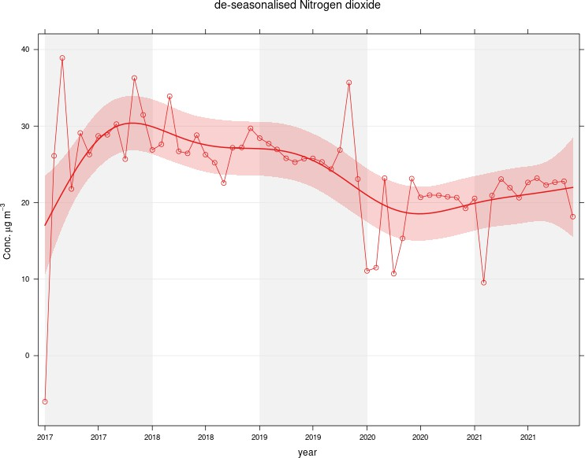

Figure 2 – A5 Falkirk Hope St Long Term NO2 Concentrations

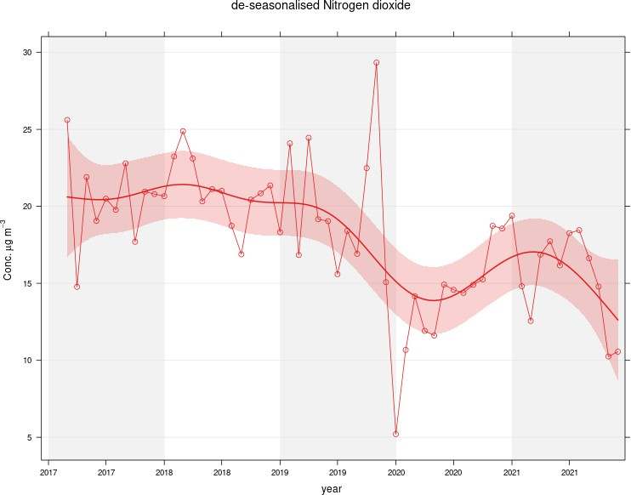

Figure 3 – A7 Falkirk West Bridge St Long Term NO2 Concentrations
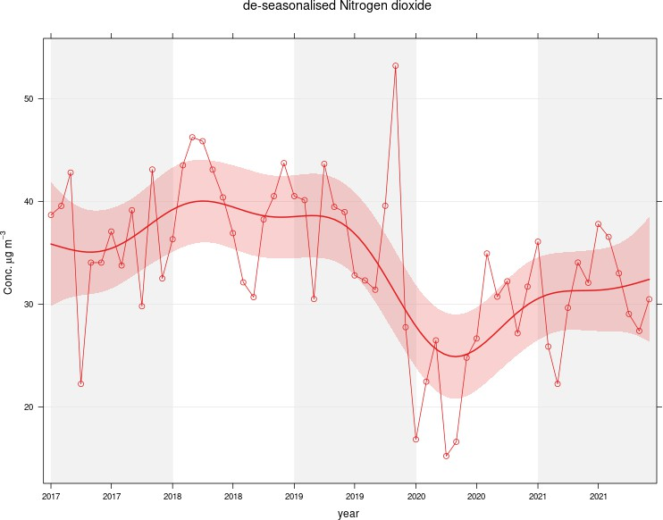

Figure 4 – A8 Grangemouth AURN Long Term NO2 Concentrations
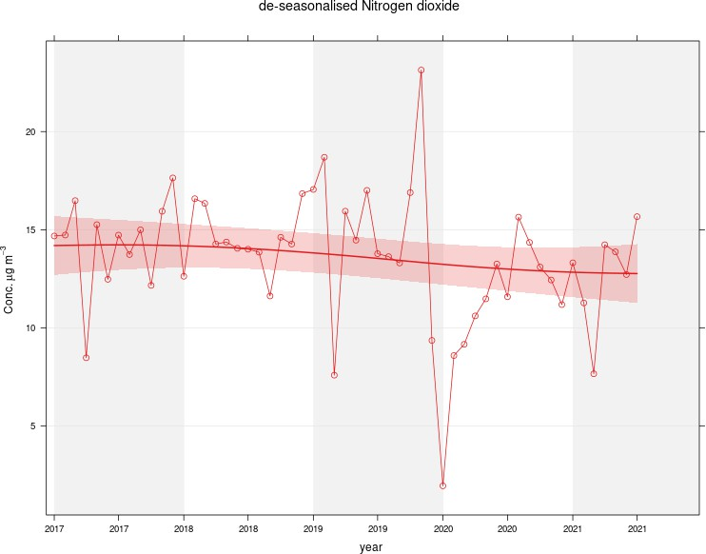

Figure 5 – A9 Grangemouth Moray Long Term NO2 Concentrations
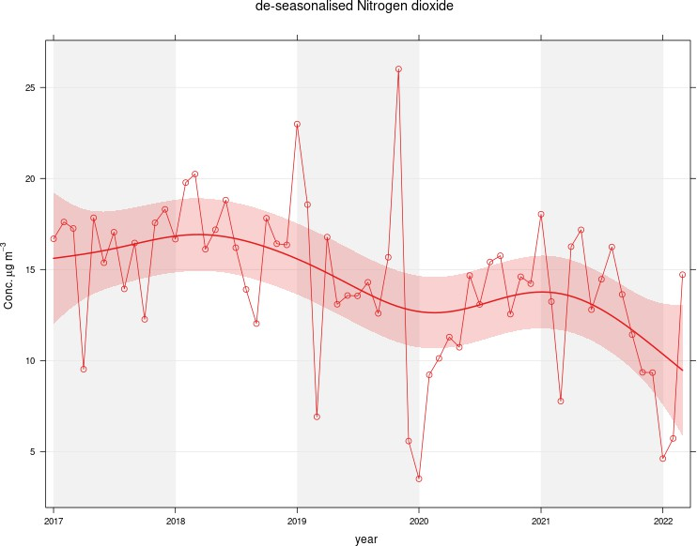

Figure 6 – A10 Grangemouth Municipal Chambers Long Term NO2 Concentrations

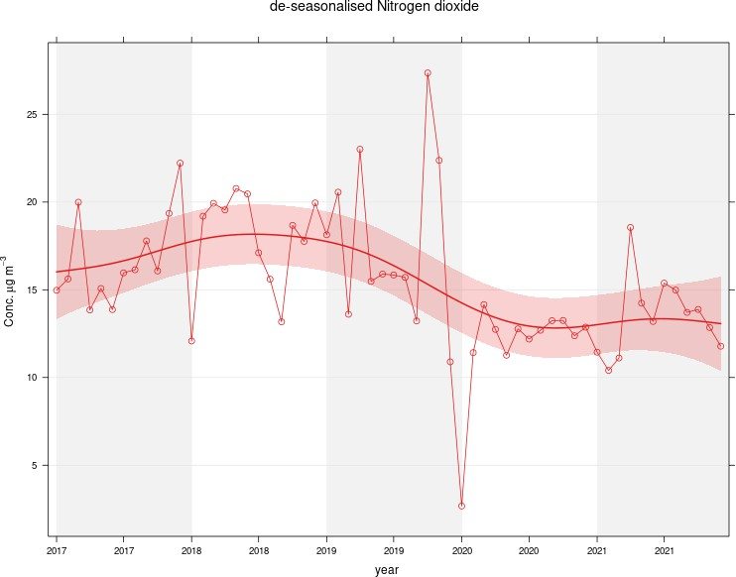

Figure 7 – A15 Main St, Bainsford Long Term NO2 Concentrations

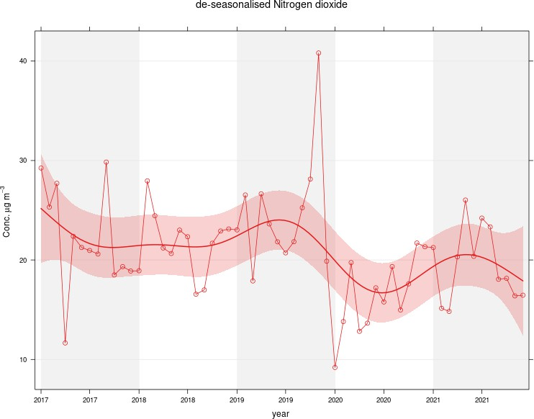

Table A.5 – Annual Mean PM10 Monitoring Results (µg/m³)

Site ID | Site Type | Valid Data Capture for Monitoring Period (%) ⁽¹⁾ | Valid Data Capture 2021 (%)  (2) | 2017 | 2018 | 2019 | 2020 | 2021
A4 | Falkirk Haggs | 99 | 99 | 12 | 14 | 14 | 10 | 10.4
A5 | Falkirk Hope St | 91 | 91 | PM10 analyser transferred from Falkirk Grahams Rd to Hope St site on  10/10/2018 | 11 | 13 | 9 | 9
A7 | Falkirk West Bridge St | 100 | 100 | 10 | 6 | 11 | 8.4 | 9.2
A8 | Grangemouth AURN | 85 | 85 | 9 | 12 | 13 | 9 | 9.3
A10 | Grangemouth Municipal Chambers | 96 | 96 | 12 | 12 | 14 | 9.6 | 8.8
A11 | Grangemouth Zetland Park | 91 | 91 |  |  |  |  | 8.6
A14 | Banknock 3 | 67 | 67 | 7 | 6.9 | 7.9 | 7.8 | 1.3
A15 | Main St, Bainsford | 83 | 83 | 13 | 12 | 14 | 11 | 11.1
Notes:
Exceedances of the PM10 annual mean objective of 18 µg/m³ are shown in bold.
All means have been “annualised” as per LAQM.TG(16), valid data capture for the full calendar year is less than 75%. See Appendix C for details.
- Data capture for the monitoring period, in cases where monitoring was only carried out for part of the year.
- Data capture for the full calendar year (e.g. if monitoring was carried out for 6 months, the maximum data capture for the full calendar year is 50%).

Table A.6 – 24-Hour Mean PM10 Monitoring Results, Number of PM10 24-Hour Means > 50µg/m³

Site ID | Site Type | Valid Data Capture for Monitoring Period (%)  (1) | Valid Data Capture 2021 (%)  (2) | 2017 | 2018 | 2019 | 2020 | 2021
A4 | Falkirk Haggs | 99 | 99 | 0 | 0 | 4 | 0 (21) | 0
A5 | Falkirk Hope St | 91 | 91 | PM10 analyser transferred from Grahams Rd to Hope  St on 10/10/2018 | 0 (30) | 1 | 0 | 0
A7 | Falkirk West Bridge St | 100 | 100 | 0 | 0 (47) | 1 | 0 (18) | 0
A8 | Grangemouth AURN | 85 | 85 | 1 | 0 | 2 | 0 | 0
A10 | Grangemouth Municipal Chambers | 96 | 96 | 0 | 0 | 2 | 0 (17) | 0
A11 | Grangemouth Zetland Park | 91 | 91 |  |  |  |  | 0
A14 | Banknock 3 | 67 | 67 | 0 | 2 (10) | 1 | 1 (15.6) | 0 (7.4)
A15 | Main St, Bainsford | 83 | 83 | 0 | 0 (33) | 5 | 0 | 0 (25)
Notes:
Exceedances of the PM10 24-hour mean objective (50 µg/m³ not to be exceeded more than seven times/year) are shown in bold. If the period of valid data is less than 85%, the 98.1st percentile of 24-hour means is provided in brackets.
- Data capture for the monitoring period, in cases where monitoring was only carried out for part of the year.
- Data capture for the full calendar year (e.g. if monitoring was carried out for 6 months, the maximum data capture for the full calendar year is 50%).

Figure 8 – A4 Haggs Long Term PM10 (Hourly Measured) Concentrations
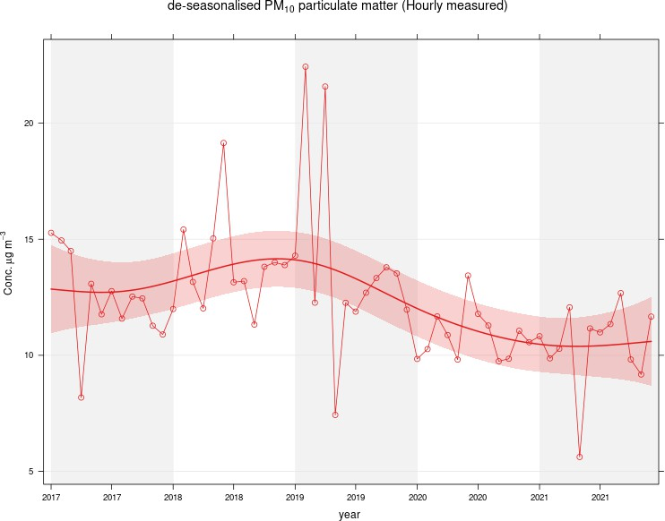

Figure 9 – A5 Falkirk Hope St Long Term PM10 (Hourly Measured) Concentrations
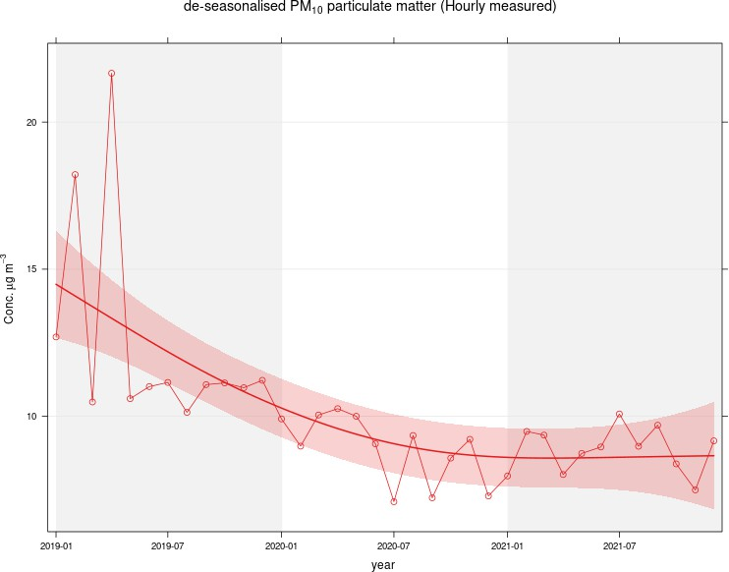

Figure 10 – A7 Falkirk West Bridge St Long Term PM10 (Hourly Measured) Concentrations
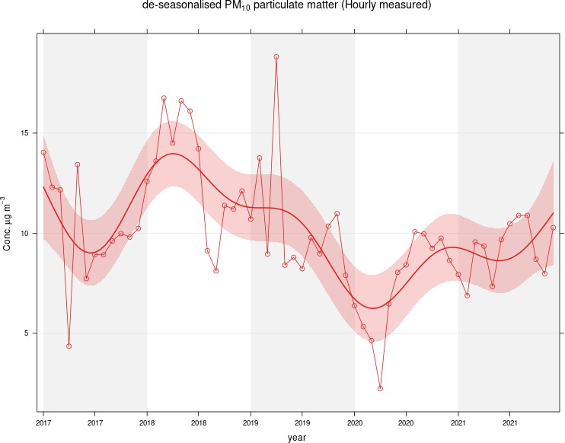

Figure 11 – A8 Grangemouth AURN Long Term PM10 (Hourly Measured) Concentrations
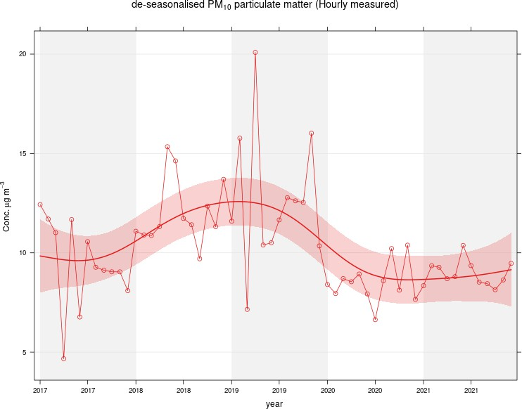

Figure 12 – A10 Grangemouth Municipal Chambers Long Term PM10 (Hourly Measured) Concentrations
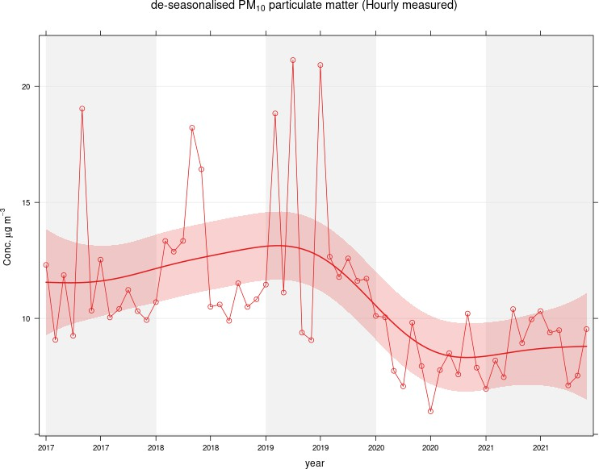

Figure 13 – A11 Grangemouth Zetland Park Long Term PM10 (Hourly Measured) Concentrations
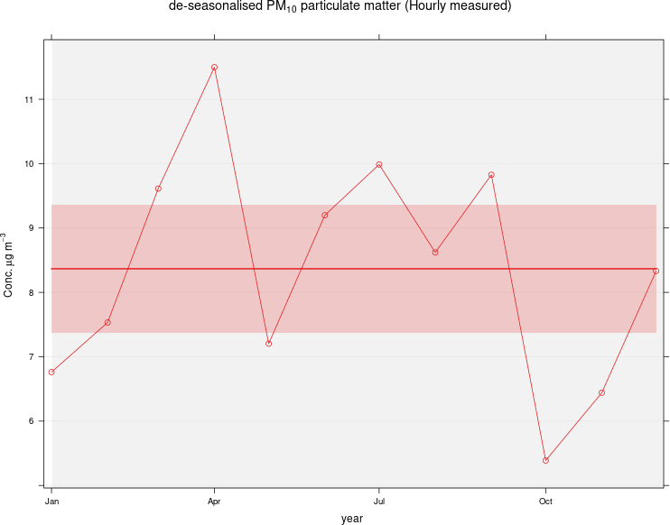

Figure 14 – A15 Main St, Bainsford Long Term PM10 (Hourly Measured) Concentrations

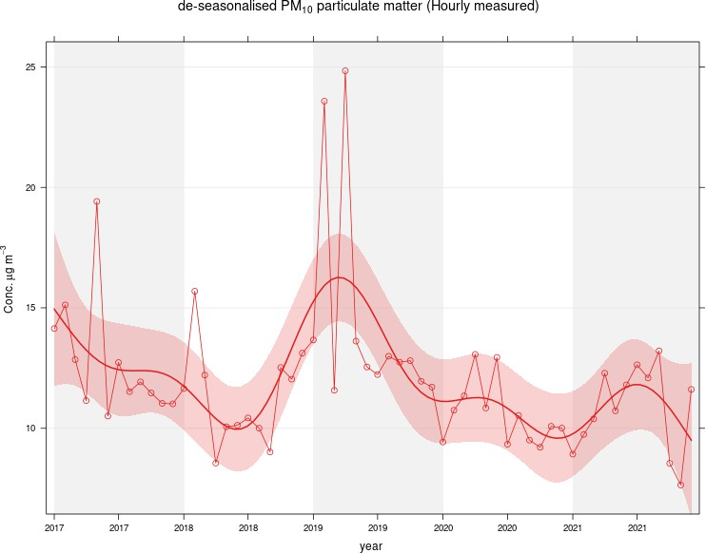

Table A.7 – Annual Mean PM2.5 Monitoring Results (µg/m³)

Site ID | Site Type | Valid Data Capture for Monitoring Period (%) ⁽¹⁾ | Valid Data Capture 2021 (%) (2) | 2017 | 2018 | 2019 | 2020 | 2021
A4 | Falkirk Haggs | 99 | 99 |  |  |  | 6 | 5.7
A5 | Falkirk Hope St | 91 | 91 |  |  |  | 5.1 | 5
A7 | Falkirk West Bridge St | 100 | 100 | 6 | 6 | 6 | 4.4 | 4.9
A8 | Grangemouth AURN | 94 | 94 | 6 | 7 | 8 | 6 | 5.4
A10 | Grangemouth Municipal Chambers | 96 | 96 |  |  |  | 4.4 | 4.7
A11 | Grangemouth Zetland Park | 91 | 91 |  |  |  |  | 5.2
A14 | Banknock 3 | 67 | 67 | 3 | 4 | 4.6 | 3.6 | 1
A15 | Main St, Bainsford | 84 | 84 |  |  |  | 6.2 | 6.1
Notes:
Exceedances of the PM2.5 annual mean objective of 10 µg/m³ are shown in bold.
All means have been “annualised” as per LAQM.TG(16), valid data capture for the full calendar year is less than 75%. See Appendix C for details.
- Data capture for the monitoring period, in cases where monitoring was only carried out for part of the year.
- Data capture for the full calendar year (e.g. if monitoring was carried out for 6 months, the maximum data capture for the full calendar year is 50%).

Figure 15 – A7 Falkirk West Bridge St Long Term PM2.5 Concentrations
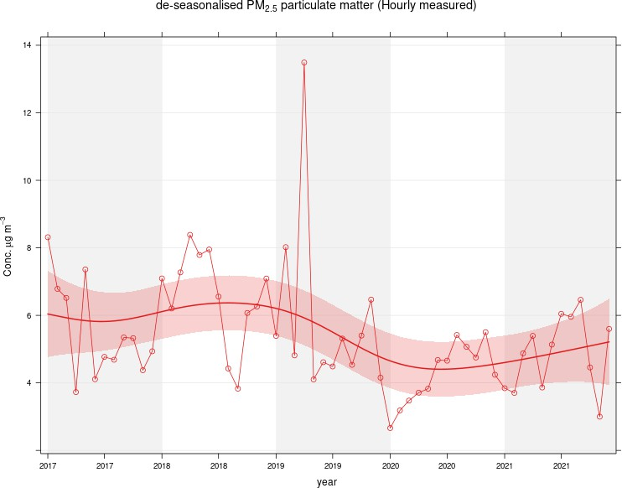

Figure 16 – A8 Grangemouth AURN Long Term PM2.5 Concentrations
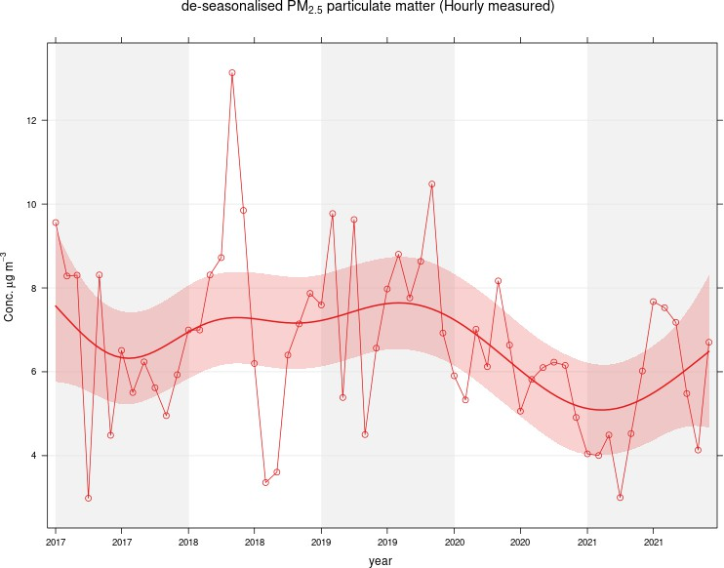

Table A.8 – SO2 2021 Monitoring Results, Number of Relevant Instances

Site ID | Site Type | Valid Data Capture for monitoring Period (%) ⁽¹⁾ | Valid Data Capture 2021 (%) ⁽²⁾ | Number of 15-minute Means > 266 µg/m | Number of 1-hour Means > 350 µg/m | Number of 24-hour Means > 125 µg/m
A3 | Bo’ness | 96 | 96 | 0 | 0 | 0
A5 | Falkirk Hope St | 97 | 97 | 0 | 0 | 0
A8 | Grangemouth AURN | 97 | 97 | 0 | 0 | 0
A9 | Grangemouth Moray | 94 | 94 | 0 | 0 | 0
A10 | Grangemouth Municipal Chambers | 97 | 97 | 0 | 0 | 0
A11 | Grangemouth Zetland Park | 94 | 94 | 0 | 0 | 0
Notes:
Exceedances of the SO2 objectives are shown in bold (15-min mean = 35 allowed a year, 1-hour mean = 24 allowed a year, 24-hour mean = 3 allowed a year)
If the period of valid data is less than 85%, the relevant percentiles are provided in brackets (15-Minute means: 99.9th percentile, 1-hour means: 99.7th percentile, 24-hour means: 99.2nd percentile).
- Data capture for the monitoring period, in cases where monitoring was only carried out for part of the year.
- Data capture for the full calendar year (e.g. if monitoring was carried out for 6 months, the maximum data capture for the full calendar year is 50%).

Figure 17 – A3 Bo’ness Long Term SO2 Concentrations
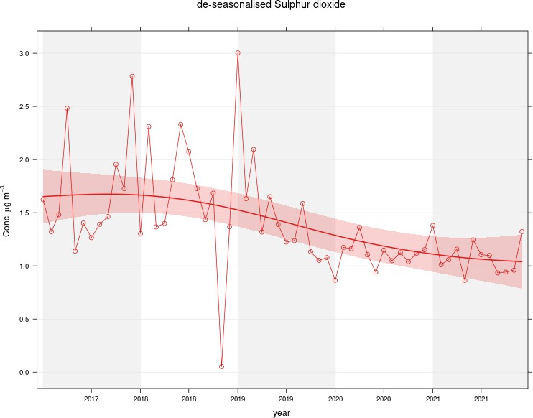

Figure 18 – A5 Falkirk Hope St Long Term SO2 Concentrations
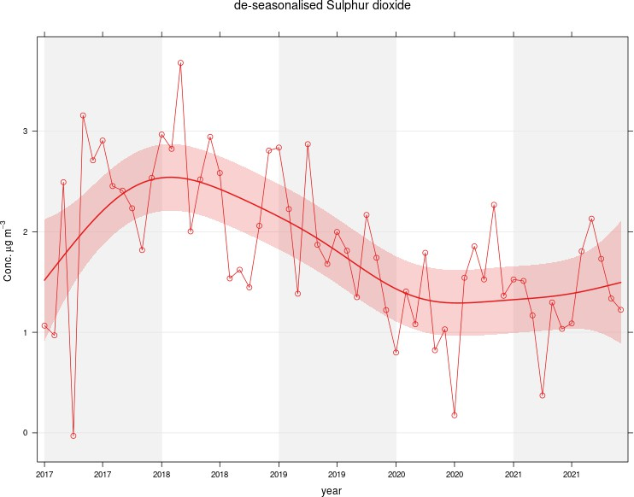

Figure 19 – A8 Grangemouth AURN Long Term SO2 Concentrations
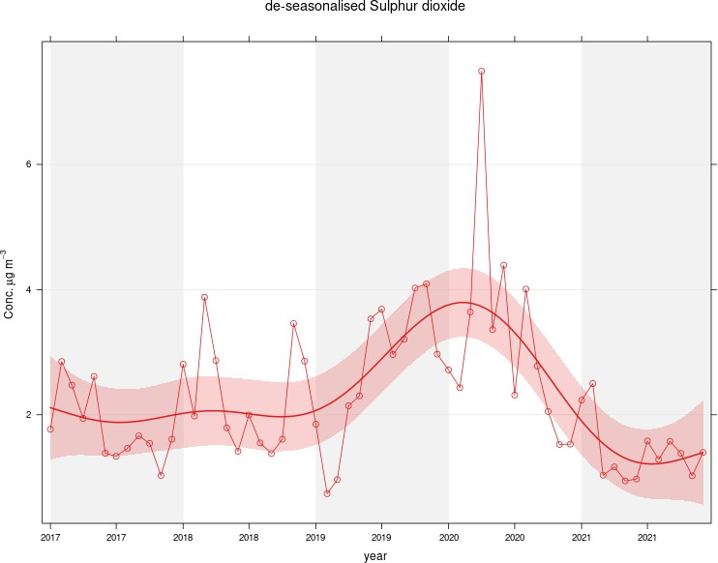

Figure 20 – A9 Grangemouth Moray Long Term SO2 Concentrations
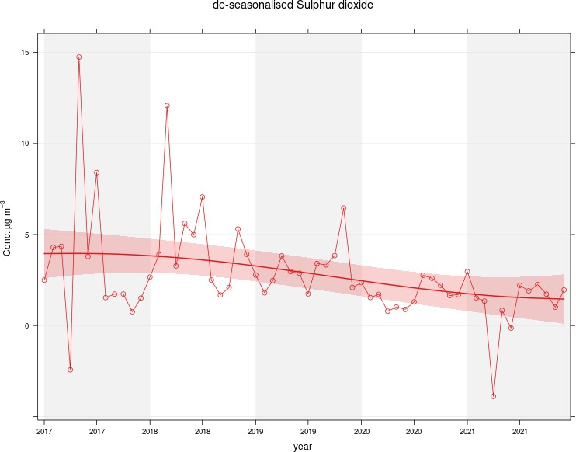

Figure 21 – A10 Grangemouth Municipal Chambers Long Term SO2 Concentrations
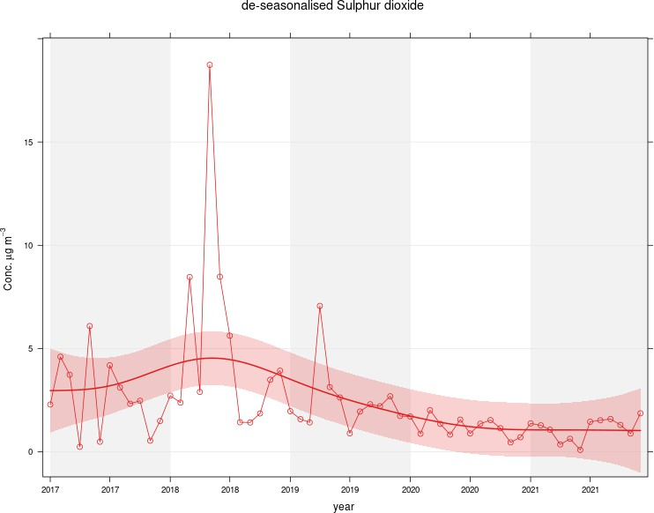

Figure 22 – A11 Grangemouth Zetland Park Long Term SO2 Concentrations
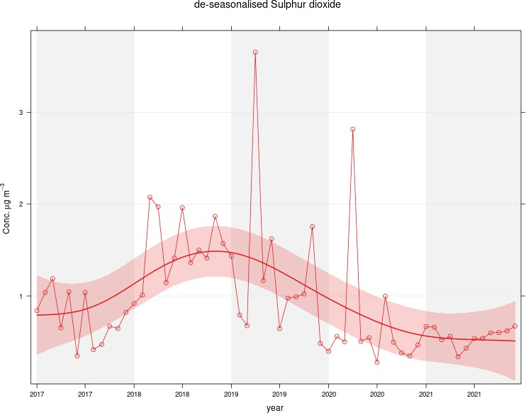

Figure 23 – Polar Plots of Average SO2 Concentrations Recorded at the Grangemouth Sites

A) Grangemouth AURN: 2021 B) Grangemouth AURN: 2017 - 2021
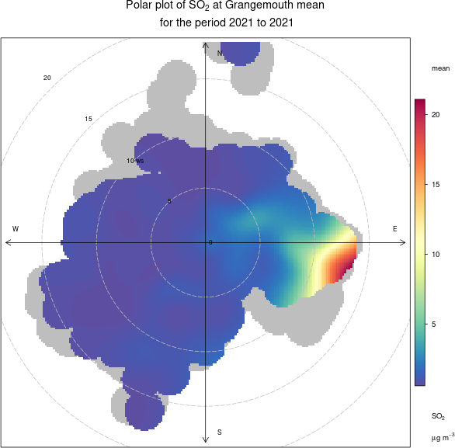
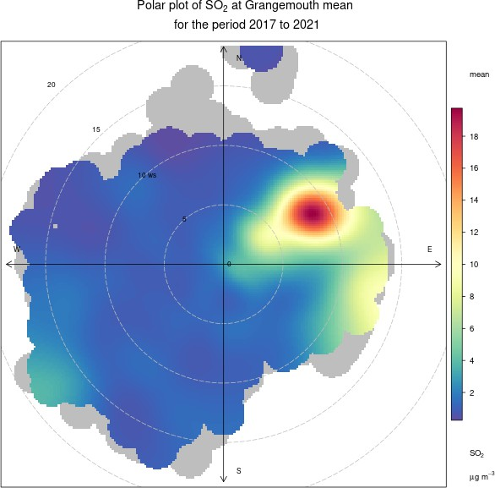

C) Grangemouth Moray: 2021 D) Grangemouth Moray 2017 – 2020
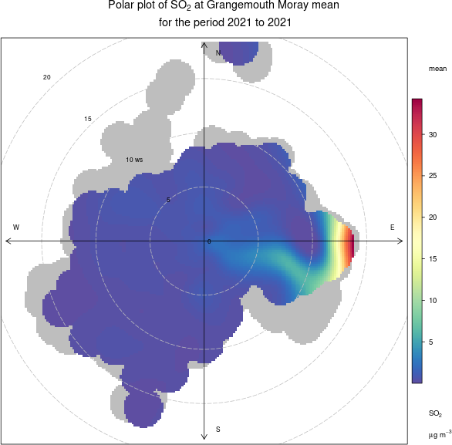
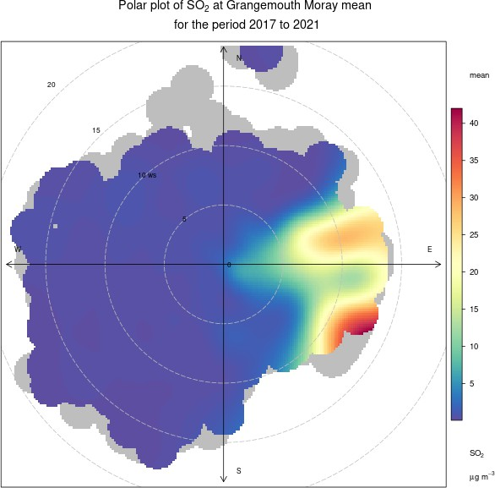

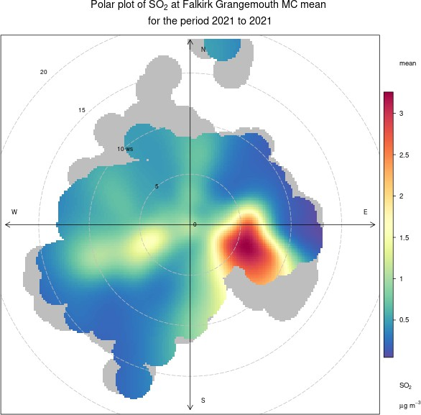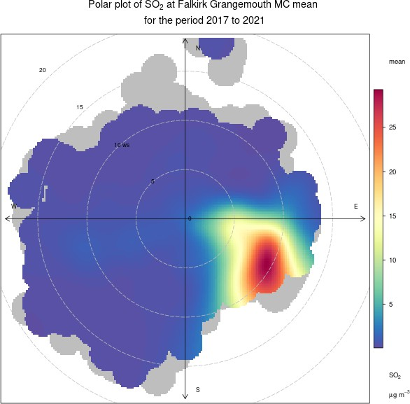

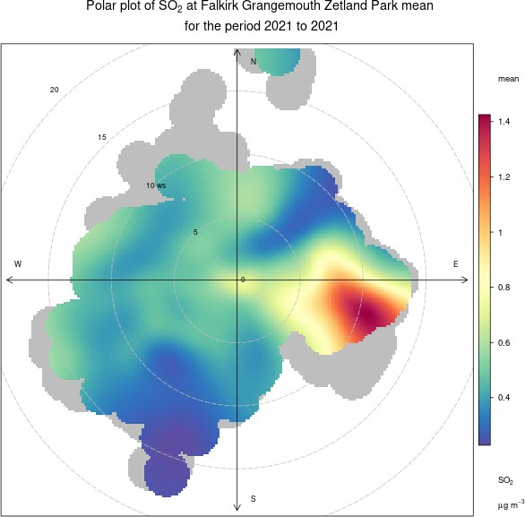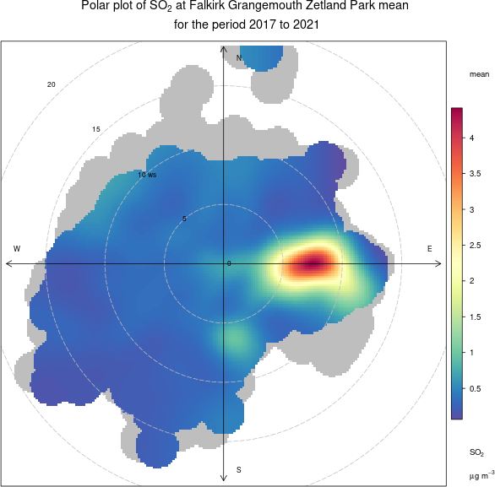

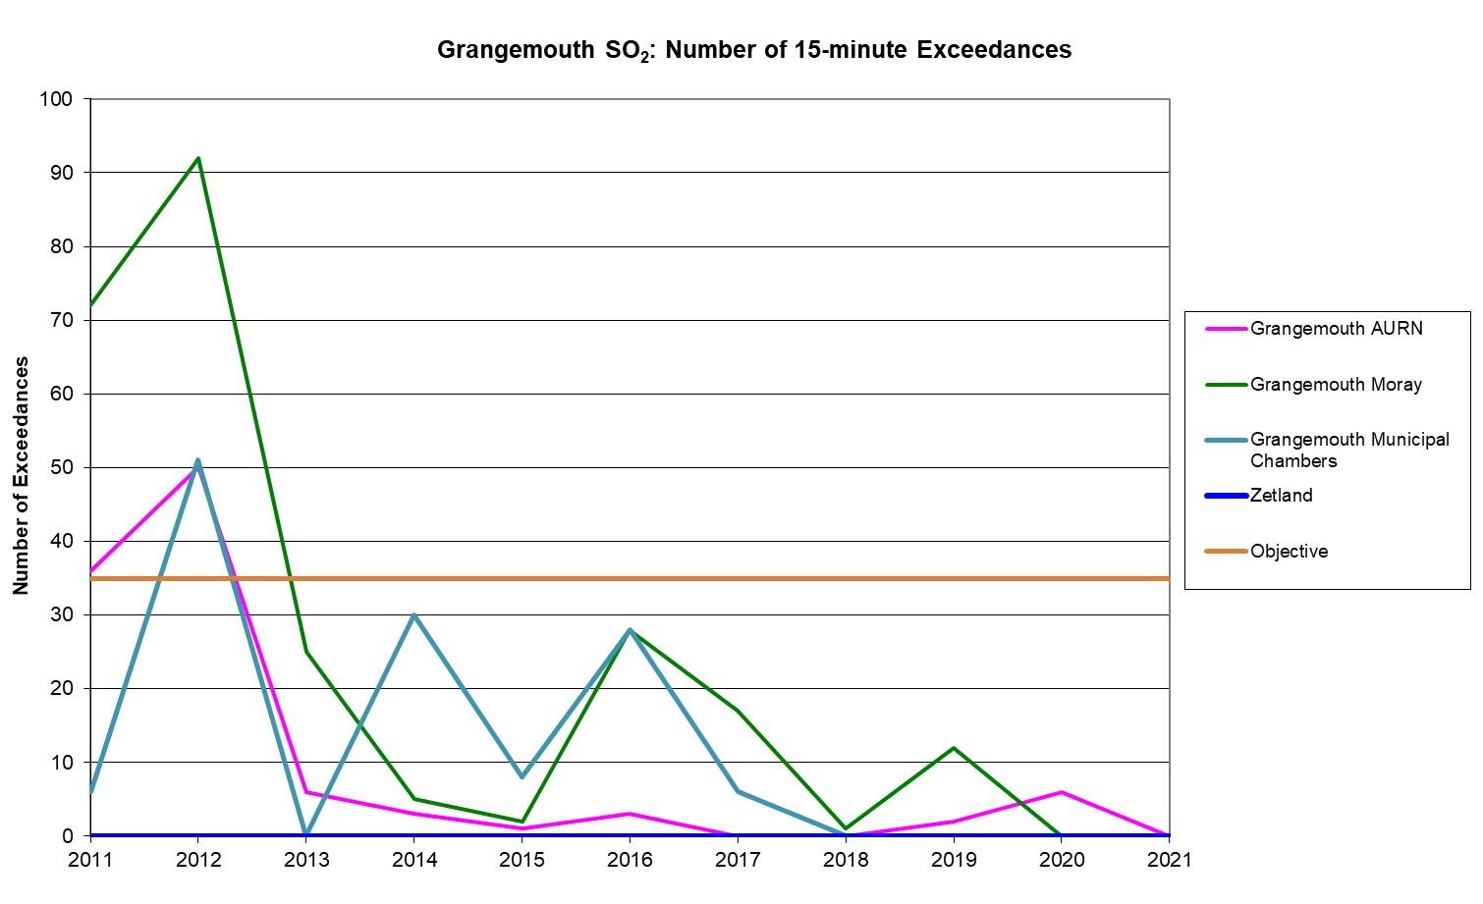

Site ID | Location | Within 1, 3 Butadiene AQMA? | Data Capture in 2021, %. (1) | Annual Mean Concentrations (µg/m³)
 |  |  |  | 2017 | 2018 | 2019 | 2020 | 2021
NA41 | Seaview Place, Bo’ness | N | 100 | 0.1 | 0.06 | 0.05 | 0.05 | 0.05
NA55 | Inchyra  Station, Grangemouth | N | 100 | 0.07 | 0.07 | 0.05 | 0.06 | 0.05
NA104 | Powdrake Road, Grangemouth | N | 91 | 0.1 | 0.11 | 0.05 | 0.05 | 0.05

Note: Exceedances of the 1, 3 butadiene running annual mean NAQS objective are shown in bold.

Site ID | Location | Within AQMA? | Data Capture in 2021, %. (1) | Annual Mean Concentrations (µg/m³)
 |  |  |  | 2017 | 2018 | 2019 | 2020 | 2021
NA3 | Tinto Drive, Grangemouth | N | 91 | 0.58 | 0.66 | 0.8 | 0.48 | 0.51
NA21 | Grangemouth Road, Falkirk College | N | 100 | 0.56 | 0.6 | 0.65 | 0.43 | 0.37
NA27 | West Bridge Street, Falkirk | N | 100 | 0.68 | 0.7 | 1.07 | 0.61 | 0.54
NA37 | Denny Town House | N | 91 | 0.56 | 0.49 | 0.77 | 0.43 | 0.39
NA38 | Larbert Village Primary School | N | 100 | 1.01 | 0.5 | 0.51 | 0.45 | 0.39
NA41 | Seaview Place, Bo’ness | N | 100 | 0.82 | 0.91 | 0.96 | 0.63 | 0.61
NA42 | Municipal Chambers, Grangemouth | N | 100 | 0.47 | 0.63 | 0.78 | 0.45 | 0.51
NA44 | Harvey Avenue, Polmont | N | 100 | 0.  39 | 0.52 | 0.67 | 0.38 | 0.41
NA55 | Inchyra AQ Station, Grangemouth | N | 100 | 0.52 | 0.52 | 0.73 | 0.49 | 0.52
NA77 | Kinnaird Village | N | 91 | 0.51 | 0.44 | 0.59 | 0.41 | 0.38
NA80 | Cow Wynd, Falkirk | N | 100 | 0.57 | 0.52 | 0.66 | 0.46 | 0.45
NA81 | Grahams Road, Falkirk | N | 100 | 0.7 | 0.81 | 0.97 | 0.62 | 0.61
NA94 | A905 (Glensburgh Rd), Grangemouth | N | 91 | 0.64 | 0.68 | 0.77 | 0.46 | 0.49
NA105 | West of Shieldhill | N | 91 | 0.69 | 0.3 | 0.4 | 0.25 | 0.28
NA116 | Kersiebank Avenue, Grangemouth | Y | 100 | New site for 2019 |  | 0.76 | 0.46 | 0.45
NA117 | Oswald Avenue (East), Grangemouth | Y | 100 | New site for 2019 |  | 0.99 | 0.53 | 0.55

Site ID | Location | Within AQMA? | Data Capture in 2021, % (1) | Annual Mean Concentrations (µg/m³)
 |  |  |  | 2017 | 2018 | 2019 | 2020 | 2021
A8 | Grangemouth AURN | Y | 100 | 0.65 | 0.74 | 0.78 | 0.53 | 0.68
Note: Exceedances of the Benzene running annual mean objective of 3.25µg/m3 are shown in bold.

Figure 25 – Maps of the AQMA Boundaries in the Falkirk Council Area
- Grangemouth AQMA (SO2, 15min mean) with relevant diffusion tube locations, declared November 2005
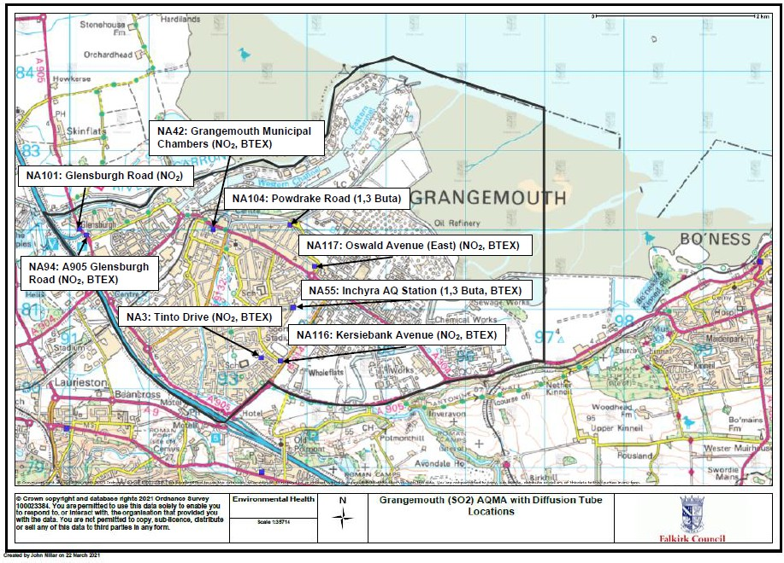

- Falkirk Town Centre AQMA (NO2 Annual Mean, PM10 annual and 24-hour mean) with relevant diffusion tube locations, declared March 2010
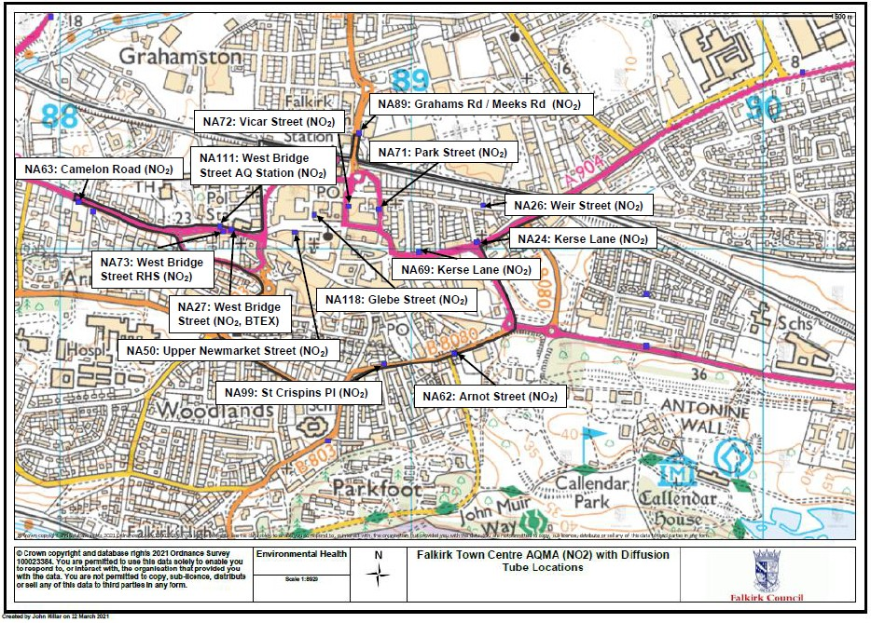

Figure 26 – Maps Showing Automatic Monitoring Locations
  - Grangemouth Air Quality (AQ) Stations
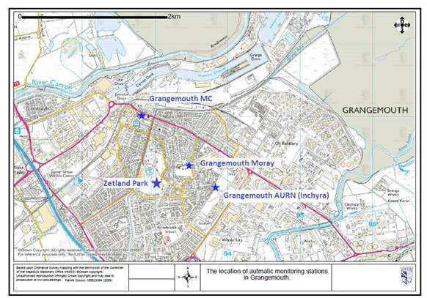

  - Falkirk Hope St AQ Station
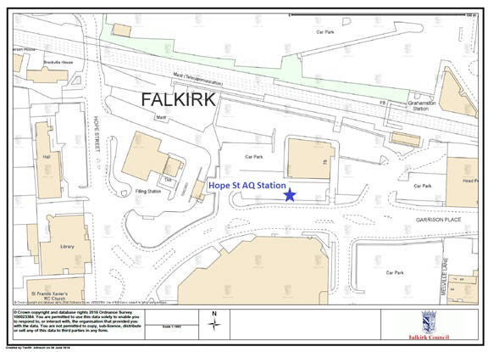

LAQM Annual Progress Report 2022

  - Falkirk West Bridge St AQ Station
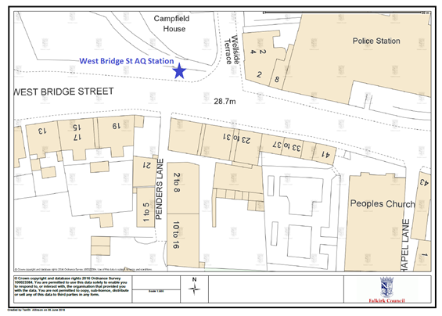
  - Bo’ness AQ Station
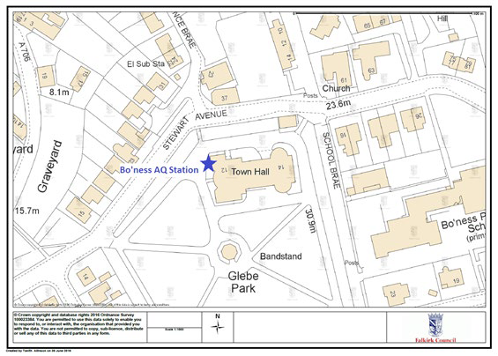

  - Falkirk Haggs AQ Station
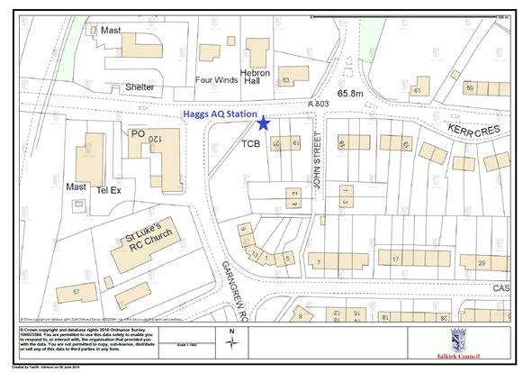
  - Main St, Bainsford, Falkirk AQ Station
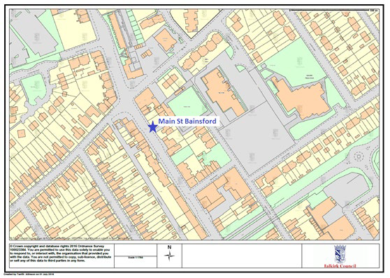

Appendix B: Full Monthly Diffusion Tube Results for 2021

Table B.1 – NO2 2021 Monthly Diffusion Tube Results (µg/m³)

Site ID | Jan | Feb | Mar | Apr (2) | May | Jun | Jul | Aug | Sep | Oct | Nov | Dec | Annual Mean: Raw Data | Annual Mean: Bias Adjusted ⁽¹⁾
NA3 | 28.8 | 18.9 | 14.7 | 18.2 | 16.3 | 11.6 | 13.4 |  | 16.6 | 18.1 | 17.9 | 21.1 | 17.8 | 14.9
NA5 | 34.7 | 25.2 | 18.6 | 21.2 | 22.2 | 13.0 | 19.6 | 22.4 | 23.3 | 19.3 | 27.0 | 30.2 | 23.1 | 19.3
NA7 | 23.4 | 15.4 | 11.7 | 13.6 | 13.2 | 8.7 | 10.8 | 15.2 | 12.8 | 13.9 | 13.5 | 17.7 | 14.2 | 11.9
NA9 | 26.0 | 19.5 | 17.9 | 16.9 | 18.7 | 14.7 | 16.8 | 18.1 | 19.6 | 23.4 | 24.9 | 26.7 | 20.3 | 17
NA19 | 36.6 | 27.6 | 20.9 | 24.5 | 25.7 | 16.2 | 16.8 | 22.3 | 22.7 | - | 21.0 | 27.3 | 23.8 | 19.9
NA20 | 31.9 | 20.4 | 16.1 | - | 16.5 | 13.7 | 13.9 | 15.9 | 18.1 | - | 25.2 | 27.2 | 19.9 | 16.6
NA21 | 35.1 | 24.8 | 17.4 | 22.7 | 23.4 | 17.2 | 20.4 | 23.8 | 23.1 | 22.9 | 24.3 | 27.5 | 23.5 | 19.7
NA24 | 37.1 | 27.5 | 26.3 | 28.6 | 26.4 | 23.7 | 26.8 | 27.4 | 31.3 | 30.5 | 30.3 | 29.0 | 28.7 | 24
NA26 | 29.8 | 17.8 | 12.7 | 13.4 | 13.9 | 10.1 | 13.3 | 14.5 | 15.4 | 16.4 | 16.1 | 21.1 | 16.2 | 13.6
NA27 | 54.8 | 38.1 | - | 41.1 | 49.7 | 32.9 | 40.2 | 39.4 | 44.9 | 35.9 | 38.5 | 42.0 | 41.6 | 34.8
NA29 | 26.8 | 18.7 | 11.5 | 12.2 | 14.4 | 8.4 | 4.5 | 13.7 | 13.3 | 12.1 | 15.7 | 20.9 | 14.3 | 12
NA36 | 38.9 | 30.9 | 26.9 | 28.1 | 30.8 | 22.4 | 24.5 | 26.8 | 31.8 | 33.9 | 32.0 | 34.8 | 30.2 | 25.2
NA37 | 25.0 | 19.7 | 11.7 | 12.7 | 13.8 | 10.5 | 11.6 | 13.4 | 13.7 | 16.3 | 14.0 | 18.3 | 15.1 | 12.6
NA38 | 27.8 | 15.3 | 12.3 | 10.7 | 10.8 | 8.3 | 10.6 | 11.9 | 12.3 | 15.7 | 15.3 | 21.9 | 14.4 | 12.1
NA41 | 33.1 | 22.3 | 18.6 | 18.1 | 19.4 | 14.6 | 17.2 | 17.9 | 20.8 | 22.3 | 22.2 | 23.2 | 20.8 | 17.4
NA42  (3 Tubes) | 30.3 | 18.7 | 14.1 | 16.4 | 14.3 | 9.8 | 11.6 | 13.6 | 15.2 | 17.3 | 20.0 | 20.9 | 16.8 | 14.1
NA42  (3 Tubes) | 30.3 | 18.7 | 14.1 | 16.4 | 14.3 | 9.8 | 11.6 | 13.6 | 15.2 | 17.3 | 20.0 | 20.9 | 16.8 | 14.1
NA42  (3 Tubes) | 30.3 | 18.7 | 14.1 | 16.4 | 14.3 | 9.8 | 11.6 | 13.6 | 15.2 | 17.3 | 20.0 | 20.9 | 16.8 | 14.1
NA44 | 27.7 | 16.5 | 13.1 | 14.3 | 14.7 | 10.3 | 12.1 | 14.2 | 14.2 | 16.0 | 15.7 | 19.0 | 15.7 | 13.1
NA48 | 32.5 | 19.2 | 14.7 | 15.9 | 15.3 | 11.1 | 16.4 | 17.4 | 16.3 | 25.3 | 18.6 | 22.5 | 18.8 | 15.7
NA50 | 31.6 | 25.2 | 13.5 | 21.0 | 25.4 | 18.1 | 22.1 | 23.1 | 21.3 | 18.4 | 17.5 | 23.7 | 21.7 | 18.2
NA51 | 27.1 | 19.5 | 9.4 | 20.6 | 19.2 | 17.1 | 20.7 | 19.4 | 22.0 | 23.5 | 22.1 | - | 20 | 16.8
NA52 | 33.7 | 21.6 | 20.0 | 18.3 | 18.4 | 15.1 | 16.4 | 19.0 | 22.7 | 24.8 | 23.1 | 24.9 | 21.5 | 18
NA53 | 33.3 | 28.9 | - | 22.8 | 21.3 | - | 18.6 | 19.2 | 19.0 | 21.1 | 24.3 | 29.5 | 23.8 | 19.9
NA58 | 28.4 | 16.7 | 12.0 | 17.4 | 16.3 | 12.0 | 13.7 | 16.0 | 17.1 | 17.5 | 18.8 | 21.6 | 17.3 | 14.5
NA59 | 37.6 | 25.3 | 21.0 | 22.7 | 25.2 | 19.3 | 22.3 | 24.0 | 24.8 | 27.5 | 30.7 | 32.9 | 26.1 | 21.8
NA60 | 35.5 | 26.2 | 22.1 | 21.2 | 21.0 | 17.2 | 18.8 | 22.0 | 23.4 | 26.4 | 17.7 | 32.1 | 23.6 | 19.8

Site ID | Jan | Feb | Mar | Apr (2) | May | Jun | Jul | Aug | Sep | Oct | Nov | Dec | Annual Mean: Raw Data | Annual Mean: Bias Adjusted ⁽¹⁾
NA61 | 35.0 | 20.8 | 18.9 | 20.1 | 17.5 | 14.2 | 17.5 | 20.9 | 19.8 | 24.0 | 21.9 | 26.9 | 21.4 | 17.9
NA62 | 35.7 | 28.5 | 26.3 | 25.9 | 27.6 | 19.7 | 21.7 | 26.8 | 30.8 | 31.5 | 31.0 | 32.4 | 28.1 | 23.6
NA63 | 46.2 | 30.1 | - | 29.6 | 33.7 | 24.1 | 27.4 | 32.8 | 34.0 | 26.1 | 36.8 | 34.4 | 32.3 | 27
NA64 | 21.9 | 14.6 | 10.6 | 14.6 | 12.4 | 8.9 | 11.3 | 13.8 | 12.7 | 14.4 | 12.4 | 15.8 | 13.6 | 11.4
NA65 | 34.0 | 20.2 | 18.7 | 22.4 | 22.8 | 15.8 | 18.7 | 20.0 | 20.1 | 19.7 | 20.9 | 25.9 | 21.6 | 18.1
NA67 | 33.8 | 27.9 | 19.2 | 26.2 | 26.6 | 19.7 | 24.4 | 27.0 | 24.1 | 27.0 | 28.0 | 27.0 | 25.9 | 21.7
NA69 | 36.5 | 26.6 | 19.7 | 28.4 | 32.2 | 22.0 | 27.6 | 28.8 | 30.8 | 26.4 | 25.4 | 30.6 | 27.9 | 23.3
NA71 | 40.3 | 28.5 | 25.9 | 26.7 | 26.8 | 23.1 | 26.2 | 27.3 | 27.7 | 28.8 | 35.4 | 32.9 | 29.1 | 24.4
NA72 | 41.0 | 26.1 | 20.4 | 24.4 | 24.9 | 18.0 | 22.3 | 25.8 | 25.8 | 24.1 | 21.9 | 23.3 | 24.8 | 20.8
NA73 | 40.8 | 31.0 | 21.2 | 28.2 | 29.4 | 20.6 | 26.3 | 26.7 | 28.4 | 29.8 | 25.7 | 27.1 | 27.9 | 23.4
NA76 | 27.7 | 17.3 | 17.4 | 14.3 | 13.1 | 10.2 | - | 14.1 | 15.8 | 21.8 | 21.1 | 24.7 | 18 | 15
NA77 | 28.2 | 22.8 | 18.5 | 18.8 | 19.2 | 12.5 | 15.6 | 16.3 | 20.0 | 22.3 | 28.2 | 25.2 | 20.6 | 17.3
NA78 | 29.8 | 22.4 | - | 20.7 | 27.0 | 19.8 | 22.9 | 24.0 | 25.7 | 16.8 | 23.9 | 26.4 | 23.6 | 19.7
NA80 | 35.5 | 25.4 | 24.4 | 21.6 | 19.1 | 18.9 | 18.4 | 22.4 | 23.9 | 18.0 | 28.1 | 28.6 | 23.7 | 19.8
NA81 | 35.5 | 29.6 | 20.3 | 23.5 | 30.2 | 19.9 | 23.1 | 27.0 | 28.1 | 26.4 | 23.5 | 29.1 | 26.4 | 22.1
NA82 | 25.4 | 19.1 | 12.7 | 13.4 | 14.0 | 11.1 | 12.6 | 14.3 | 13.6 | 17.3 | - | 21.2 | 15.9 | 13.3
NA83 | 28.1 |  | 21.6 | 28.4 | 30.8 | 25.4 | 29.0 | 30.1 | 31.2 | 34.9 | 32.3 | 37.9 | 30 | 25.1
NA85 | 28.1 | 20.8 | 11.1 | 14.8 | 17.0 | 11.9 | 13.7 | 16.2 | 15.9 | 15.9 | 13.3 | 20.6 | 16.6 | 13.9
NA86 | 23.4 | 15.2 | 10.8 | 13.4 | 12.2 | 7.6 | 10.9 | 11.9 | 12.8 | 12.8 | 13.2 | 18.0 | 13.5 | 11.3
NA87 | 33.5 | 21.9 | 20.1 | 23.3 | 26.2 | 20.8 | 24.2 | 24.4 | 27.9 | 29.0 | 19.3 | 30.0 | 25.1 | 21
NA88 | 31.9 | 22.4 | 22.3 | 24.0 | 23.7 | 16.9 | 20.7 | 21.8 | 23.4 | 26.0 | 26.9 | 27.9 | 24 | 20.1
NA89 | 34.5 | 27.7 | 21.8 | 25.1 | 24.4 | 19.2 | 23.9 | 25.8 | 25.3 | 27.9 | 27.3 | 30.0 | 26.1 | 21.8
NA94 | 39.1 | 27.9 | 25.8 | 24.4 | 25.6 | 17.9 | 19.5 | 24.1 | 25.1 | 30.9 | 33.1 | 28.4 | 26.8 | 22.4
NA98 | 31.5 |  | 13.8 | 19.1 | 18.3 | 13.1 | 15.7 | 16.1 | - | - | - | 21.6 | 18.7 | 15.4
NA99 | 33.1 | 25.2 | 18.4 | 19.7 | 20.7 | 14.2 | 18.5 | 18.9 | 21.1 | 22.2 | 24.3 | 25.2 | 21.8 | 18.2
NA101 | 31.5 | 21.5 | 15.5 | 15.3 | 18.3 | 11.6 | - | 18.1 | 19.4 | 19.7 | 21.7 | 22.3 | 19.5 | 16.3
NA105 | 11.5 | 8.6 | 4.9 | 6.2 | 6.9 | 4.9 | 6.1 | 6.2 | 6.1 | 5.9 | 5.9 | 9.9 | 6.9 | 5.8
NA107 | 40.0 | 24.6 | 21.9 | - | 19.9 | 14.2 | 16.5 | 21.6 | 19.1 | 23.1 | 20.5 | 26.6 | 22.5 | 18.9
NA110 | 23.6 | 14.1 | 12.4 | 13.2 | 13.5 | 10.2 | 10.7 | 11.8 | 12.0 | 12.6 | 11.8 | 15.6 | 13.5 | 11.3
NA111  (3 tubes) | 47.5 | 34.3 | 27.5 | 36.4 | 37.6 | 28.0 | 36.2 | 32.4 | 37.5 | 33.6 | 32.3 | 39.0 | 35.2 | 29.4
NA111  (3 tubes) | 47.5 | 34.3 | 27.5 | 36.4 | 37.6 | 28.0 | 36.2 | 32.4 | 37.5 | 33.6 | 32.3 | 39.0 | 35.2 | 29.4
NA111  (3 tubes) | 47.5 | 34.3 | 27.5 | 36.4 | 37.6 | 28.0 | 36.2 | 32.4 | 37.5 | 33.6 | 32.3 | 39.0 | 35.2 | 29.4
NA114 | 47.3 | 34.9 | 32.9 | 31.9 | - | 28.1 | 35.1 | 35.3 | 36.4 | 22.6 | - | 41.5 | 34.6 | 28.9
NA115 | 26.5 | 17.6 | 11.4 | - | 14.2 | 10.1 | 12.6 | 14.5 | 13.5 | 14.5 | 17.1 | 21.3 | 15.8 | 13.2
NA116 | 22.4 | 23.5 | 12.9 | 21.0 | 20.4 | 14.6 | 16.0 | 16.1 | 16.2 | 16.4 | 15.5 | 21.3 | 18 | 15.1

Site ID | Jan | Feb | Mar | Apr (2) | May | Jun | Jul | Aug | Sep | Oct | Nov | Dec | Annual Mean: Raw Data | Annual Mean: Bias Adjusted ⁽¹⁾
NA117 | 27.5 | 18.0 | 15.0 | 16.3 | 14.7 | 10.4 | 11.5 | 13.4 | 15.2 | 14.7 | 19.8 | 18.1 | 16.2 | 13.6
NA118 | 35.8 | 23.7 | 14.3 | 19.3 | 21.2 | 14.5 | 17.7 | 19.7 | 19.1 | 19.7 | 18.7 | 24.1 | 20.7 | 17.3
NA119 | 31.2 | 23.4 | 17.2 | 19.3 | 20.9 | 14.3 | 17.8 | 18.6 | 19.6 | 20.3 | 21.0 | 25.4 | 20.8 | 17.4
Notes:
    - See Appendix C for details on bias adjustment

Table B.2 – 1,3 Butadiene Monthly Diffusion Tube Results for 2021

Site ID | Jan | Feb | Mar | Apr | May | Jun | Jul | Aug | Sep | Oct | Nov | Dec | Annual Mean: Raw Data (ppb) | Annual Mean: Raw Data (µg/m³)
41 | 0.02 | 0.02 | 0.03 | 0.03 | 0.02 | 0.02 | 0.02 | 0.02 | 0.02 | 0.02 | 0.02 | 0.02 | 0.02 | 0.05
55 | 0.02 | 0.02 | 0.02 | 0.02 | 0.03 | 0.03 | 0.02 | 0.02 | 0.02 | 0.02 | 0.02 | 0.03 | 0.02 | 0.05
104 | 0.02 | 0.02 | 0.03 | 0.02 | 0.02 | - | 0.02 | 0.02 | 0.02 | 0.02 | 0.02 | 0.02 | 0.02 | 0.05

Table B.3 – Benzene Monthly Diffusion Tube Results for 2021

Site ID | Jan | Feb | Mar | Apr (1) | May | Jun | Jul | Aug | Sep | Oct | Nov | Dec | Annual Mean: Raw Data (ppb) | Annual Mean: Raw Data (µg/m³)
3 | 0.21 | 0.20 | 0.12 | 0.21 | 0.15 | 0.09 | - | 0.17 | 0.14 | 0.05 | 0.16 | 0.21 | 0.16 | 0.51
21 | 0.07 | 0.20 | 0.10 | 0.14 | 0.09 | 0.07 | 0.09 | 0.15 | 0.16 | 0.08 | 0.07 | 0.16 | 0.12 | 0.37
27 | 0.22 | 0.23 | 0.14 | 0.22 | 0.18 | 0.09 | 0.13 | 0.19 | 0.17 | 0.11 | 0.07 | 0.26 | 0.17 | 0.54
37 | 0.07 | 0.20 | 0.12 | 0.14 | 0.12 | 0.07 | 0.10 | 0.13 | 0.14 | 0.09 | 0.13 | - | 0.12 | 0.39
38 | 0.16 | 0.19 | 0.12 | 0.13 | 0.09 | 0.07 | 0.07 | 0.12 | 0.11 | 0.09 | 0.14 | 0.16 | 0.12 | 0.39
41 | 0.27 | 0.25 | 0.19 | 0.23 | 0.18 | 0.11 | 0.12 | 0.22 | 0.20 | 0.15 | 0.07 | 0.26 | 0.19 | 0.61
42 | 0.26 | 0.22 | 0.15 | 0.18 | 0.13 | 0.07 | 0.10 | 0.17 | 0.18 | 0.09 | 0.15 | 0.20 | 0.16 | 0.51
44 | 0.25 | 0.23 | 0.11 | 0.17 | 0.09 | 0.07 | 0.07 | 0.12 | 0.11 | 0.09 | 0.07 | 0.12 | 0.13 | 0.41
55 | 0.25 | 0.18 | 0.12 | 0.21 | 0.20 | 0.11 | 0.13 | 0.19 | 0.18 | 0.09 | 0.12 | 0.15 | 0.16 | 0.52
77 | 0.18 | 0.17 | 0.08 | 0.14 | - | 0.07 | 0.07 | 0.11 | 0.12 | 0.07 | 0.12 | 0.16 | 0.12 | 0.38
80 | 0.19 | 0.22 | 0.08 | 0.15 | 0.13 | 0.07 | 0.09 | 0.15 | 0.16 | 0.10 | 0.14 | 0.17 | 0.14 | 0.45
81 | 0.24 | 0.22 | 0.19 | 0.21 | 0.17 | 0.10 | 0.13 | 0.19 | 0.21 | 0.14 | 0.21 | 0.23 | 0.19 | 0.61
94 | 0.21 | 0.21 | - | 0.17 | 0.14 | 0.10 | 0.13 | 0.18 | 0.20 | 0.09 | 0.07 | 0.17 | 0.15 | 0.49
105 | - | 0.17 | 0.09 | 0.13 | 0.07 | 0.07 | 0.05 | 0.10 | 0.07 | 0.05 | 0.07 | 0.09 | 0.09 | 0.28
116 | 0.07 | 0.22 | 0.09 | 0.18 | 0.17 | 0.07 | 0.12 | 0.16 | 0.15 | 0.10 | 0.14 | 0.18 | 0.14 | 0.45
117 | 0.23 | 0.22 | 0.14 | 0.19 | 0.19 | 0.11 | 0.15 | 0.22 | 0.23 | 0.07 | 0.07 | 0.20 | 0.17 | 0.55

Appendix C: Supporting Technical Information / Air Quality Monitoring Data QA/QC

New or Changed Sources Identified Within Falkirk Council During 2021
Falkirk Council has not identified any new sources relating to air quality within the reporting year of 2021.

Additional Air Quality Works Undertaken by Falkirk Council During 2021
Falkirk Council has not completed any additional reports within the year of 2021.

QA/QC of Diffusion Tube Monitoring
In 2021, the nitrogen dioxide (NO2), benzene and 1, 3-butadiene ambient air diffusion tubes deployed by Falkirk Council were supplied and analysed by Gradko International Ltd. The analysis method used for the NO2 tubes was 50% tri-ethanolamine (TEA) and 50% acetone. The benzene tube type was Carbograph 1TD (thermal desorption / gas chromatography) and for 1, 3-butadiene the tube type was Carbopack X (ATD) with analysis using TD-GCMS. The diffusion tube monitoring has been completed in adherence with the DEFRA 2021 Diffusion Tube Calendar and with all monitoring data and additional bias / annualisation information entered into the latest DEFRA Diffusion Tube Data Processing Tool.

Nitrogen Dioxide Diffusion Tubes
In 2021, the NO2 diffusion tube analysis was completed by Gradko International Ltd. Gradko adheres to the DEFRA guidance for the preparation and analysis of the NO2 diffusion tubes. All the results relating to the concentration of NO2 present on the diffusion tube are within the scope of Gradko’s United Kingdom Accreditation Service (UKAS) accreditation.
The full set of monthly NO2 diffusion tube results are shown in Table B.1 in Appendix B.

LAQM Annual Progress Report 2022

1, 3-Butadiene Diffusion Tubes
Gradko International Ltd. Performed the quantitative analysis of 1, 3-butadiene on diffusion tubes by TD-GCMS. Analysis has been completed in accordance with in-house method ‘GLM 13-6’ under UKAS fixed scope accreditation.
The full set of monthly 1, 3-butadiene diffusion tube results are shown in Table B.2 in Appendix B.

Benzene Diffusion Tubes
Gradko International Ltd. analysed Falkirk Council’s benzene diffusion tubes by ATD-GC- MS. Analysis has been completed in accordance with Gradko’s in-house method ‘GLM 4’ under UKAS fixed scope accreditation. The full set of monthly Benzene diffusion tube results are shown in Table B.3 in Appendix B.

Diffusion Tube Annualisation

All diffusion tube monitoring locations within Falkirk Council recorded data capture of 75% therefore it was not required to annualise any monitoring data. In addition, any sites with a data capture below 25% do not require annualisation.

Diffusion Tube Bias Adjustment Factors

Falkirk Council have applied a local (combined) bias adjustment factor of 0.84 to the 2021 monitoring data.
A summary of bias adjustment factors used by Falkirk Council over the past five years are presented in Table C.1.

Table C.1 – Bias Adjustment Factor

Year | Local or National | If National, Version of National Spreadsheet | Adjustment Factor
2021 | Local | - | 0.84
2020 | Local | - | 0.94
2019 | Local | - | 0.94
2018 | Local | - | 0.88
2017 | Local | - | 0.93
NO2 Diffusion Tube Bias Adjustment Factor (Local and National)
In accordance with LAQM TG16Ref 2, a locally derived Bias Adjustment Factor has been calculated for the 2021 NO2 diffusion tube results based on the following two co-location sites: NA42 Grangemouth Municipal Chambers and NA111 Falkirk West Bridge Street. The local results have been submitted to the LAQM Helpdesk to contribute to the national bias factor.
The results of the locally derived bias adjustment factor spreadsheets are shown in Figure 28 A) and B).
The national diffusion tube bias adjustment factor spreadsheet is displayed in Figure 28 for comparison purposes. The overall national bias factor in 2021 was 0.83.
A comparison in summary form of the local and national bias factor summary is shown in table C.2.

Table C.2 – Comparison of Local vs National Bias Factor Summary

Local NO₂ Bias Adjustment Factor | 0.84
National NO₂ Bias Adjustment Factor | 0.83
Difference | -0.01

LAQM Annual Progress Report 2022

In accordance with LAQM TG16Ref 2 Box 7.11 – data quality checks of the local bias adjustment spreadsheet have been assessed as ‘good’ for both co-location sites. Falkirk Council have a full years’ worth of co-location data at the representative locations (A10 Grangemouth Municipal Chambers: Urban background / Industrial – typical off-street urban location that is likely to measure traffic and industrial emissions. A7 West Bridge Street: roadside – traffic related, elevated NO2 levels at typical daytime peak traffic periods).
Using the above reasons, it has been decided to apply the locally derived bias adjustment factor for the 2021 NO2 diffusion tube results.

NO2 Fall-off with Distance from the Road

No diffusion tube NO2 monitoring locations within Falkirk Council required distance corrections during 2021.

Figure 27 – NO2 Locally Derived Bias Adjustment Factor Spreadsheets

- A7 Falkirk West Bridge St

Checking Precision and Accuracy of Triplicate Tubes
Diffusion Tubes Measurements
Period | Start Date  dd/mm/yyyy | End Date  dd/mm/yyyy | Tube 1  µgm ⁻³ | Tube 2  µgm ⁻³ | Tube 3  µgm ⁻ ³ | Triplicate Mean | Standard Deviation | Coefficient  of Variation (CV) | 95% CI  of mean
1 | 06/01/2021 | 03/02/2021 | 47.5 | 46.8 | 47.8 | 47 | 0.5 | 1 | 1.3
2 | 03/02/2021 | 03/03/2021 | 34.3 | 38.6 | 36.2 | 36 | 2.1 | 6 | 5.2
3 | 03/03/2021 | 31/03/2021 | 27.5 | 26.9 | 27.5 | 27 | 0.3 | 1 | 0.8
4 | 31/03/2021 | 05/05/2021 | 36.4 | 40.7 | 39.8 | 39 | 2.3 | 6 | 5.6
5 | 05/05/2021 | 02/06/2021 | 37.6 | 40.5 | 38.9 | 39 | 1.4 | 4 | 3.6
6 | 02/06/2021 | 30/06/2021 | 28.0 | 29.8 | 27.7 | 28 | 1.1 | 4 | 2.8
7 | 30/06/2021 | 04/08/2021 | 36.2 | 37.6 | 34.5 | 36 | 1.6 | 4 | 3.9
8 | 04/08/2021 | 01/09/2021 | 32.4 | 34.3 | 33.3 | 33 | 1.0 | 3 | 2.4
9 | 01/09/2021 | 29/09/2021 | 37.5 | 27.5 | 37.6 | 34 | 5.8 | 17 | 14.4
10 | 29/09/2021 | 03/11/2021 | 33.6 | 33.2 | 30.9 | 33 | 1.5 | 5 | 3.7
11 | 03/11/2021 | 01/12/2021 | 32.3 | 34.1 | 35.2 | 34 | 1.4 | 4 | 3.6
12 | 01/12/2021 | 05/01/2022 | 39.0 | 33.9 | 38.3 | 37 | 2.8 | 7 | 6.9
13

It is necessary to have results for at least two tubes in order to calculate the precisi
 | Automatic Method |  | Data Quality Check
 | Period Mean | Data  Capture (% DC) | Tubes  Precision Check | Automatic  Monitor Data
 | 43 | 99 | Good | Good
 | 30 | 100 | Good | Good
 | 24 | 100 | Good | Good
 | 37 | 100 | Good | Good
 | 33 | 100 | Good | Good
 | 24 | 100 | Good | Good
 | 28 | 99 | Good | Good
 | 30 | 100 | Good | Good
 | 30 | 100 | Good | Good
 | 28 | 100 | Good | Good
 | 30 | 100 | Good | Good
 | 37 | 100 | Good | Good
on of the measurements Overall survey --> |  |  | Good  precision | Good  Overall DC
Precision 12 out of 12 periods have a CV smaller than 20%

Falkirk West Bridge Street
Site Name/ ID:

Accuracy (with 95% confidence interval)
without periods with CV larger than 20%
Bias calculated using 12 periods of data Bias factor A 0.88 (0.84 - 0.92)
Bias B 14% (9% - 18%)
Diffusion Tubes Mean: 35 µgm⁻³
Mean CV (Precision): 5
Automatic Mean: 31 µgm⁻³ Data Capture for periods used: 100%
Adjusted Tubes Mean: 31 (30 - 33) µgm⁻³

Accuracy (with 95% confidence interval)
WITH ALL DATA
Bias calculated using 12 periods of data Bias factor A 0.88 (0.84 - 0.92)
Bias B 14% (9% - 18%)
Diffusion Tubes Mean: 35 µgm⁻³
Mean CV (Precision): 5
Automatic Mean: 31 µgm⁻³
Data Capture for periods used: 100%
Adjusted Tubes Mean: 31 (30 - 33) µgm⁻³

(Check average CV & DC from Accuracy calculations)


Jaume Targa, for AEA Version 04 - February 2011
Without CV>20 With all data 14% 14%
4.9% 4.9%
50%

25%

0%
Without CV>20% With all data

-25%

-50%
Diffusion Tube Bias B

- A10 Grangemouth Municipal Chambers

Checking Precision and Accuracy of Triplicate Tubes
Diffusion Tubes Measurements
Period | Start Date  dd/mm/yyyy | End Date  dd/mm/yyyy | Tube 1  µgm ⁻³ | Tube 2  µgm ⁻³ | Tube 3  µgm ⁻ ³ | Triplicate Mean | Standard Deviation | Coefficient  of Variation (CV) | 95% CI  of mean
1 | 06/01/2021 | 03/02/2021 | 30.3 | 29.4 | 24.4 | 28 | 3.1 | 11 | 7.8
2 | 03/02/2021 | 03/03/2021 | 18.7 | 15.6 | 18.8 | 18 | 1.8 | 10 | 4.5
3 | 03/03/2021 | 31/03/2021 | 14.1 | 14.9 | 13.9 | 14 | 0.5 | 4 | 1.3
4 | 31/03/2021 | 05/05/2021 | 16.4 | 16.5 | 13.7 | 16 | 1.6 | 10 | 3.9
5 | 05/05/2021 | 02/06/2021 | 14.3 | 14.4 | 14.6 | 14 | 0.2 | 1 | 0.4
6 | 02/06/2021 | 30/06/2021 | 9.8 | 11.0 | 10.5 | 10 | 0.6 | 6 | 1.5
7 | 30/06/2021 | 04/08/2021 | 11.6 | 11.6 | 11.3 | 11 | 0.2 | 2 | 0.5
8 | 04/08/2021 | 01/09/2021 | 13.6 | 14.2 | 13.9 | 14 | 0.3 | 2 | 0.8
9 | 01/09/2021 | 29/09/2021 | 15.2 | 14.5 | 14.7 | 15 | 0.3 | 2 | 0.8
10 | 29/09/2021 | 03/11/2021 | 17.3 | 16.5 | 16.7 | 17 | 0.4 | 2 | 0.9
11 | 03/11/2021 | 01/12/2021 | 20.0 | 20.2 | 20.6 | 20 | 0.3 | 2 | 0.8
12 | 01/12/2021 | 05/01/2022 | 20.9 | 20.6 | 17.2 | 20 | 2.0 | 10 | 5.0
13

It is necessary to have results for at least two tubes in order to calculate the precisi
 | Automatic Method |  | Data Quality Check
 | Period Mean | Data  Capture (% DC) | Tubes  Precision Check | Automatic  Monitor Data
 | 24 | 98 | Good | Good
 | 14 | 95 | Good | Good
 | 12 | 99 | Good | Good
 | 15 | 98 | Good | Good
 | 11 | 98 | Good | Good
 | 7 | 100 | Good | Good
 | 9 | 98 | Good | Good
 | 9 | 98 | Good | Good
 | 12 | 98 | Good | Good
 | 12 | 98 | Good | Good
 | 16 | 98 | Good | Good
 | 20 | 98 | Good | Good
on of the measurements Overall survey --> |  |  | Good  precision | Good  Overall DC
Precision 12 out of 12 periods have a CV smaller than 20%

Grangemouth MC
Site Name/ ID:
Accuracy (with 95% confidence interval)
without periods with CV larger than 20%
Bias calculated using 12 periods of data Bias factor A 0.82 (0.75 - 0.89)
Bias B 23% (12% - 33%)
Diffusion Tubes Mean: 16 µgm⁻³
Mean CV (Precision): 5
Automatic Mean: 13 µgm⁻³ Data Capture for periods used: 98%
Adjusted Tubes Mean: 13 (12 - 15) µgm⁻³

Accuracy (with 95% confidence interval)
WITH ALL DATA
Bias calculated using 12 periods of data Bias factor A 0.82 (0.75 - 0.89)
Bias B 23% (12% - 33%)
Diffusion Tubes Mean:  Mean CV (Precision): | 16 µgm⁻³  5
Automatic Mean: 13 µgm⁻³ Data Capture for periods used: 98%
Adjusted Tubes Mean: | 13 (12 - 15) | µgm⁻³


(Check average CV & DC from Accuracy calculations)
Without CV>20 With all data 26% 26%
10.6% 10.6%
50%

25%

0%
Without CV>20% With all data

-25%

-50%
Diffusion Tube Bias B

Jaume Targa, for AEA Version 04 - February 2011

- Calculation of Two Colocation Results: A7 Falkirk West Bridge St and A10 Grangemouth Municipal Chambers

Local Bias Adjustment Outputs - Information Only
Go back to STEP 3 - Bias Adjustment to define factor

 | STEP 3a Local Bias  Adjustment Input 1 | STEP 3b Local Bias  Adjustment Input 2 | STEP 3c Local Bias  Adjustment Input 3 | STEP 3d Local Bias  Adjustment Input 4 | STEP 3e Local Bias  Adjustment Input 5 | STEP 3f Local Bias  Adjustment Input 6 | STEP 3g Local Bias  Adjustment Input 7
Periods used to calculate bias | 12 | 12
Bias Adjustment Factor A | 0.87 (0.84 - 0.91) | 0.81 (0.75 - 0.87)
Diffusion Tube Bias B | 15% (10% - 19%) | 24% (15% - 33%)
Diffusion Tube Mean (µg/m³) | 35.4 | 16.4
Mean CV (Precision) | 5.2% | 5.2%
Automatic Mean (µg/m³) | 30.8 | 13.3
Data Capture | 100% | 100%
Adjusted Tube Mean (µg/m³) | 31 (30 - 32) | 13 (12 - 14)

Overall Diffusion Tube Precision | Good Overall Precision | Good Overall Precision
Overall Continuous Monitor Data Capture | Good Overall Data Capture | Good Overall Data Capture

Combined Local Bias Adjustment Factor | 0.84

QA/QC of Automatic Monitoring

Table C. 2 – Details of the QA / QC at the Automatic Monitoring Stations in 2021

QA / QC in 2021
Site | Analyser | Network
A3. Bo’ness | SO2 | SAQN
A4. Falkirk Haggs | NOx | SAQN
A4. Falkirk Haggs | PM10+2.5 (Fidas) | SAQN
A5. Falkirk Hope St | NOx | SAQN
A5. Falkirk Hope St | SO2 | SAQN
A5. Falkirk Hope St | PM10+2.5 (Fidas) | SAQN
A7. Falkirk West Bridge St | NOx | SAQN
A7. Falkirk West Bridge St | PM10+2.5 (Fidas) | SAQN
A8. Grangemouth AURN (Inchyra) | NOx | AURN
A8. Grangemouth AURN (Inchyra) | PM10 (BAM) | AURN
A8. Grangemouth AURN (Inchyra) | PM2.5 (BAM) | AURN
A8. Grangemouth AURN (Inchyra) | SO2 | AURN
A9. Grangemouth Moray | NOx | AURN
A9. Grangemouth Moray | SO2 | SAQN

LAQM Annual Progress Report 2022

A10. Grangemouth Municipal Chambers | NOx | SAQN
A10. Grangemouth Municipal Chambers | PM10+2.5 (Fidas) | SAQN
A10. Grangemouth Municipal Chambers | SO2 | SAQN
A11. Grangemouth Zetland Park | SO2 | SAQN
A11. Grangemouth Zetland Park | PM10+2.5 (Fidas) | SAQN
A14. Banknock 3 | PM10+2.5 (Osiris) | Local
A15 Main St Bainsford | NOx | SAQN
A15 Main St Bainsford | PM10+2.5 (Fidas) | SAQN

Local sites:
- Analyser data is downloaded, and a flow check is completed on a fortnightly basis.
- A filter change is completed on an approximate four weekly basis, although this is dependent on the weather and filter loading. The filters are retained for analysis.
- As with the other sites all LSO site visits are completed by Falkirk Council staffs that are audited to AURN standards.
- The Turnkey Osiris at Banknock 3 site is serviced on an annual basis and covered by a service agreement for any breakdowns, both are completed off-site.

AURN and Scottish AQ network sites:
- All NOx and SO2 analysers receive fortnightly zero and span checks and filter changes.
- BAM PM10 and PM2.5 nozzles are cleaned and tapes are changed every eight weeks.
- All LSO site visits are carried out by Falkirk Council staffs that are audited to AURN standards.
- Analysers are covered by an emergency callout contract and receive a service every six months.
- QA / QC are conducted to AURN / ‘national’ standards.

- All air quality data presented within this APR are fully ratified. Ratified data is collected from the Air Quality in Scotland website. Full details of the data QA / QC ratification process are detailed here: https://www.scottishairquality.scot/data/verification-ratification
- Live air quality data from all Falkirk Council sites are presented on the Air Quality in Scotland website.
- Falkirk Council also checks the data on its internal systems and is in regular communication with Ricardo to ensure the best data quality is collected / presented. Unscaled data is supplied by Falkirk Council to Ricardo for the Scottish AQ Network sites on a six-monthly basis to improve data capture

PM10 and PM2.5 Monitoring Adjustment

The type of PM10 and PM2.5 monitor(s) utilised within Falkirk Council do not require the application of a correction factor.

Automatic Monitoring Annualisation

From assessing all automatic and non-automatic monitoring results, the sites and associated pollutants that required annualisation are as follows:

Table C.3 – Automatic Monitoring Annualisation Required (concentrations presented in µg/m3) – Before Annualisation

Site ID | Site Type | Monitoring Type |  | Valid Data Capture for Monitoring Period (%) | Valid Data Capture 2021 (%) | NO2 Annual Mean Concentration (µg/m³)
 |  |  |  |  |  | 2017 | 2018 | 2019 | 2020 | 2021
A8 | Grangemouth AURN | Automatic |  | 52 | 52 | 14 | 14 | 15 | 11 | 13.1
Annual Mean PM10 Monitoring Results (µg/m³)
Site ID | Site Type |  | Valid Data Capture for Monitoring Period (%) |  | Valid Data Capture 2021 (%) | 2017 | 2018 | 2019 | 2020 | 2021
A14 | Banknock 3 |  | 67 |  | 67 | 7 | 6.9 | 7.9 | 7.8 | 1.7
Annual Mean PM2.5 Monitoring Results (µg/m³)
Site ID | Site Type |  | Valid Data Capture for Monitoring Period (%) |  | Valid Data Capture 2020 (%) | 2017 | 2018 | 2019 | 2020 | 2021
A14 | Banknock 3 |  | 67 |  | 67 | 3 | 4 | 4.6 | 3.6 | 1.2

NO2 Fall-off with Distance from the Road

No automatic NO2 monitoring locations within Falkirk Council required distance correction during 2021.

Table C.4 – Annualisation Summary (concentrations presented in µg/m3) – After Annualisation

NO2 Annual Mean Concentration (µg/m³)
Site ID | Annualisation Factor:  A9 Grangemouth Moray | Annualisation Factor: A10 Grangemouth MC | Average Annualisation Factor | Raw Data Annual Mean | Annualised Annual Mean | Comments
A8 Grangemouth AURN | 1.1 | 1 | 1 | 13.1 | 13.1 | Period Mean: Aug – Dec 2021
Annual Mean PM10 Monitoring Results (µg/m³)
Site ID | Annualisation Factor:  A5 Falkirk Hope St | Annualisation Factor:  A8 Grangemouth AURN | Average Annualisation Factor | Raw Data Annual Mean | Annualised Annual Mean | Comments
A14 Banknock 3 | 0.8 | 0.8 | 0.8 | 1.7 | 1.3 | Period Mean: Jan – Apr 2021
Annual Mean PM2.5 Monitoring Results (µg/m³)
Site ID | Annualisation Factor:  A5 Falkirk Hope St | Annualisation Factor:  A8 Grangemouth AURN | Average Annualisation Factor | Raw Data Annual Mean | Annualised Annual Mean | Comments
A14 Banknock 3 | 0.9 | 1 | 0.9 | 1.2 | 1 | Period Mean: Jan – Apr 2021

Glossary of Terms

Abbreviation | Description
AADT | Annual Average Daily Traffic – total volume of vehicle traffic on a highway or road for a year divided by 365 days.
AQAP | Air Quality Action Plan – A detailed description of measures, outcomes, achievement dates and implementation methods, showing how the LA intends to achieve air quality limit values’
AQMA | Air Quality Management Area – An area where air pollutant concentrations exceed / are likely to exceed the relevant air quality objectives. AQMAs are declared for specific pollutants and objectives
APR | Annual Progress Report in relation to air quality
AURN | Automatic Urban and Rural Network (UK air quality monitoring network)
BAM | Beta Attenuation Monitor
CAFS | Cleaner Air for Scotland
DEFRA | Department for Environment, Food and Rural Affairs
DMRB | Design Manual for Roads and Bridges – Air quality screening tool produced by Highways England
ECSVEP | East Central Scotland Vehicle Emissions Partnership
EfW | Energy from Waste
EIA | Environmental Impact Assessment
EPUK | Environmental Protection UK
EU | European Union
FEL | Forth Environment Link
FDMS | Filter Dynamics Measurement System
FPS | Flood Prevention Scheme
GCMS | Gas Chromatography–Mass Spectrometry - analysis method
HDV | Heavy Duty Vehicle
LAQM Annual Progress Report 2022

IAQM | Institute of Air Quality Management
LAQM | Local Air Quality Management
LDV | Light Duty Vehicle
MCPD | Medium Combustion Plant Directive
NAQS | National Air Quality Strategy
NO2 | Nitrogen Dioxide
NOx | Oxides of Nitrogen
PDU | Public Display Unit
PM10 | Airborne particulate matter with an aerodynamic diameter of 10µm (micrometres or microns) or less
PM2.5 | Airborne particulate matter with an aerodynamic diameter of  2.5µm or less
PV | Photovoltaic (in relation to solar energy)
QA/QC | Quality Assurance and Quality Control
SEA | Supporting Environmental Appraisal
SEPA | Scottish Environment Protection Agency
SO2 | Sulphur Dioxide
TD | Thermal Desorption – Analysis Method
TEOM | Tapered Element Oscillating Microbalance
TGT | Tail Gas Treatment

References
- https://www.gov.scot/coronavirus-covid-19/ The Scottish Government ‘Coronavirus (Covid-19) in Scotland’ Information, 11 May 2021.
- https://laqm.defra.gov.uk/documents/LAQM-TG16-April-21-v1.pdf DEFRA and Devolved Administrations, April 2021.
- Civil Aviation Authority, UK Airport Statistics, CAA, Accessed June 2022.
- Institute of Air Quality Management (IAQM) 'Guidance on the Assessment of Mineral Dust Impacts for Planning' Version 1.1, May 2016.

LAQM Annual Progress Report 2022

